ISO/TC 215/SC
Date: 2015-07-22
N/A
ISO/TC 215/SC /WG 6
Secretariat: ANSI
Health informatics — Identification of Medicinal Products - Implementation Guide of EN ISO 11238 Data Elements and Structures for the Unique Identification and Exchange of Regulated information on Substances, and annex A,B,C,D
Élément introductif — Élément central
Copyright notice
This ISO document is a Draft International Standard and is copyright-protected by ISO. Except as permitted under the applicable laws of the user's country, neither this ISO draft nor any extract from it may be reproduced, stored in a retrieval system or transmitted in any form or by any means, electronic, photocopying, recording or otherwise, without prior written permission being secured.
Requests for permission to reproduce should be addressed to either ISO at the address below or ISO's member body in the country of the requester.
ISO copyright office
Case postale 56 • CH-1211 Geneva 20
Tel. + 41 22 749 01 11
Fax + 41 22 749 09 47
E-mail copyright@iso.org
Web www.iso.org
Reproduction may be subject to royalty payments or a licensing agreement.
Violators may be prosecuted.
Contents Page
Foreword vii
Introduction viii
1 Scope 1
2 Normative references 2
3 General background and history 2
4 Substance 3
4.1 Introduction 3
4.2 Defining Substances 5
4.3 Substance Types 7
4.4 Substance ID 11
4.5 Substance Names 12
4.5.1 Substance Name 12
4.5.2 Substance Name Type 13
4.5.3 Language 13
4.5.4 Official Name (repeat as necessary) 14
4.6 Reference Sources 16
4.6.1 Public Domain 16
4.6.2 Reference Source Type 17
4.6.3 Reference Source Class 17
4.6.4 Reference Source ID 18
4.6.5 Reference Source Citation 18
4.6.6 Reference Source Document (new classes to be included in the ISO 11238 Standard in the next revision) 19
4.6.7 Reference Source Document Type 19
4.6.8 Reference Source Document Classification 19
4.6.9 Reference Source URL 20
4.7 Substance Code 20
4.7.1 Code 20
4.7.2 Code System 21
4.7.3 Code System 21
4.7.4 Code System ID 22
4.7.5 Code System Status 22
4.7.6 Code System Status Change Date 23
4.7.7 Comment 23
4.7.8 Reference Source 24
4.7.9 Substance Classification (repeat as necessary) 24
4.7.10 Target 27
4.7.11 Gene 30
4.7.12 Gene Elements 31
4.7.13 Substance Relationship 32
4.8 Structure (repeat as necessary) 35
4.8.1 Structural Representation Type 41
4.8.2 Structural Representation 42
4.8.3 Structural Representation Attachment 42
4.8.4 Stereochemistry 42
4.8.5 Optical Activity 43
4.8.6 Molecular Formula 43
4.8.7 Molecular Formula by Moieties 44
4.8.8 Isotope (repeat as necessary) 44
4.9 Amount 45
4.9.1 Average 45
4.9.2 Low Limit 46
4.9.3 High Limit 46
4.9.4 Unit 47
4.9.5 Non Numeric Value 47
4.10 Source Material 47
4.10.1 Source Material Class 48
4.10.2 Source Material Type 49
4.10.3 Source Material state 49
4.10.4 Organism ID 49
4.10.5 Organism Name 50
4.10.6 Development Stage 50
4.10.7 Part Description (repeat as necessary) 50
4.10.8 Fraction (repeat as necessary) 51
4.10.9 Organism 52
4.11 Modification (repeat as necessary) 60
4.11.1 Modification Type 61
4.11.2 Residue Modified 62
4.11.3 Residue Site 62
4.11.4 Structural Modification 62
4.12 Property 68
4.12.1 Property Type 68
4.12.2 Property Name 69
4.12.3 Property Parameters (new classes to be included in the ISO 11238 Standard in the next revision) 69
4.12.4 Substance Name 69
4.12.5 Substance ID 70
4.12.6 Amount type 70
4.13 Version (repeat as necessary) 70
4.13.1 Version Number 70
4.13.2 Effective date 71
4.13.3 Change Made 71
5 Substance definitions 71
5.1 Chemical Substance 71
5.1.1 Structure 72
5.1.2 Stoichiometric 73
5.1.3 Stoichiometric Chemicals 73
5.1.4 Comment 75
5.1.5 Non- Stoichiometric Chemicals 76
5.2 Proteins/ Peptides 78
5.2.1 Microheterogeneity 79
5.2.2 Sequence Type 80
5.2.3 Number of subunits 80
5.2.4 Disulfide Linkage 80
5.2.5 Comment 81
5.2.6 Protein Subunit (repeat as necessary) 81
5.2.7 Molecular Weight (repeat as necessary) 84
5.2.8 Glycosylation 85
5.2.9 Structure 87
5.2.10 Modification 87
5.2.11 Property 87
5.2.12 Molecular Weight 87
5.3 Nucleic Acids 87
5.3.1 Structure 88
5.3.2 Sequence Type 89
5.3.3 Number of Subunits 89
5.3.4 Area of hybridisation 90
5.3.5 Comment 90
5.3.6 Nucleic Acid Subunit (repeat as necessary) 90
5.3.7 Modification 95
5.3.8 Property 95
5.3.9 Molecular Weight 95
5.4 Polymers –To be addressed in more detail in the next version of the TS 95
5.4.1 Substance Name 97
5.4.2 Structure 97
5.4.3 Polymer Class 97
5.4.4 Polymer Geometry 97
5.4.5 Copolymer Sequence type 98
5.4.6 Comment 98
5.4.7 Monomer Description (repeat as necessary) 98
5.4.8 Structural Repeat (repeat as necessary) 100
5.4.9 Molecular Weight (repeat as necessary) 102
5.4.10 Property (repeat as necessary) 102
5.4.11 Reference Source (repeat as necessary) 102
5.5 Structurally-Diverse Substances 102
5.5.1 Herbals and Substances Used in the Preparation of Plant-Based Allergenic Extracts 103
5.5.2 Vaccines - Annex addressing this will be included in the next version of the TS 114
5.5.3 Purified Blood Products and Polyclonal Antibodies – Annex addressing this will be included in the next version of the TS 114
5.5.4 Cells and Tissues – Annex addressing this will be included in the next version of the TS 114
5.5.5 Minerals - Annex addressing this will be included in the next version of the TS 114
5.6 Mixture Substance (repeat as necessary) 115
5.6.1 Mixture Type 115
5.6.2 Mixture Constituent (repeat as necessary) 116
6 Specified Substance 117
6.1 Specified Substance Group 1 (repeat as necessary) 117
6.1.1 Specified Substance Group 1 ID 118
6.1.2 Specified Substance Group1 Name 118
6.1.3 Substance Name (repeat as necessary) 119
6.1.4 Substance Code 119
6.1.5 Version (repeat as necessary) 119
6.1.6 Reference Sources 119
6.1.7 Property (repeat as necessary) 119
6.1.8 Fraction (new classes to be included in the ISO 11238 Standard in the next revision) 119
6.1.9 Modification 120
6.1.10 Reference Information (repeat as necessary) 120
6.1.11 Constituent (repeat as necessary) 120
6.1.12 Physical Form (repeat as necessary) 121
6.2 Specified Substance Group 1 intended for Herbal Substance and Herbal Preparation 122
6.2.1 Specified Substance Group 1 ID 123
6.2.2 Specified Substance Group1 Name 123
6.2.3 Reference Sources 124
6.2.4 Fraction (new classes to be included in the ISO 11238 Standard in the next revision) 124
6.2.5 Modification (new classes to be included in the ISO 11238 Standard in the next revision) 124
6.2.6 Constituent (repeat as necessary) 124
6.2.7 Physical Form (repeat as necessary) 125
6.3 Specified Substance Group 2 (repeat as necessary) 127
6.3.1 Specified Substance Group2 ID 129
6.3.2 Specified Substance Group2 Name 129
6.3.3 Parent Substance ID 129
6.3.4 Manufacturing 130
6.4 Specified Substance Group 2 for Herbal preparations 133
6.4.1 Specified Substance Group2 ID 133
6.4.2 Specified Substance Group2 Name 134
6.4.3 Parent Substance ID 134
6.4.4 Manufacturing 135
6.4.5 Version (repeat as necessary) 136
6.5 Specified Substance Group 3 (repeat as necessary) 136
6.5.1 Specified Substance Group3 ID 137
6.5.2 Specified Substance Group3 Name 138
6.5.3 Parent Substance ID 138
6.5.4 Grade 138
6.5.5 Reference Source (repeat as necessary) 140
6.5.6 Version (repeat as necessary) 140
6.5.7 Reference Source (repeat as necessary) 140
6.5.8 Version (repeat as necessary) 140
Annex A (informative) Annex A 142

Foreword
ISO (the International Organization for Standardization) is a worldwide federation of national standards bodies (ISO member bodies). The work of preparing International Standards is normally carried out through ISO technical committees. Each member body interested in a subject for which a technical committee has been established has the right to be represented on that committee. International organizations, governmental and non-governmental, in liaison with ISO, also take part in the work. ISO collaborates closely with the International Electrotechnical Commission (IEC) on all matters of electrotechnical standardization.
International Standards are drafted in accordance with the rules given in the ISO/IEC Directives, Part 2.
The main task of technical committees is to prepare International Standards. Draft International Standards adopted by the technical committees are circulated to the member bodies for voting. Publication as an International Standard requires approval by at least 75 % of the member bodies casting a vote.
In other circumstances, particularly when there is an urgent market requirement for such documents, a technical committee may decide to publish other types of normative document:
— an ISO Publicly Available Specification (ISO/PAS) represents an agreement between technical experts in an ISO working group and is accepted for publication if it is approved by more than 50 % of the members of the parent committee casting a vote;
— an ISO Technical Specification (ISO/TS) represents an agreement between the members of a technical committee and is accepted for publication if it is approved by 2/3 of the members of the committee casting a vote.
An ISO/PAS or ISO/TS is reviewed after three years in order to decide whether it will be confirmed for a further three years, revised to become an International Standard, or withdrawn. If the ISO/PAS or ISO/TS is confirmed, it is reviewed again after a further three years, at which time it must either be transformed into an International Standard or be withdrawn.
Attention is drawn to the possibility that some of the elements of this document may be the subject of patent rights. ISO shall not be held responsible for identifying any or all such patent rights.
ISO/TS 19844 was prepared by Technical Committee ISO/TC 215, Health informatics, Subcommittee SC , .
This second/third/... edition cancels and replaces the first/second/... edition (), [clause(s) / subclause(s) / table(s) / figure(s) / annex(es)] of which [has / have] been technically revised.
Introduction
This document is a guide for implementing EN ISO 11238 Health Informatics - Identification of Medicinal Products Data Elements and Structures for the Unique Identification and Exchange of Regulated Information on Substances (hereafter ISO 11238). This technical specification was developed in response to a worldwide demand for guidance on the implementation of internationally harmonised specifications for medicinal products. It is one of a group of four implementation guides for a total of five ISO standards which together provide the basis for the unique identification of medicinal products. The other standards in this group are:
- EN ISO 11615 Health Informatics - Identification of Medicinal Products - Data Elements and Structures for the Unique Identification and Exchange of Regulated Medicinal Product Information
- EN ISO 11616 Health informatics - Identification of Medicinal Products - Data Elements and Structures for the Unique Identification and Exchange of Regulated Pharmaceutical Medicinal Product
- EN ISO 11239 Health Informatics - Identification of Medicinal Products - Data Elements and Structures for the Unique Identification and Exchange of Regulated Information on Pharmaceutical Dose Forms, Units of Presentation, Routes of Administration and Packaging
- EN ISO 11240 Health informatics -Identification of Medicinal Products - Data Elements and Structures for the Unique Identification and Exchange of Units of Measurement
The standards for the Identification of Medicinal Products (IDMP) support the activities of medicines regulatory agencies worldwide by jurisdiction. These include a variety of regulatory activities related to development, registration and life cycle management of medicinal products as well as pharmacovigilance and risk management.
The business objective of this implementation guide is to provide a means for exchanging regulatory substance information. To meet the primary objectives of the regulation of medicines and pharmacovigilance, it is necessary to exchange medicinal product information in a robust and reliable manner.
For the purposes of this document, all conditions (e.g., required, conditional, optional) correspond to the necessary requirements to uniquely and unambiguously identify a substance. Implementation of the ISO IDMP standards may dictate that required elements for identification be tagged as conditional or optional, based on regional requirements. The scope of this technical specification is to identify the scientifically necessary elements for the unique identification of substances/specified substances.

Health informatics — Identification of Medicinal Products - Implementation Guide of EN ISO 11238 Data Elements and Structures for the Unique Identification and Exchange of Regulated information on Substances, and annex A,B,C,D

Scope
This document is an ISO technical specification for implementation of ISO 11238. This technical specification defines substances based on their scientific identity (i.e. what they are) rather than on their use or method of production.
ISO 11238 provides the conceptual framework for defining substances and specified substances and for assigning unique identifiers in the context of the ISO IDMP standards. The standard describes general concepts for defining and distinguishing substances and a high level model for the structuring of information for substances. This technical specification provides detailed explanation of each type or grouping of substance information, an element-by-element description for implementation of the ISO standard, and examples for a variety of substances and specified substances.
This version of the technical specification will only address substances, and Groups 1 through 3 of the specified substances as defined in ISO 11238 and Annex A, B, C, and D. It is anticipated that Specified Substances Group 4, as defined in ISO 11238, will be addressed in a subsequent version of the document. It should be noted that some information that would typically fall under Specified Substances Group 4 may be covered in the Annexes of this document. This information although not defining of either a substance or a Specified Substance Group 1 may be essential to distinguishing substances.
This document addresses the following:
- Data elements necessary for defining substances and Specified Substances Groups 1 through 3;
- The logical use of data elements as defined in ISO 11238;
- Substances and Specified Substances Groups 1 through 3 business rules for:
  - determining necessary data elements;
  - distinguishing and defining materials according to ISO 11238;
  - triggering the assignment of identifiers.

This document does not address the following:
- Business processes for data management;
- Implementation of a specific data information system (e.g. a relational database schema);
- Normative messaging standards for substances;
- The maintenance of controlled vocabularies;
- Which specific global identifier system should be used;
- Nomenclature standards for substances.

Normative references
The following referenced documents are indispensable for the application of this document. For dated references, only the edition cited applies. For undated references, the latest edition of the referenced document (including any amendments) applies.
EN ISO 11238, Health informatics — Identification of medicinal products — Data elements and structures for the unique identification and exchange of regulated information on substances
HL7 Version 3 Standard: Common Product Model, in its latest version and as available at http://www.hl7.org/implement/standards/product_brief.cfm?product_id=57
HL7 Common Product Model, Substance Model (POCP_MT080100) and Substance Specification Model (POCP_MT090100)

General background and history
Due to the lack of a common and harmonised approach, both regulators and pharmaceutical industry are confronted with the following issues:
- No possibility to exchange medicinal substance information between regulatory authorities and the pharmaceutical industry in a structured and efficient way;
- Difficulties in ensuring data consistency and in evaluating and comparing medicinal product-related information across the ISO regions due to the lack of harmonised definitions of terminologies and data sets. This currently impairs pharmacovigilance activities in particular;
- For the pharmaceutical industry, major administrative burdens and duplication of effort requiring substantial human and financial resources to comply with and handle different regional requirements;
- Lack of consistency in the use of terminology in the healthcare community.
The objectives of the IDMP standards are to address the issues outlined above by developing harmonised standards that build on the regulatory and technical processes already established and to support the population and maintenance of existing systems/applications with fully reliable regulatory medicinal product information.
Harmonised standards will stimulate vendors to develop “off-the-shelf” tools (that are interoperable due to the standard itself). Harmonised standards will also help to maximise forward compatibility of data and minimise the complexities of backward compatibility.
This implementation guide is intended to assist reporters (including pharmaceutical companies, regulatory authorities and non-commercial sponsors) in constructing messages or transmitting information that allows substances to be defined unambiguously and assigned unique IDs. It will also provide guidance to help choose the correct Substance ID from a public data source that provides unique substance and specified substance identifiers. It is anticipated that an extensive list of substance identifiers as well the definitional elements upon which the ID was based will be provided. This document is not intended to be a guide for a maintenance organisation. The maintenance organisation may also create alternative methods to submit information consistent with the ISO model.
Table 1 is an example table for class and elements description.
Table 1 – Example table for class and element description
User Guidance
Example(s)
Conformance
Data Type
Values Allowed
Business Rule(s)

In contrast to other parts of the guide, conformance will refer to whether an element is required for a given substance type or a specified substance group. Conformance is not meant to be applied globally to all types of messages.
Conformance will be expressed based on the following terminology:
Required, which refers to mandatory data elements
Conditional data elements that are subject to business rules and may became required by:
  - Data rules;
  - Process rules;
  - Regional rules.
Optional data elements that are informative but not definitional
The description on whether a data element is conditional by data, by process or by regional rule is out of scope of this technical specification and will be defined within regional implementation guides.

Substance

Introduction
All medicinal products consist of substances; these substances can be active ingredients, excipients, or packaging materials. There are two fundamental levels of information described in the standard, a substance level and what is called a specified substance level. Both levels are included in the more generic concept of an ingredient. At the substance level, substances are defined based on inherent attributes rather than use or method of manufacture. At the specified substance level, four separate groups of elements provide additional information.
In order to define or distinguish material either at a substance or specified substance level, a number of attributes should be taken into consideration:
- For chemicals, the molecular structure is captured at the substance level;
- For proteins, the amino acid sequence, sites and type of glycosylation, and the presence and position of disulfide bonds will be captured at the substance level;
- For nucleic acids, the sequence, type of sugar and linkage will be captured at the substance level;
- For other polymers, the monomers used to synthesise the polymer, the structural repeating units, the molecular weight and/or a property related to molecular weight (e.g. viscosity), the source of naturally derived polymers and any modifications that irreversibly alter the molecular structure will be captured at the substance level;
- For structurally diverse material, taxonomic, anatomical and fractionation information, properties related to the underlying molecular structure of the material, and modifications that alter the underlying molecular structure will be captured at the substance level;
- Mixture substance consists of a simple combination of single substances that are either isolated together or are the result of the same synthetic process. The biological source of the mixture is also captured where relevant at the substance level. Proportions are not captured at the substance level. It should be noted that a mixture substance description should only include the substances that are generally or consistently present in the material. This excludes impurities and degradants.
Other attributes will be specific to the specified substance levels:
- Constituent substances in a multi-substance material;
- Proportions of constituent substances in a multi-substance material;
- Physical state;
- Grade or purity of material;
- Manufacturing information;
- Analytical data.
There are four groups of elements that are used to further define and specify substances. Specified substances are always composed of at least one substance.
Specified Substance Group 1 is typically used to define:
  - Multi-substance materials consisting of multiple substances, which are not defined as mixture substances;
  - Additional information regarding Herbal and allergenic extracts;
  - Physical state, including polymorphic forms;
  - Detailed glycosylation information.

Specified Substance Group 2 is typically used to define:
  - Manufacturer and the overall manufacturing process and critical process version number;
  - In addition there is the possibility to make use of the reference source document class to store Release specifications of the intended manufactured substance.

Specified Substance Group 3 is typically used to define:
  - Grade or level of purity (Pharmacopoeial Specifications) and In house specification used to cover a set of specifications of all approved manufacturers for the substance.

Specified Substance Group 4 is typically used to define:
  - Detailed Analytical Data;
  - Detailed Manufacturing Information.
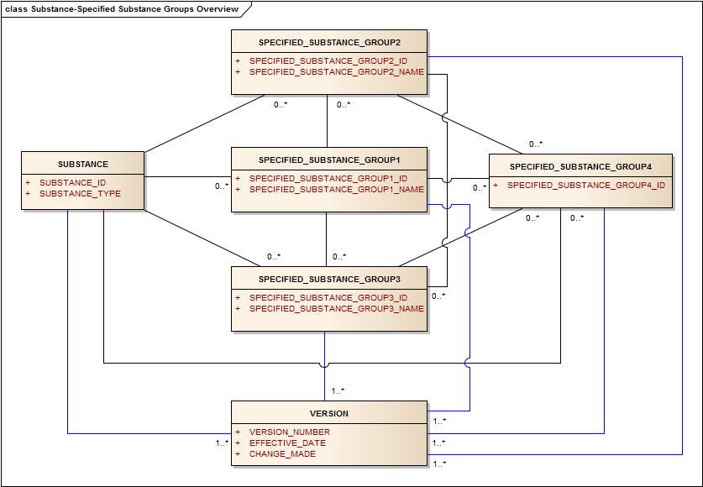
Figure 1 – High-level Substance-Specified substance information model

Defining Substances
A substance is any matter that has a discrete existence, irrespective of origin, which may be biological or chemical. Substances can be single well-defined chemical entities containing a definite molecular structure, synthetic (e.g. isomeric mixtures) or naturally-occurring (e.g. conjugated oestrogens) mixtures of chemicals, or materials derived from plants, animals, microorganisms or inorganic matrices that are not definable by a single or limited number of molecular structures. Substances may be active moieties, salts, solvates, stoichiometric complexes or mixtures of compounds that are isolated or synthesised/ obtained or produced in a process together. Materials that are combined from multiple sources to form a product are not considered substances.
A substance is generally defined by what it is, and not by how it is made or used. Substance definitions are typically based on the immutable properties of a given material. These properties include the molecular structure, or structures of a given material, taxonomic, anatomical or fractionation information for material that cannot be represented by molecular structures. Purity, physical form, and method of production are typically not considered when defining substances.
In addition to defining information there is also information that is essential to validate the defining information and this information should be submitted if available. Validation may be performed based on relevant provided documents (e.g. regulatory dossier) or information available in recognised source (e.g. pharmacopoeias).
The primary goal of the ISO IDMP standard - Data Elements and Structures for the Unique Identification and Exchange of Regulated Information on Substances is to define unambiguously all substances present in regulated products. Once a substance has been defined, a unique identifier that is permanently associated with that substance will be assigned. This document describes the necessary information for this registration process. Reference information, names, codes and IDs that can be associated with a substance are also described. The document is not comprehensive in regards to reference and definitional information. Other substance attributes may be associated for both reference and definitional information as new scientific standards or information becomes available.
Substances that are mixed together to form a product, even if there are physical interactions between the substances will be described as a specified substance or a product.
EXAMPLE FD&C Blue No. 1 Aluminium Lake is not defined as a mixture substance but rather as two separate substances FD&C Blue No. 1 and aluminium oxide. Also, simethicone is not a substance because it contains two substances, namely dimethicone and silicon dioxide. These materials would be described as Group 1 Specified Substances.
Conversely, if new covalent bonds and/or simple salts or solvates are formed, separate Substance IDs for each molecular entity are assigned.
EXAMPLE Fluticasone propionate would have a separate ID from fluticasone; atorvastatin calcium trihydrate would have a separate ID from atorvastatin calcium anhydrous.
Differences at the specified substance level should trigger a new Specified Substance ID and should not require a new Substance ID if what is defined at the substance level is identical.
EXAMPLE Insulin Human Crystalline and Insulin Human Amorphous will have different Group 1 Specified Substances IDs whilst the Insulin Human Substance ID is identical and referenced in the Specified Substance Group 1.

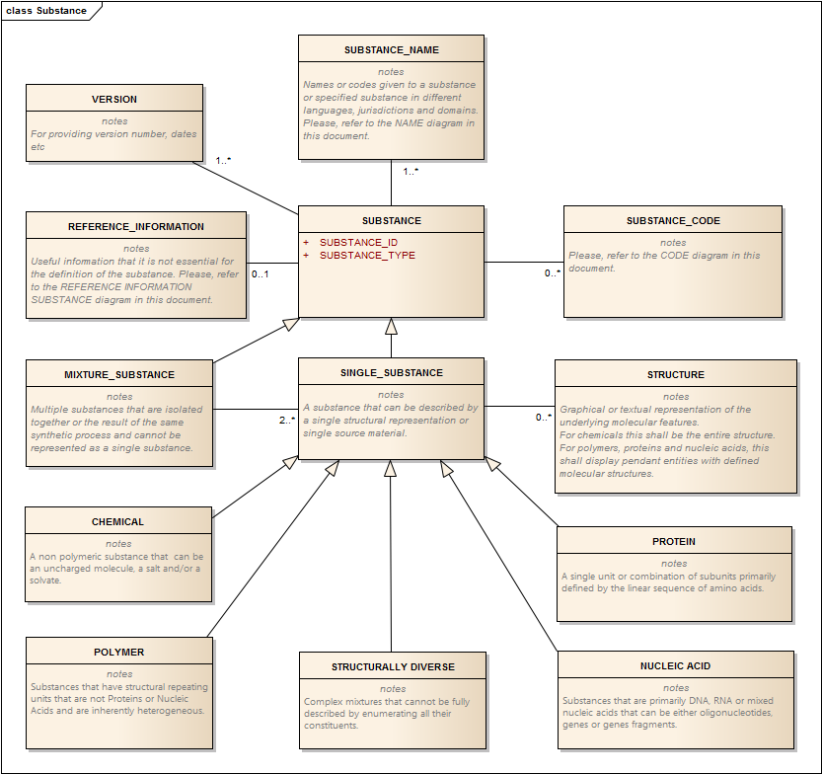
Figure 2 – High-level information model for Substances

Substance Types
At the basic level, all material present in medicinal products will either be described as a substance and/or a Specified Substance Group 1. Additional information, such as manufacturer, grade and manufacturing information on a given material will be associated with Specified Substance Groups 2-4.
Substances are either one of five types of single substances or a mixture. Mixtures consist of a combination of related single substances where the source material and essential properties are also captured but proportions are not. For the purposes of definition, all single substances are of one of the following types:
  - (simple) chemical;
  - protein;
  - nucleic acid;
  - polymer;
  - structurally-diverse.

Each of these different types of substances has distinct elements essential for definition. Substances can also be a mixture of single substances, typically related and of the same type. Some materials may appear to have elements from multiple types of substances e.g. PEGylated proteins, drugs covalently linked to polymeric matrices or proteins, etc., to fully define the substance. Each of these substances will be described as a single type, although it is possible for the same to be defined as two types one of which would be an alternative definition.
EXAMPLE 1: Proteins modified with a polymer or drug will be described as a protein with the polymer or drug captured as a modification. Drugs covalently linked to a polymer will be described as a polymer with the drug either captured as an end group or as structural modification. Detailed examples will be provided in the Annex to address these complex materials. Although every substance definition will be defined with a single type it is possible that an alternative definition of a substance will be of a different type.
EXAMPLE 2: Desmopressin can either be defined as a modified peptide or as a chemical substance.
Mixtures consist of a combination of related single substances where the source material and essential properties are also captured but proportions are not. At the Specified Substance Group 1 level proportions can be captured.
Additional information, such as manufacturer, grade, and manufacturing information on a given material will be associated with Specified Substances Groups 2-4. The first step in defining a material is to determine whether the material can be defined as a single substance, a mixture of single substances or a Specified Substance Group 1. A mixture substance is a substance that cannot be defined using a single set of substance elements or structural representations. Racemic mixtures, most polymers and structurally diverse substances, although inherently mixtures, can be defined using a single set of elements and therefore are not described as mixtures. Material that contains multiple substances that are not related and not synthesised or isolated together will be described as Specified Substance Group 1. Specified substance Group 1 would also include crystalline polymorphs, substances in varied physical states along with the capture of additional properties regarding sterility or the presence of endotoxin.
Examples of Specified Substance Group 1 include simethicone, adjuvanted vaccine antigens, isophane insulins and additional herbal and allergenic extractinformation not captured at the Substance level. Sterile water, water for injection, ice, and steam would be different Specified Substances Group 1 that would map to the substance water.
Mixtures are substances like Gentamicin sulfate, USP or Gentamicin sulfate, EP which consists of mixtures of distinct but related individual aminoglycosides. In USP Gentamicin sulfate is described as a mixture of Gentamicin C1A sulfate, Gentamicin C1 sulfate, and Gentamicin C2 sulfate. In EP it is described as a mixture of five components Gentamicin C1, C1a, C2, C2a, and C2b respectively which are typically isolated together from a bacterial culture. At the substance level all related substances typically present at a level greater than 1% would be listed as components of the mixture regardless of whether the substance is listed in a given pharmacopoeia. Mixture Substances are defined in the ISO 11238 Substance standard as a simple combinations of single substances that are either isolated together of are the result of the same synthetic process.

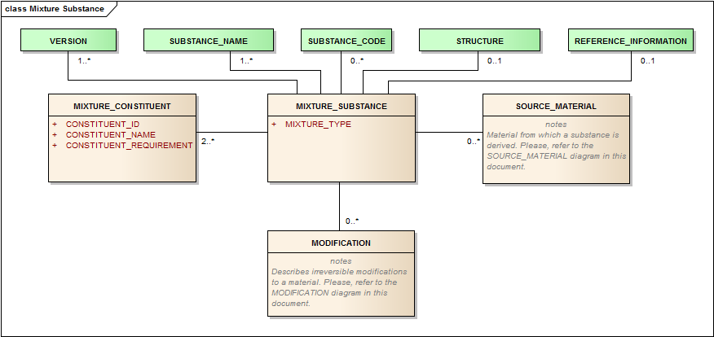
Figure 3 – High-level information model for Mixture Substance
For mixture substances in which multiple related substances are isolated together from a single source, the source will be a defining element. Starches are typically a mixture substance of the two distinct polymers amylose and amylopectin. Corn, wheat, potato and tapioca starches are all distinct substances distinguished by the source.
Most other polymers will be described as single substances with the definition based on the structural repeating unit and a representation of the average molecular weight of the polymer as well as the biological source for biopolymers or polymers derived from biological matrices.
Figure 4 represents a decision tree or process by which the type of substance is determined. Monodisperse substances are substances that can be described as a single molecular entity. Polydisperse substances are substances that typically have multiple molecular entities that are too numerous or too diverse to be captured as a mixture (e.g. cells or tissues) or where the production of the substance inherently results in polydispersity (e.g. polymers).
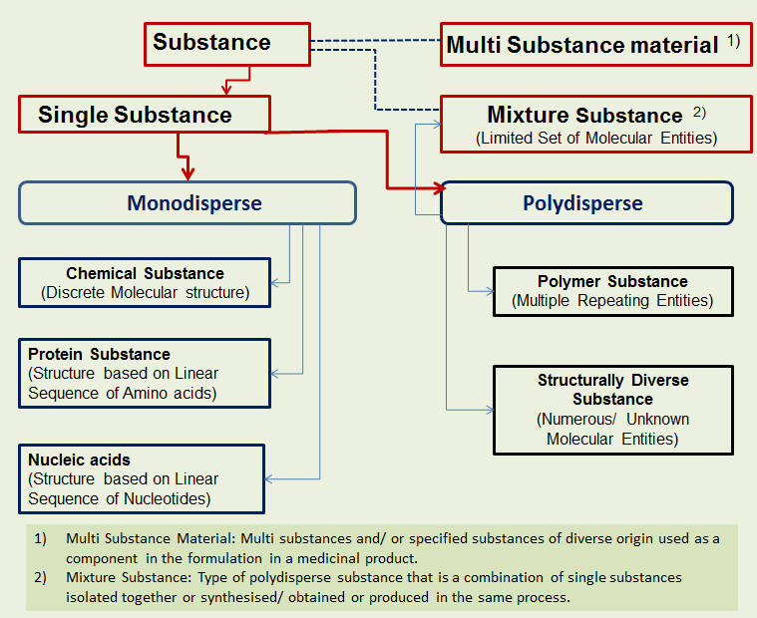
Figure 4 – Decision tree or process by which the type of substance is determined

Table 2 – Substance types
User Guidance | Information about the substance type as described in and in accordance with ISO 11238 definitions
Example(s) | “Chemical“ “Protein” “Nucleic acid, “Polymer”, “Structurally Diverse”
Conformance | REQUIRED
Data Type | CD
Values Allowed | Chemical, Protein, Nucleic Acid, Polymer, Structurally Diverse, Mixture, Specified Substance Group 1, Specified Substance Group 2, Specified Substance Group 3, Specified Substance Group 4
Business Rule(s)

Substance ID
Every substance will be identified by an ID. An ID will be generated following the initial submission of substance data. The ID should be unique to each substance, non-semantic, non-chronological, and of fixed length with an integrity check. Once an ID is assigned to a given physical or conceptual material the ID will not change. Changes or additions to defining information result in a new version of the substance definition but would not result in a new Substance ID. Although an effort should always be made to obtain complete information prior to assignment there will be instances when additional definitional information on a given substance is transmitted after assignment. When incorrect or incomplete information may be transmitted and used to define a substance the information will be changed or added but the ID will not change. In rare cases when the same substance is found to have two IDs one of the IDs will remain a primary ID and the use of the other ID will be deprecated and captured in the Substance Code class For some materials there may be multiple IDs that a material could map to. A submitter should always submit the ID that is the most descriptive of the material.
EXAMPLE Glucose, when a solid crystalline material can exist with an alpha or beta pyranose structure in an anhydrous state, or as a monohydrate with an alpha pyranose structure. If a solid crystalline form of glucose exists in a medicinal product the ID specific to the structure should be used. Glucose in a liquid or an amorphous solid state would use the Substance ID that does not specify the specific form.
Both substances and specified substances will be identified with an ID. IDs will be released to the public if the substance is in a licensed medicinal product. The IDs for substances in the investigational stage will only be released if an official name exists or a company code is associated with defining information and is found together in at least one single reference that is from a reputable source in the public domain (i.e. scientific journal, presentations or posters at scientific conferences, company publication, patent or published patent application, public databases such as STN from CAS). Substance IDs will always be issued to the requester if sufficient information is provided to unambiguously define the substance.
Table 3 – Substance ID
User Guidance | ID to be used in all electronic submissions to identify a substance. Generated when sufficient information is available to unambiguously define a substance. ID will be permanently associated with a given substance and each substance at the substance level shall have one and only one ID.  NOTE If a unique “Substance ID” has been assigned, this “Substance ID” shall be specified based on the Substance Name controlled vocabulary. In the absence of a unique “Substance ID”, e. g. for the initial submission of the substance, this data element is not required.
Example(s) | UNII Code, EV-Code
Conformance | REQUIRED
Data Type | II
Values Allowed | Value could be a code associated with a preferred term, or a specific type of data. If a code is transmitted the preferred term associated with that code should also be transmitted.
Business Rule(s) | All substances will be identified by a single ID.  NOTE: the Substance ID is NOT SPECIFIED for Substance ID Request  NOTE: The ID will only be released to the public if the defining information is in the public domain or if a company that provides the defining information requests public release or releases the code in public marketing materials. Defining information found in patents will usually not be sufficient to release the ID to the public. Even if an ID can be released there may be elements that will not be released to the general public. An ID will always be issued to an organisation that requests an ID and supplies the information necessary to define a substance. A flag to control the release of the ID to the general public is part of the Reference Source information (Section 4.6).

Substance Names
Although the standard does not provide any guidance on substance nomenclature, it does provide a structure for the capture of names and codes that are used to refer to a substance. For the purpose of the standard there are basically five types of names, Official names, systematic names, other names, brand names and company codes.
At least one name or company code should be associated with each substance. Names for a given substance and/or standardised names submitted by another party may be available in the substance terminology. Indication that a name is the preferred name or term by which a substance will be referred to in a given jurisdiction and domain may be presented in the terminology. This preferred term may vary depending on jurisdiction or domain or the state of development of a given substance.
EXAMPLE During the early stages of clinical development, the preferred term for a substance may be its company code. In later stages an INN name may be associated with the substance and become the preferred term for that substance.
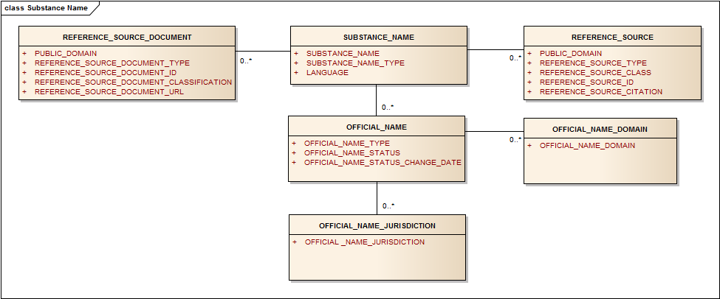
Figure 5 – Information model for Substance Names

Substance Name
When requesting an ID a submitter should submit all names and company codes which have been associated with the substance. A submitter may also want to add a name to a substance that is already in the database. Defining information for a given substance should also be transmitted when requesting that a name is added to the database to ensure the correct substance identity. A submitter may also submit names in multiple languages. Although there is no requirement that names are unique, other or common names should also explicitly distinguish related substances from one another. Distinguishing characteristics for many polymers, such as molecular weight, degree of polymerisation, and viscosity, should be indicated in the names of these substances. Standardisation on such names to facilitate searching and identification of substances may be adopted within regions.
EXAMPLE Polyethylene glycol is a name for a family of polymers, so it would not be an acceptable name for an individual substance. Polyethylene Glycol 1000 is an official name in the US for a polyethylene glycol polymer with an average molecular weight of 1000. In Europe the INN name Macrogol 1000 would be an official name for the same substance. In the personal care products domain PEG-20 is the official name for the same substance and 20 refers to the average degree of polymerisation.
Table 4 – Substance name
User Guidance | Name or company code associated with the Substance.
Example(s) | “Amoxicillin”
Conformance | REQUIRED
Data Type | ST
Values Allowed | Free text, multiple names allowed, each in its own <asNamedEntity> element.
Business Rule(s)

Substance Name Type
Every name shall have one and only one name type. Official names are typically non-proprietary names used in a given jurisdiction and domain to refer to a specific substance. The domain, jurisdiction, and authority that assigned the name (USAN, INN, JAN etc.) and the language of the name are also captured.
Systematic names will typically be used for simple chemicals and structurally diverse materials where the definitions are based on a chemical structure or systematic taxonomic information. For chemicals these names are typically derived from IUPAC or CAS systems of nomenclature. From the systematic names of chemicals a molecular structure can typically be derived and the name can be checked by a number of chemical drawing programmes that convert a given name to a molecular structure. Other names associated with a given substance are for instance generic names. Brand names are names by which a company identifies a given substance typically for marketing purposes. Company codes (also known as lab/laboratory codes or clinical trial codes) are also treated as names. They are assigned by a given company to substances in clinical or preclinical development.
Table 5 – Substance name type
User Guidance | Each name shall be associated with a type.
Example(s) | Official name, systematic name, other name, brand name, company code
Conformance | REQUIRED
Data Type | CD
Values Allowed | OFFICIAL, SYSTEMATIC, COMPANY CODE, OTHER, BRAND
Business Rule(s) | A name shall have one and only one name type.

Language
All names should be associated with at least one language. Often the name, particularly INN names, will be identical in multiple languages. The language for company codes that use a Latin character set will be described as English (en). The language for the systematic name of plant, microorganism or animal derived substances will be also be described as English since many of these will be a hybrid of a Latin Name for the species and an English name for the part and/or the subspecies information.
EXAMPLE The INN name alisertib is identical in English, French and Spanish.
Table 6 - Language
User Guidance | If the name is language dependent, that language shall be specified. The language used to provide the structured substance information shall be specified according to the XML standard’s xml:lang attribute specification, which is based on ISO 639-2 alpha-2 codes
Example(s) | en – English, de – German, fr –French
Conformance | CONDITIONAL
ata Type | CD
Values Allowed | ISO 639-2 alpha-2 codes
Business Rule(s) | While xml:lang allows country-specification of language, e.g., en_US vs. en_UK or pt_PT vs. pt_BR, such specificity is to be avoided except if the country variant of the language exceptionally does give rise to an alternative spelling. In that case, only the exceptional spelling needs to be tagged with the country-specific language code, not the regular spelling for that language in all other countries.  If the same name spelling exists for multiple languages of interest, the entire name is repeated each time with its own language code.

Official Name (repeat as necessary)

Each official name shall have one or more Official Name Types. The Official Name Type reflects the organisation that assigns or recognises the name associated with the substance. These names are typically non-proprietary names that are used in the labelling of pharmaceuticals. The domains and jurisdictions in which the Official Name is used are also captured, tracked and maintained within the terminology. Although most official names will refer to material at the Substance level there will be instances where an official name will refer to material at the Specified Substances Group 1 level (e.g. Simeticone (BAN, INN) or Simethicone (USAN)). The Official name class is optional and shall be repeated as necessary.

Official Name Type
Any authority which assigns official names will typically do so in a publication, and as such, referencing the publication is sufficient indication for the name being “official” and sufficient representation for the “official name type”. When new official names are issued by official naming bodies, the naming bodies will be reflected in this terminology.
Table 7 – Official name type
User Guidance | Designation of which authority assigned the Official Name. All official names need to have at least one such designation. The name type is the name of the authority or authorities that have assigned or have adopted the name.
Example(s) | BAN, COSING, EP, FCC, INCI, INN, JAN, JECFA, MARTINDALE, USAN, USP.
Conformance | REQUIRED – all official names require a designation of the naming authority
Data Type | CD
Values Allowed | All values in the name assigning authority identifier system.
Business Rule(s) | All official names must have a naming authority designated. If multiple authorities have assigned the same name, a separate <asNamedEntity> is specified for each authority that needs to be listed.

Official Name Status
The status of the official name is associated with a given jurisdiction. It is possible that an official name could be official in one jurisdiction and superseded in another. With some official name types an initial name will be proposed and the name will later become recommended. Recommended INN names would be considered to be the Primary Official name in many jurisdictions.
Table 8 – Official name status
User Guidance | The status of the official name.
Example(s) | Current, Alternate, Superseded, Proposed
Conformance | OPTIONAL
Data Type | CD
Values Allowed | Current, Alternate, Superseded, Proposed
Business Rule(s) | Each official name shall have a single status.  The fact that a name is alternate is evident by having more than one name assigned to the same substance by the same authority for the same language, domain, etc.

Official Name Status Change Date
The change date of the status of the official name shall be specified according to the ISO 8601 date format (the variant without any delimiters).
Table 9 – Official name status change date
User Guidance | Date of official name change if known.
Example(s) | 20110601
Conformance | CONDITIONAL
Data Type | DATE
Values Allowed
Business Rule(s) | If official name status changes the date of the official change will be captured if known.

Official Name Domain (repeat as necessary)
Official names will also be associated with a domain. The domain and the actual name of a domain will vary according to jurisdiction.
EXAMPLE The terms DRUG and BIOLOGIC could be used in Japan and the US as official name domain. In the EU the term MEDICINE may cover the name of many substances that would be either DRUGS or BIOLOGICS in the US and Japan.
Table 10 – Official name domain
User Guidance | Specifies when and for what purpose the official name is to be used. All official names can have at least one domain. This is useful to differentiate different names for the same substance as used for a drug active ingredient as opposed to a food colour additive.
Example(s) | BIOLOGIC,COSMETIC, DRUG, FOOD, MEDICINE, DIETARY SUPPLEMENT
Conformance | CONDITIONAL
Data Type | CD
Values Allowed
Business Rule(s) | Used if different names exist that are not appropriate to be used across all domains.

Official Name Jurisdiction (repeat as necessary)
When a product is on the market and contains pharmaceutically active substances at least one jurisdiction should be associated with the name of the active substance. For inactive substances or excipients the jurisdiction may not be apparent or captured. Pharmacopoeias will often be consulted to determine the jurisdiction of an official name. The Official Name Jurisdiction class is optional; when necessary the following conformances apply:
Table 11 – Official name jurisdiction
User Guidance | The jurisdiction of the official name shall be provided.
Example(s) | US, EU, JA
Conformance | CONDITIONAL
Data Type | CD
Values Allowed | ISO 3166-1 alpha-2 codes For the European Union EU shall be used.
Business Rule(s) | All the jurisdictions in which the Official Name is to be used should be indicated.

Reference Sources
All data elements associated with a substance or specified substance should have a reference source. These sources could be regulatory submissions, publications by naming authorities such as INN or USAN, pharmacopoeias, books, journals, web sites, meeting materials of public databases such as chemical abstracts. A source can refer to multiple data elements and a given element can have multiple sources.

Public Domain
Most reference sources other than regulatory submissions will be in the public domain. All regulatory submissions will typically be considered to not be in the public domain. If the reference source is in the public domain the data elements referenced by the source could be made public. There may be a separate determination whether any portion of the record can be made public. This determination may vary depending on type of substance. Regardless submitters of information should always explicitly indicate whether data should be considered confidential.
EXAMPLE Particular care should be taken in the release of company codes. Although the company codes are frequently mentioned in the public domain the release of a company code associated with a Substance ID and the defining information should only be made if all of the defining elements are associated with the company code in a single source in the public domain. For chemicals, the chemical structure should be associated with the company code in the public domain. For proteins such as monoclonal antibodies, names or company codes could be released to the public only if the target of the antibody is mentioned in the same public source as the name or code. A separate determination will be made as to whether the protein sequence is in the public domain.
Table 12 – Public domain reference source
User Guidance | Indication of whether the source is in the public domain. Company codes will only be released if the defining information is associated with the code in a public source such as chemical abstracts (CAS), a journal article, or a poster at scientific meeting attributable to the company.
Example(s) | Yes, No
Conformance | REQUIRED
Data Type | BL
Values Allowed | Yes, No
Business Rule(s) | All regulatory submissions are considered not to be in the public domain. There may be an additional flag that determines whether any information can be released on a given substance.

Reference Source Type
All reference sources will be associated with a type. The type may actually identify the source of the information if it is a public database or naming authority. For official names and defining information, the primary source should be used if available. A single source can be used for many data elements. Public databases particularly those of official naming bodies, regulatory submissions, manufacturer‘s technical specifications, scientific journal articles and pharmacopoeias are all sources that can be used.
Table 13 – Reference source type
User Guidance | The reference source type in which the data elements were actually found.
Example(s) | BP, CHEMID (NLM), EP, IND, INN, ITIS, JAN, JOURNAL, JP, KEGG, MARTINDALE, NDA, PERSONAL CARE PRODUCTS COUNCIL (PCPC), PUBCHEM, USAN, USP, WEB PAGE
Conformance | REQUIRED
Data Type | CD
Business Rule(s) | All names should have at least one source and hence source type.

Reference Source Class
Each reference information type will be associated with a class. The class will be automatically associated with each type of information.
Table 14 – Reference source class
User Guidance | Useful for classification of sources.
Example(s) | Regulatory submission
Conformance | CONDITIONAL
Data Type | CD
Values Allowed | LITERATURE, OFFICIAL NAME SOURCE, REGULATORY SUBMISSION, WEB.
Business Rule(s) | Need not be entered as the value is dependent on the Reference Source Type.

Reference Source ID
Many sources such as regulatory submissions, INN lists and others will be associated with a number or ID. The ID should be captured.
Table 15 – Reference source ID
User Guidance | An ID associated with reference source.
Example(s) | IND number, INN list; PMID (Pubmed Identifier).
Conformance | CONDITIONAL
Data Type | ST
Values Allowed
Business Rule(s)

Reference Source Citation
A citation should be captured for a literature reference. The specific format for a given citation may be defined at regional level.
Table 16 – Reference source citation
User Guidance | The actual reference source or citation in which the name was found.
Example(s) | Literature reference: Encycl. 3: 429 (1792)
Conformance | CONDITIONAL
Data Type | ST
Values Allowed
Business Rule(s)

Reference Source Document (new classes to be included in the ISO 11238 Standard in the next revision)
The document should be concise and contain information specific for given data elements.
Table 17 – Reference source document
User Guidance | Documents that contain relevant information on data elements and are referenced should be stored if available.
Example(s)
Conformance | OPTIONAL
Data Type | ED
Values Allowed | The documents can be saved as PDF files or TEXT files. if the documents or data source contains structured data such as spectra, it can be transmitted in a standard format that can be visualised and searched.
Business Rule(s)

Reference Source Document Type
Table 18 – Reference source document type
User Guidance | The type of the document
Example(s) | Regulatory submission, Journal article , Release specification, In House specification
Conformance | OPTIONAL
Data Type | CD
Values Allowed
Business Rule(s)

Reference Source Document Classification
A classification system will be also developed for documents. The classification system will indicate the type of information contained within the reference document based on a terminology for the classification of reference source documents.
Table 19 – Reference source document classification
User Guidance | The reference document should be classified according to the information contained within
Example(s) | Chemical structure, Name, NMR spectra, Mass Spectra,
Conformance | OPTIONAL
Data Type | CD
Values Allowed
Business Rule(s)

Reference Source URL
Table 20 – Reference source URL
User Guidance | The reference source URL in which the name was found. The URL can be captured here.
Example(s)
Conformance | CONDITIONAL
Data Type | ST
Values Allowed
Business Rule(s)

Substance Code
This section of reference information allows the capture of codes that are typically associated with a substance. The capture of these codes typically facilitates the defining and mapping of substances and linking of substances to a variety of information sources. Codes should be communicated if known but are not necessary or mandatory. The terminology should have the ability to capture, store and distribute codes as necessary. All the codes that are captured should be associated with a publicly recognised code system and map directly to a given substance. It should be noted that company codes are not captured in this section but are considered a type of name for a given substance. Commonly used public codes such as CAS registry numbers with a given substance should be provided and associated to the substance.
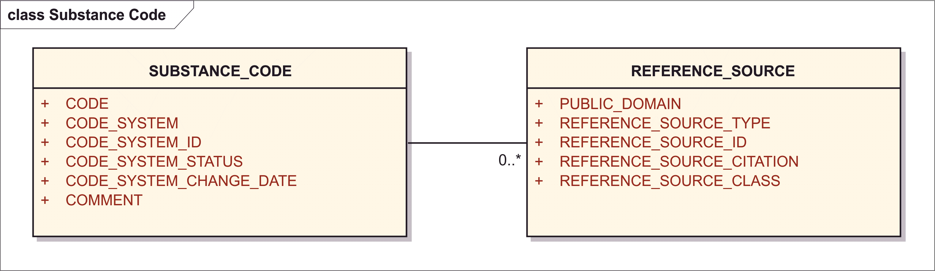
Figure 6 – Information model for Substance Codes

Code
The actual code should be captured using the same format that is used in the code system. Only codes associated with a code system will be captured. The code should be specifically associated with a given substance. Many public and non-public databases identify substances with a code and these codes can be very helpful in mapping substances to various systems. Codes should always be verified against the source system. Different jurisdictions may require a code from a code system or multiple code systems to be associated and submitted with a substance.
Table 21 - Code
User Guidance | The specific code (the value) with regard to a referenced code system.  NOTE: InChI is not considered a code and shall be specified within the structure description.
Example(s) | 11-22-356
Conformance | CONDITIONAL
Data Type | ST
Values Allowed
Business Rule(s) | Only codes from recognised code systems will be captured. The code should specifically link to a substance but need not uniquely link to substance. This code can also be a deprecated Substance ID generated based on ISO 11238.

Code System
Every code should be associated with a code system and a list of names of code systems expected to be submitted should be developed and maintained for the purpose of this terminology.
EXAMPLES CAS registry numbers, EC numbers, FDA UNII codes, EMA XEVMPD codes, ASK numbers, EPA Pesticide codes.
Table 22 – Code system
User Guidance | The ID of the code system.
Example(s)
Conformance | CONDITIONAL
Data Type | CD
Value Allowed
Business Rule(s) | If the Code class applis, the code system ID is required as all codes must be linked to a code system.

Code System
Every code should be associated with a code system and a list of names of code systems expected to be submitted should be maintained by the maintenance organisation.
Examples CAS registry numbers, EC numbers, FDA UNII codes, EMA XEVMPD codes, ASK numbers, EPA Pesticide codes.
Table 23 – Code system
User Guidance | Name of the code system.
Example(s) | CAS, EINECS, NSC, ASK, ATC, NDF-RT; RX-CUI ETC.
Conformance | CONDITIONAL
Data Type | CD
Values Allowed
Business Rule(s) | If the Code class applies, the code system name is implicit and derived from the Code System ID.

Code System ID
The code system ID may be an OID or an ID as applicable. The ID is associated with code system and need not be submitted.
Table 24 – Code system ID
User Guidance | The ID of the code system.
Example(s) | CAS Registery code: 0049; FDA Substance Registration System (UNII) 0050
Conformance | CONDITIONAL
Data Type | II
Values Allowed
Business Rule(s) | If the Code class applies, the code system ID is required as all codes must be linked to a code system.

Code System Status
The code system status is typically the status provided by the system for a given code. Many code systems can end up with multiple codes representing the same substance. Often one code will be the preferred code and others will either be deleted or deprecated. Ad-hoc terms may also be developed to indicate a code status.
Table 25 – Code system status
User Guidance | The status of the code assignment
Example(s) | current, proposed,
Conformance | CONDITIONAL
Data Type | CD
Values Allowed | “active” – Current, “active” – Alternate, “superseded” – Terminated, “pending” – Proposed
Business Rule(s)

Code System Status Change Date
Table 26 – Code system status change date
User Guidance | The date at which the code status is changed as part of the terminology maintenance.
Example(s) | 20110601
Conformance | OPTIONAL
Data Type | TS.DATE
Values Allowed
Business Rule(s)

Comment
Table 27 - Comment
User Guidance | Any comment can be provided in this field, if necessary.
Example(s)
Conformance | OPTIONAL
Data Type | ST
Values Allowed
Business Rule(s)

Reference Source
The reference source will be captured according to Section 4.6.

Reference Information
Where applicable, the reference information shall be provided according to the following specifications:

Substance Classification (repeat as necessary)
Compounds that either have similar chemical structures or similar effects when administered in a medicinal product. The standard should have the ability to capture a variety of classification systems. Classification systems are typically based on molecular structure, chemical properties, pharmacological effects, mechanism of action, therapeutic targets or indication.
The standard shall have the ability to capture multiple classifications and variable levels of classification. Although most classification will be associated with an external classification system, ad-hoc classification of substances may be developed within this terminology as needed.
The information in figure 7 shall be provided:
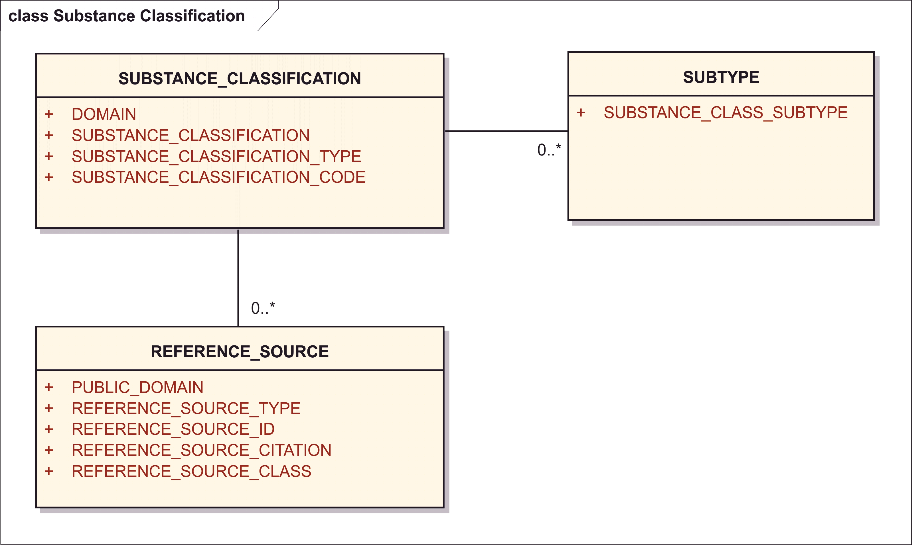
Figure 7 – Information model for Substance Classification

Domain
Classification systems will often only be used within a specific domain. The domain will be associated with the classification system.
Table 28 - Domain
User Guidance | The domain of the substance classification shall be provided.
Example(s) | Human pharmaceuticals, human vaccine, animal drug, animal vaccine, food, food additive, colorant, pesticide; tobacco additive; flavour, excipient
Conformance | OPTIONAL
Data Type | CD
Values Allowed
Business Rule(s)

Substance Classification (Code System)
There are a number of systems that classify substances based on chemical structure, pharmacological effect, organ system affected, mechanism of action or molecular targets. These classification systems are useful and this information, if available, should be provided and maintained as applicable.
Table 29 – Substance classification (code system)
User Guidance | Substance Classification terms based on a controlled vocabulary that is controlled by the system or type of substance classification.  The system should be capable of capturing a variety of classification systems and each system should be identified. All active ingredients are typically classified in multiple systems. Ad-hoc classification may be created as necessary.
Example(s) | ATC, NDF-RT, NCI, AHPA, MESH; Therapeutic Category of Drugs in Japan
Conformance | OPTIONAL
Data Type | CD
Values Allowed
Business Rule(s)

Substance Classification Type
Nearly all classification systems contain multiple levels. Type is the highest level or the initial level of the classification system.
Table 30 – Substance classification type
User Guidance | The initial type or highest level of a classification system.
Example(s) | Organ system in ATC.
Conformance | OPTIONAL
Data Type | CD
Values Allowed
Business Rule(s) | The value is IMPLICIT and can be derived by the “Substance Classification – Subtype “if available.

Substance Classification Subtype (repeat as necessary)
Table 31 – Substance classification subtype
User Guidance | Many classification systems will have multiple subtypes of classification this field will attempt to capture this information.
Example(s) | NDF-RT Mechanism of Action (MOA) or Physiological Effect.
Conformance | OPTIONAL
Data Type | CD
Values Allowed
Business Rule(s)

Substance Classification Code
Classification code with map to the active moiety of a given substance.
Table 32 – Substance classification code
User Guidance | Code from the classifying code system. The code should be tied to the substance...
Example(s) | N0000175684 NDF-RT code for Oxycodone that maps to the mechanism of action classification. N02AA05 ATC code that maps to Oxycodone.
Conformance | OPTIONAL
Data Type | II
Values Allowed
Business Rule(s) | The classification code shall be part of an internationally recognised classification system.

Reference Source
The reference source will be captured according to Section 4.6.

Target
The Target section allows the capture of information related to the targets that a substance is known to interact with and the interaction results in a biological effect or transformation. These targets can be therapeutic, metabolic, interactions postulated to result in toxicity or interactions of unknown effect. Targets are typically proteins, or complexes of proteins. The target may be a substance in its own right and ID shall be assigned and/or existing ID of a known system used (i.e. GENE, Uniprot) to refer to a target.
For monoclonal antibodies the target shall always be provided. For other types substances the target may be provided if known. Ideally the target is a substance with its own Substance ID. However, in specific circumstances, the target may be handled as a relationship between two substances.

Target ID
Typically the ID is either a Substance or Specified Substance ID. The ISO 11238 standard will be updated to rename Target Gene ID element as Target ID.
Table 33 – Target ID
User Guidance | ID of the target relation molecular entity upon which the substance acts.  One Target ID should be specified. The target should be a molecular entity or a family of molecular entities. The target is usually a protein entity that the drug actually interacts with. Both therapeutic and metabolic targets and targets associated with toxicity should be captured.
Example(s)
Conformance | CONDITIONAL
Data Type | CD
Values Allowed | ISO 11238 Substance ID
Business Rule(s) | The ISO 11238 Substance ID shall be referenced.

Target Name
At least one name of the target shall be provided when target information is submitted. Target names will typically be handled no differently than other substance names. If an active ingredient targets more than one target each target should be listed. In addition to names a list of codes associated with the target may also be used. Gene bank and Uniprot codes can be particularly useful for identifying and tracking targets. The ISO 11238 standard will be updated to rename Target Gene Name element as Target Name.
Table 34 – Target name
User Guidance | Name of the target molecular entity upon which the substance acts.  Each target should be associated with a target name.
Example(s)
Conformance | CONDITIONAL
Data Type | CD
Values Allowed | ISO 11238 substance name
Business Rule(s) | ISO 11238 substance name implicitly derived from Target ID. A variety of names can be captured. A single name will be a preferred name and associated with the Target ID.

Interaction Type
The type of interactions between a substance and its target should also be captured. A controlled vocabulary should be developed to capture these types of interactions.
Table 35 – Interaction type
User Guidance | Type of interaction between the substance and the target. The interaction type will be captured for all substrate-target interactions. A substance can have multiple types of interactions.
Example(s) | AGONIST, INDUCER, INHIBITOR, PARTIAL ANTAGONIST, SUBSTRATE, PRODUCT
Conformance | CONDITIONAL
Data Type | CD
Values Allowed
Business Rule(s)

Target Organism
When drugs are targeted against a specific organism the organism should be captured. For antivirals and antibacterials there is typically no need to give the strain level unless the organism is resistant to more commonly used drugs.
Table 36 - Target organism
User Guidance | The organism for which the active substance is targeted.
Example(s) | HOMO SAPIENS; M. TB, HIV-1 etc.
Conformance | CONDITIONAL
Data Type | CD
Values Allowed
Business Rule(s) | At least one organism type should be associated.

Target Organism Type
Every organism should have a type that is maintained within this terminology. The organism type may also be used independent of the organism particularly for substances such as antibacterials which may be targeted against a wide range of organisms.
Table 37 – Target organism type
User Guidance | Every target organism should have a type associated with the organism.
Example(s) | HUMAN, VIRAL, BACTERIAL, FUNGAL, INSECT, HELMINTH, MALARIAL
Conformance | CONDITIONAL
Data Type | CD
Values Allowed
Business Rule(s) | At least one organism type should be associated.

Target Type
Each target-substance interaction should be assigned a type. The type is dependent on the substance and also to some extent the use of the substance. A given target-substance interaction can be of more than one type.
EXAMPLE The therapeutic target would be HIV-1 protease when ritonavir is used in HIV-related therapy. The metabolic target is Cyp 3A4 and ritonavir is an inhibitor of this target. Ritonavir is also an inhibitor of P-glycoprotein a drug transporter. In many combination products ritonavir is used strictly to inhibit Cyp 3A4/5 and transporter enzymes.
Table 38 – Target type
User Guidance | Type is a limited form of classification associated with a target of an active substance. Some targets can be both toxic and therapeutic; the choice is dependent on the dose of a given substance.
Example(s) | THERAPEUTIC, METABOLIC, TOXIC; TRANPORTER
Conformance | OPTIONAL
Data Type | CD
Values Allowed
Business Rule(s) | Each target should be associated with a target type when the target can be classified,

Reference Source
The reference source will be captured according to Section 4.6 when necessary.

Gene
The Gene section will only be captured for proteins and nucleic acids. It does not apply for chemicals, polymers or structurally diverse substances. It is only used as reference information and refers to the gene that is the origin of the substance (typically a protein). Genes may also be substances and would be described as nucleic acids.

Gene Sequence Origin
For monoclonal antibodies the Gene Sequence Origin will be used to capture species from which the antibody was derived.
EXAMPLES For monoclonal antibodies the typical values can be HUMAN, HUMANISED MOUSE; HUMANISED RAT; CHIMERIC MOUSE-HUMAN; CHIMERIC RAT-HUMAN.
Table 39 – Gene sequence origin
User Guidance | Common name for the organism from which the final gene sequence originated.
Example(s) | Human, Bovine, Human; Humanised; Mouse-Human Chimeric; Mouse
Conformance | OPTIONAL
Data Type | CD
Values Allowed | Typically from the NCBI Gene database.
Business Rule(s) | NOTE: it applies primarily to proteins.

Gene ID
Table 40 – Gene ID
User Guidance | ID associated with the gene of origin
Example(s) | YP_299723.1
Conformance | CONDITIONAL
Data Type | CD
Values Allowed | Typically from the NCBI Gene database.
Business Rule(s)

Gene Name
Table 41 - Gene name
User Guidance | Complete name given for a gene. Every gene which has an ID should also have a name.
Example(s) | hIL-10 gene
Conformance | CONDITIONAL
Data Type | CD
Business Rule(s)
Business Rule(s) | Implicit from the Gene ID from the applicable Gene database.

Reference Source
The reference source and related information will be captured according to Section .

Gene Elements
Gene Elements will be captured for genes that are used in gene therapy.
When the gene element section applies, the following information shall be provided:

Gene Element Type
Table 42 – Gene element type
User Guidance | Type of the gene element.  Should be captured for all genes that are transduced into cells and are intended to be expressed.
Example(s) | enhancer, promoter, silencer, terminator, repressor
Conformance | CONDITIONAL
Data Type | CD
Values Allowed
Business Rule(s)

Gene Element ID
Table 43 – Gene element ID
User Guidance | Unique identifier for gene element.
Example(s)
Conformance | CONDITIONAL
Data Type | CD
Values Allowed | A unique identifier will be associated with each gene element.
Business Rule(s)

Gene Element Name
Table 44 – Gene element name
User Guidance | Specific gene element name.
Example(s) | SV40 Enhancer
Conformance | CONDITIONAL
Data Type | CD
Values Allowed | A unique identifier will be associated with each gene element.
Business Rule(s) | Implicit from the Gene element ID from the applicable Gene element controlled vocabulary.

Reference Source
The reference source and related information will be captured according to Section 4.6. One or more reference sources could be cited.

Substance Relationship
Relationships between substances such as the relationship between a salt form and its active moiety or parent substance should be captured. These relationships are often essential to the description of medicinal products, the basis of strength and the classification of substances. These relationships are often obvious and rules will be developed for specifying substances involved in each type of relationship. For example the active moiety of all sodium salts would be the free acid, conversely the active moiety of a hydrochloride salt would be a free base.

Relationship
The relationship is not a mere code but the actual connection between the two substances which may be different for different kinds of relationships:
There are a variety of different relationships that are possible but for the identification of medicinal products the most important relationships are between a substance, its active moieties, the basis of strength and constituents in herbal and other complex substances. Parent and salt-solvate relationships and relationship of drug substance to its metabolites and impurities are also important although not essential for the description of a medicinal product. If there are known relationships between substances the relationships should be provided and maintained. The parent-active moiety relationship may be essential in describing medicinal products.
Table 45 - Relationship
User Guidance | Relationship between substances.  NOTE: Target and gene elements are not to be specified in this section.
Example(s) | parent, active moiety, salt, radiolabeled, prodrug, metabolite, enantiomer
Conformance | CONDITIONAL
Data Type | CD
Value Allowed
Business Rule(s)

Interaction Type
Table 46 – Interaction type
User Guidance | The Type of interaction between the substances.
Example(s)
Conformance | OPTIONAL
Data Type | CD
Values Allowed
Business Rule(s)

Related Substance ID
Table 47 – Related substance ID
User Guidance | Substance ID associated with the related substance. All related substances should have a Substance ID.
Example(s)
Conformance | CONDITIONAL
Data Type | CD
Values Allowed | ISO 11238 Substance ID
Business Rule(s)

Related Substance Name
Table 48 – Related substance name
User Guidance | Preferred term or primary name of related substance.
Example(s)
Conformance | CONDITIONAL
Data Type | CD
Values Allowed | Based on ISO 11238 substance name
Business Rule(s) | The preferred term of the related substance is captured; this information is required when there is a “Substance Relationship”; The substance name is implicit and derived from the Substance ID.

Amount Type
Table 49 – Amount type
User Guidance | Most elements that require a quantitative value will also have a field called amount type. Amount type should always be specified because the actual value of the amount is often dependent on it.  EXAMPLE: In capturing the actual relative amounts of substances or molecular fragments it is essential to indicate whether the amount refers to a mole ratio or weight ratio. For any given element an effort should be made to use same the amount type for all related definitional elements.
Example(s) | Mole percent; Weight percent; Mole ratio; Weight ratio, Weight, Moles
Conformance | CONDITIONAL
Data Type | CD
Values Allowed
Business Rule(s)

Amount
For some substance relationships it may be desirable to capture a quantitative or semi-quantitative amount that may further define the relationship (i.e. major metabolite, degradants etc.). Amount shall be captured according to Section 4.9.
Substance Relationships which refer to reactions (e.g., metabolism, prodrug) are quantified by specifying the quantity of the reactants:

Reference Source
The reference source will be captured according to Section 4.6.

Structure (repeat as necessary)
Structural information is an essential element for all chemical substances and for other types of substances that have structurally definable elements or modifications. The representation should contain structural information in one or more of the standardised formats as indicated below. A graphical image of the molecular structure should also be provided if available. A complete representation of the structure should be provided and is usually sufficient to define chemical substances. Structural representations can be in a variety of formats or even multiple formats. The commonly used formats include molfile, SMILES, InChI, and cdx. Indication of a preferred structural representation may be defined at regional level. Although most chemical substances may be represented by a single unambiguous structural representation, there are also many substances that can be represented by multiple structural representations or as a mixture of single substances. For the initial implementation and the transmittal of data for substance definitions, an approach that limits submissions to a single or a limited number of unambiguous structural representations is recommended. There are several examples below that illustrate the process in choosing a defining structural representation to submit. A more detailed structure representation guide is provided as part of the annex B (Chemical substance).
For Amine Salts, with the exception of ammonium and quarternium, salts shall be represented as a free base.
EXAMPLE: DIFLOXACIN HYDROCHLORIDE
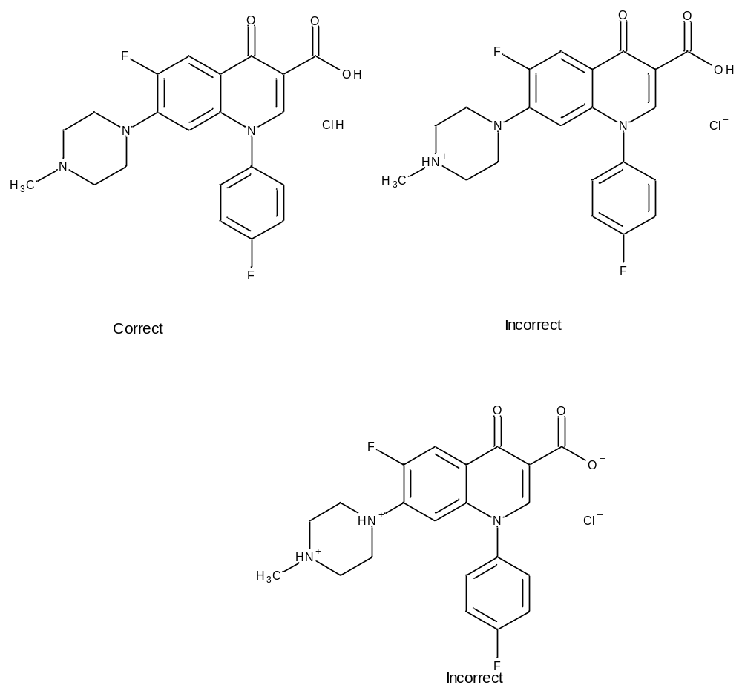
Figure 8 – Correct and incorrect graphical images of the molecular structure of DifloxacinI Hydorochloride
Metal and Ammonium Salts: All metal and ammonium salts (NH4+) shall be represented in a charged configuration with all equivalent functional groups ionised. Charge balance will be achieved when necessary by adding hydrogen ions (protons).
EXAMPLE: MONOSODIUM CITRATE
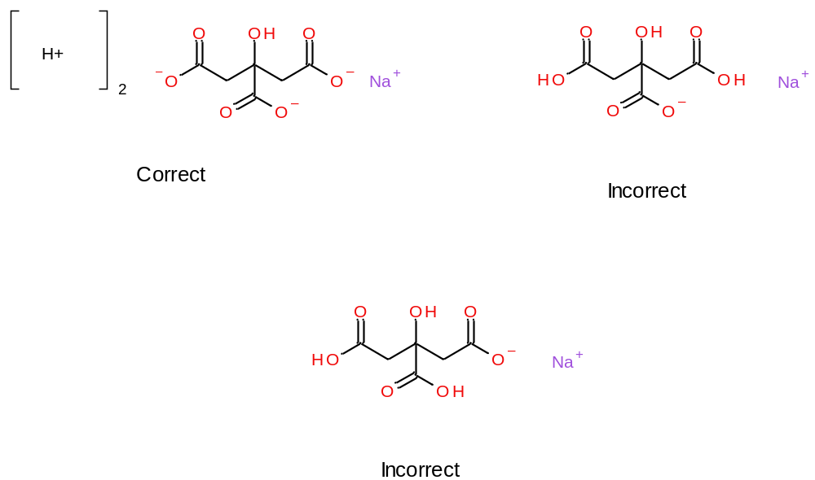
Figure 9 – Correct and incorrect graphical images of the molecular structure of Monosodium Citrate
Racemic mixtures can be represented as mixtures of enantiomers or by a single structural representation. When using a single structural representation and the substance only contains one chiral centre, a single structure will be drawn that does not contain a chiral bond. If more than one chiral centre exists, relative stereochemistry shall be indicated. The stereochemistry of each moiety of a given substance will be captured separately (Section 4.9).
EXAMPLE: OFLOXACIN
A racemic mixture of the R and S isomers. A single structural representation can be used in this case.
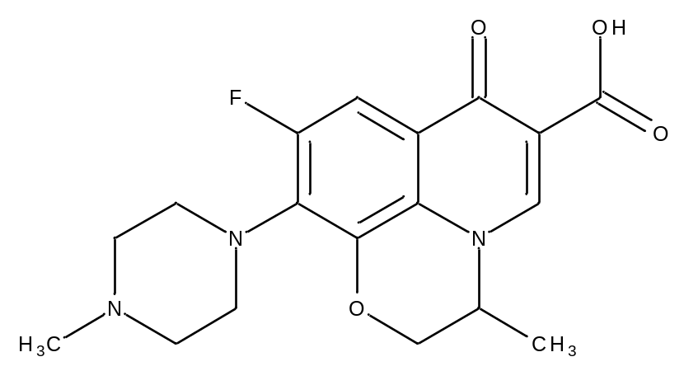
Figure 10 – Graphical image of the molecular structure of DifloxacinI Hydorochloride
There are also substances that are mixtures of multiple enantiomers. These substances can also be transmitted in a single structural representation.
Substances can exist in interconverting forms or with a different defined structure depending on the physical state. In cases where the actual structure is a single configuration in a solid physical state, that structure should be captured. When a substance exists in a liquid state and can interconvert to a variety of structures, the least ambiguous single structure should be chosen
EXAMPLE DEXTROSE (GLUCOSE): Exists as three separate substances in the crystalline state. For a crystalline substance one of the following representations should be chosen.
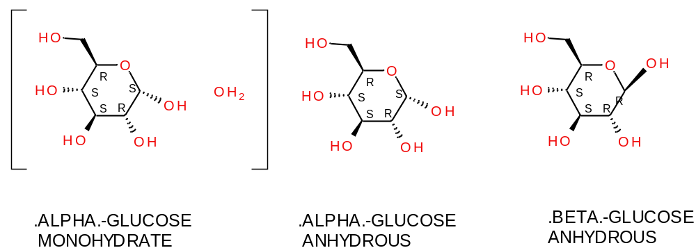
Figure 11 – Graphical images of the molecular structure of the three cristalline states of Dextrose
In the liquid state dextrose and many other monosaccharides, disaccharides and higher homologs that end in an aldehyde are often referred to as reducing sugars and exist as mixtures of interconverting substances as illustrated in the structures of glucose below.
In this case the linear single representative structure is chosen to represent dextrose in the liquid or amorphous state. If pyranose or furanose forms were chosen the representative structure would have one site of stereochemical ambiguity. One general rule is that if there are multiple interconverting structural representations for a substance the preferred representation is the one with the least ambiguity. In figure 12 the pyranose and furanose structures have one site of stereochemical ambiguity.
DEXTROSE (liquid) structural representation:
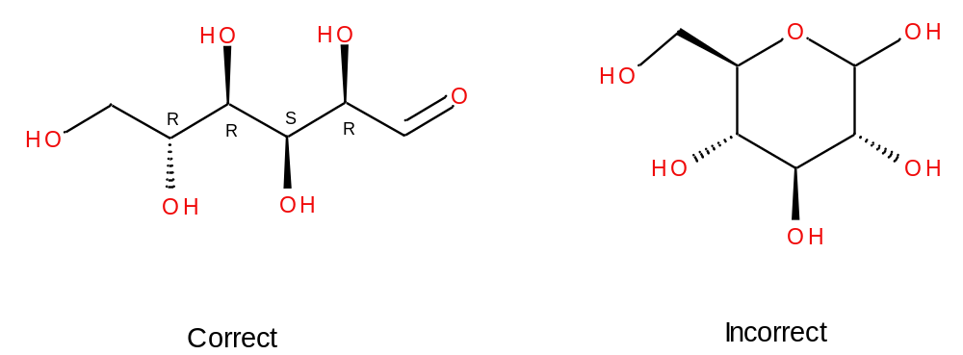
Figure 12 – Correct and incorrect graphical images of the molecular structure of (liquid) Dextrose
In this case the linear single representative structure is chosen to represent dextrose in the liquid or amorphous state. If pyranose or furanose forms were chosen the representative structure would have one site of stereochemical ambiguity. One general rule is that if there are multiple interconverting structural representations for a substance the preferred representation is the one with the least ambiguity. In the example below the pyranose and furanose structures have one site of stereochemical ambiguity.
Structural representations will also be used to represent fragments of molecules. Fragments will be used in describing partially modified polymers and are typically generated to describe partially acylated polymers, proteins or even nucleic acids. In order to consistently describe substances a fragment will be generated in a defined manner. Ester and amides will always be broke such the oxygen or nitrogen with stays with the alcohol or amine. Ethers will be broken such that the oxygen stays with polymeric or larger structural unit.
EXAMPLE: Cellulose Acetate
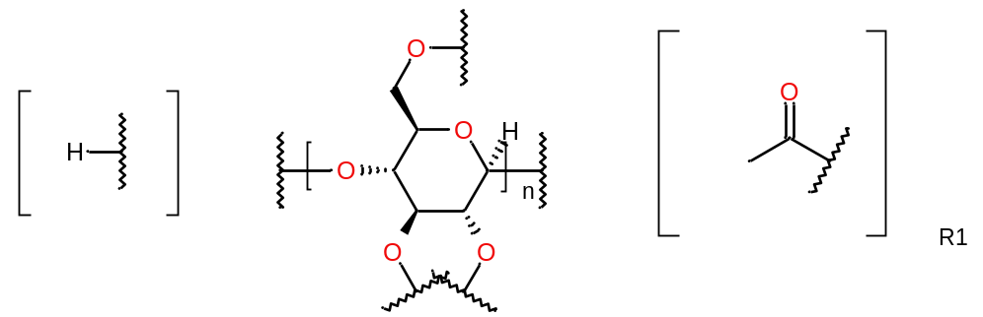
Correct
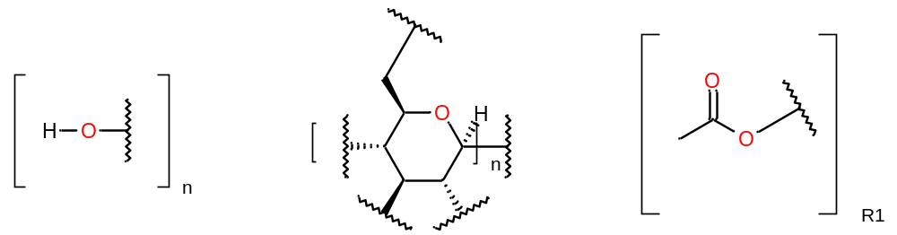
Incorrect
Figure 13 – Correct and incorrect graphical images of the molecular structure of Cellulose Acetate

The acetyl fragment is represented in figure 14.
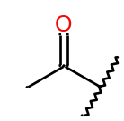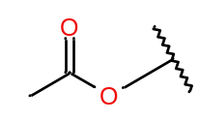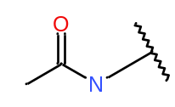
Correct Incorrect
Figure 14 – Correct and incorrect graphical images of the molecular structure of the acetyl fragment
In fragments derived from ethers, the oxygen will be retained by the polymer or largest portion of a molecule.
EXAMPLE: Hypromelloses
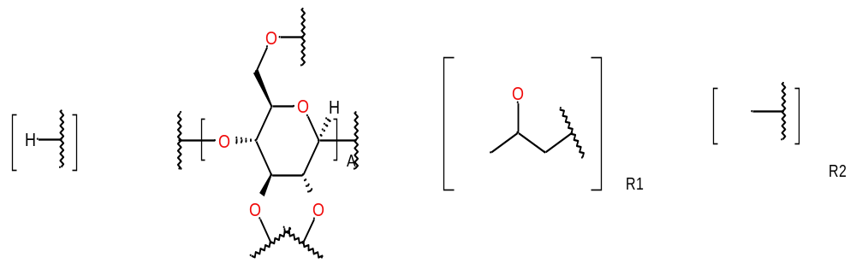
Figure 15 – Graphical images of the molecular structure of Hypromelloses

Figure 16 provides the High level information for the Class Structure.
In the Class Structure the element group molecular formula is represented by molecular formula by moieties and by the total of moieties in accordancee with the Hill system captured by the term molecular formula. In addition the element group molecular weight is connected to the Class Structure also for stoichiometric substances. This addition will be proposed in the next version of the ISO 1238 Standard.
See also the high level information at the Substance Type Chemical
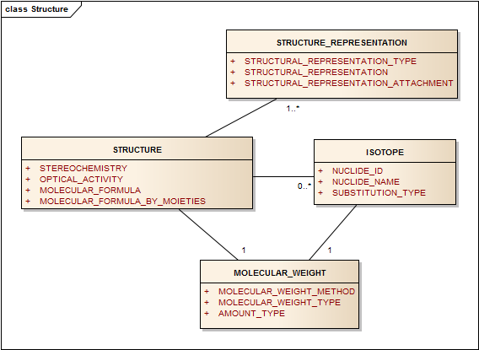
Figure 16 – Information model for Structure and Isotope
A structural representation is an essential element for defining chemical substances and is often sufficient for defining most chemical substances.
Four common structural representation types are listed below. Each of the types can unambiguously describe substances with a definite molecular structure. Stereochemistry should be completely defined in each structural representation. Only MOLFILES and CDX have the ability to describe polymeric repeating units and molecular fragments. There are a number of tools available, both free and commercial, that allow the creation of molecular structural representations. Multiple representations can be submitted.
This class is CONDITIONAL. When the Substance type (as defined in Section 4.3) is either chemical, polymer or nucleic acid, this class becomes REQUIRED and the following data elements should be described:

Structural Representation Type
Table 50 – Structural representation type
User Guidance | This field indicates the type of structure. A FULL structure is a structure in which the complete connectivity of the substance is known and the substance is monodisperse. A PARTIAL structure is a structure in which either complete connectivity or stereochemistry is not defined. A REPRESENTATIVE structure is used when the connectivity of the underlying material is diverse and a single structure is needed to represent that material
Example(s) | Full, partial, representative, fragment, ionic moiety, structural repeating unit
Conformance | CONDITIONAL
Data Type | CD
Values Allowed
Business Rule(s) | A structure can only be of one type. Field is mandatory when structural elements are present.  When the Substance type (as defined in Section 4.3) is either chemical, protein, polymer or nucleic acid, this class becomes REQUIRED

Structural Representation Type is specified as a MIME Media Type code:
Type | MIME Media Type
InChI | application/x-InChI
MOLFILE | application/x-mdl-molfile
SMILES | application/x-smiles
CHIME | application/x-mdl-chime

Structural Representation
Table 51 – Structural representation
User Guidance | The structural representation shall be provided as text string, the following formats are acceptable: InChI, SMILES, MOLFILE, CDX.
Example(s) | InChI, MOLFILE SMILES, CDX
Conformance | CONDITIONAL
Data Type | ST
Values Allowed
Business Rule(s) | Each structural representation will have one and only one type. When the Substance type (as defined in Section 4.3) is either chemical, protein, polymer or nucleic acid, this class becomes REQUIRED

Structural Representation Attachment
Table 52 – Structural representation attachment
User Guidance | An attached file that may contain the structural representation shall be provided for complex data formats, e.g. CDX, MOLFILE.
Example(s)
Conformance | OPTIONAL
Data Type | ED
Values Allowed
Business Rule(s)

Stereochemistry
The overall stereochemistry of the substance should be indicated in this field.
Table 53 – Stereochemistry
User Guidance | The stereochemistry of the substance shall be indicated in the structure and should be captured here. Special cases of stereochemistry that can’t be indicated in the structure shall be described based on a controlled vocabulary.  Mixtures of stereoisomers shall be represented explicitly as a mixture of substances with absolute stereochemistry. In case the absolute stereochemistry is unknown the substance definition should be marked as “Incomplete”.
Example(s) | AXIAL R, AXIAL S, SQUARE PLANAR 1, SQUARE PLANAR 2, SQUARE PLANAR 3, SQUARE PLANAR 4, TETRAHEDRAL, OCTAHEDRAL 12, OCTAHEDRAL 22, OCTAHEDRAL 21, CHIRAL, ACHIRAL
Conformance | CONDITIONAL
Data Type | CD
Values Allowed | AXIAL R, AXIAL S, SQUARE PLANAR 1, SQUARE PLANAR 2, SQUARE PLANAR 3, SQUARE PLANAR 4, TETRAHEDRAL, OCTAHEDRAL 12, OCTAHEDRAL 22, OCTAHEDRAL 21; RACEMIC, MIXED, CHIRAL, ACHIRAL, ABSOLUTE, AXIAL, EPIMERIC, MESO, UNKNOWN, CIS, TRANS
Business Rule(s) | When the Substance type (as defined in Section 4.3) is either chemical, protein, polymer or nucleic acid, this class becomes REQUIRED

Optical Activity
The optical activity of a chiral substance should be captured if known. The extent of optical rotation is not required at the substance level.
Table 54 – Optical activity
User Guidance | The optical activity shall be described based on a controlled vocabulary.
Example(s) | (+/-), (+), (-)
Conformance | CONDITIONAL
Data Type | CD
Values Allowed | (+/-), (+), (-)
Business Rule(s) | Shall be entered if known for substances that have at least one moiety with stereochemistry defined as chiral. Can be a defining element when the absolute stereo configuration is not known.

Molecular Formula
Table 55 – Molecular formula
User Guidance | Molecular formula is written as a sequence of pairs of atom symbol and stoichiometric number without any text formatting or special characters. This formal notation is essentially a code system.  Specified according to the Hill system, i.e., first C, then H, then alphabetical.
Example(s) | C₂₆H₃₃ClN₂O₉S
Conformance | CONDITIONAL
Data Type | ST
Values Allowed
Business Rule(s) | Can be implicitly derived from the structure; Validity check for identity and structural representation

Molecular Formula by Moieties
Table 56 – Molecular formula by moieties
User Guidance | Specified per moiety according to the Hill system, i.e., first C, then H, then alphabetical. and each moiety separated by a dot.
Example(s) | C₂₀H₂₅ClN₂O₅·C₆H₆O₃S .H₂O
Conformance | CONDITIONAL
Data Type | ST
Values Allowed
Business Rule(s) | Can be implicitly derived from the structure; Validity check for identity and structural representation

Isotope (repeat as necessary)
Applicable for single substances that contain a radionuclide or a non-natural isotopic ratio, e.g. C-13 enriched material. All radionuclide and non-natural isotopes will also be represented in the structure representation for chemical substances. For other types of substances a structural representation could be created to indicate the position of substitution.

Nuclide ID
Table 57 – Nucide ID
User Guidance | A Substance ID for each non-natural or radioisotope is created. The ID is linked to a single atom zero valence element.
Example(s)
Conformance | CONDITIONAL
Data Type | CD
Values Allowed | ISO 11238 Substance ID
Business Rule(s) | Mandatory when substance contains non-natural or radioisotope.

Nuclide Name
Table 58 – Nuclide name
User Guidance | The name for each isotope shall be provided.
Example(s) | CARBON C-13
Conformance | CONDITIONAL
Data Type | CD
Values Allowed | ISO 11238 Substance names
Business Rule(s) | Mandatory when substance contains non-natural or radioisotope. Implicitly derived from Nuclide ID.

Substitution Type
Applicable for single substances that contain a radionuclide or a non-natural isotopic ratio, e.g. C-13 enriched material. All radionuclide and non-natural isotopes will also be represented in the structure representation.
Table 59 – Substitution type
User Guidance | The type of isotopic substitution present in a single substance:  - specific if the site of attachment/substitution indicated in structure;  - non-specific if the nuclide is distributed throughout molecule or substance;  - Unknown if site unknown.  Substitution refers to the relationship between the nuclide and the rest of the substance.
Example(s) | specific; non-specific; unknown
Conformance | CONDITIONAL
Data Type | CD
Values Allowed
Business Rule(s) | Mandatory when substance contains non-natural or radioisotope.

Amount
The amount section serves to provide the quantitative or qualitative values that are associated with a variety of elements. The same format will be used for all quantitative, semi-quantitative and qualitative values. This amount section will be used throughout the standard for any properties or elements where quantitative, semi- quantitative or qualitative values apply. An amount type will usually be associated with each amount and the same amount type will typically apply to all of the quantitative values in a given section (i.e. for multiple fragment substitution either mole percent, weight percent or degree of substitution should be applied to each fragment they should not be mixed).

Average
Table 60 – Average
User Guidance | Used to capture quantitative values for a variety of elements. If only limits are given, the arithmetic mean would be the average. If only a single definite value for a given element is given, it would be captured in this field.
Example(s) | Average, Exact, Numeric Value
Conformance | CONDITIONAL
Data Type | PQ
Values Allowed | Single quantitative values or an average value for a given element.
Business Rule(s)

Low Limit
It should be noted that there can be two types of low limit, one is a limit on actual values and the other is the lower limit of the average of values. Both these limits can be captured and type of lower limit should be indicated either in the amount type for a given element or in the units indicated for the amount. The low limit can also be used alone to express one-sided ranges greater than or equal to this limit.
Table 61 – Low limit
User Guidance | Lower limit for a given quantitative value.
Example(s)
Conformance | CONDITIONAL
Data Type | PQ
Values Allowed
Business Rule(s) | To be used to express the lower limit of a range of values, if applicable

High Limit
Similar to the low limit, the high limit should indicate whether the value refers to a range of values or a range of averages. The high limit can also be used to express one-sided limits.
Table 62 – High limit
User Guidance | Higher limit for a given quantitative value.
Example(s)
Conformance | CONDITIONAL
Data Type | PQ
Values Allowed
Business Rule(s) | To be used to express the higher limit of a range of values

Unit
Most units should be consistent with those described in UCUM. There may be a need for additional units to describe particular properties and the maintenance organisation should maintain them. Units may be dependent on the method of measurement or calculation to determine the property.
EXAMPLE The hydrophobic-lipophilic balance can be a defining property for amphiphilic polymers particularly when the exact ratio of monomers or structural repeating units is not provided. There are at least two methods of calculation for this property and the method may be indicated in the unit (i.e. Davies Method; Griffin’s Method).
Table 63 – Unit
User Guidance | The unit of measure
Example(s) | 1, g, mg, mol, mmol, L, [IU], mg/L, mol/L, g/mol, [IU]/g
Conformance | CONDITIONAL
Data Type | CD
Values Allowed | UCUM / ISO 11240 units
Business Rule(s) | The Unit is required for amount expressed as numeric value.  When used with limits, both limits must have the same dimension (and usually will have the same unit.)

Non Numeric Value
Table 64 – No numeric value
User Guidance | Qualitative, coded property value. To be used to capture qualitative values.
Example(s) | Positive, negative, Yes, No, complete, partial
Conformance | CONDITIONAL
Data Type | CD
Values Allowed
Business Rule(s)

Source Material
Source material shall capture information on the taxonomic and anatomical origins as well as the fraction of a material that can result in or can be modified to form a substance. This set of data elements shall be used to define polymer substances isolated from biological matrices. Taxonomic and anatomical origins shall be described using controlled vocabulary as required. This information is captured for naturally derived polymers (e.g. starch) and structurally diverse substances. For Organism belonging to the Kindom Plantae the Substance is defined referring to the fresh material of a single species or infraspecies. For (herbal) substance the fraction information will be captured at the Substance information and additional information for Herbal extracts will be captured at the specified substance Group 1 information level. See for further explanation the Substance Class: Structurally Diverse and the Herbal annex.
The information model for the source material is shown in figure 17.
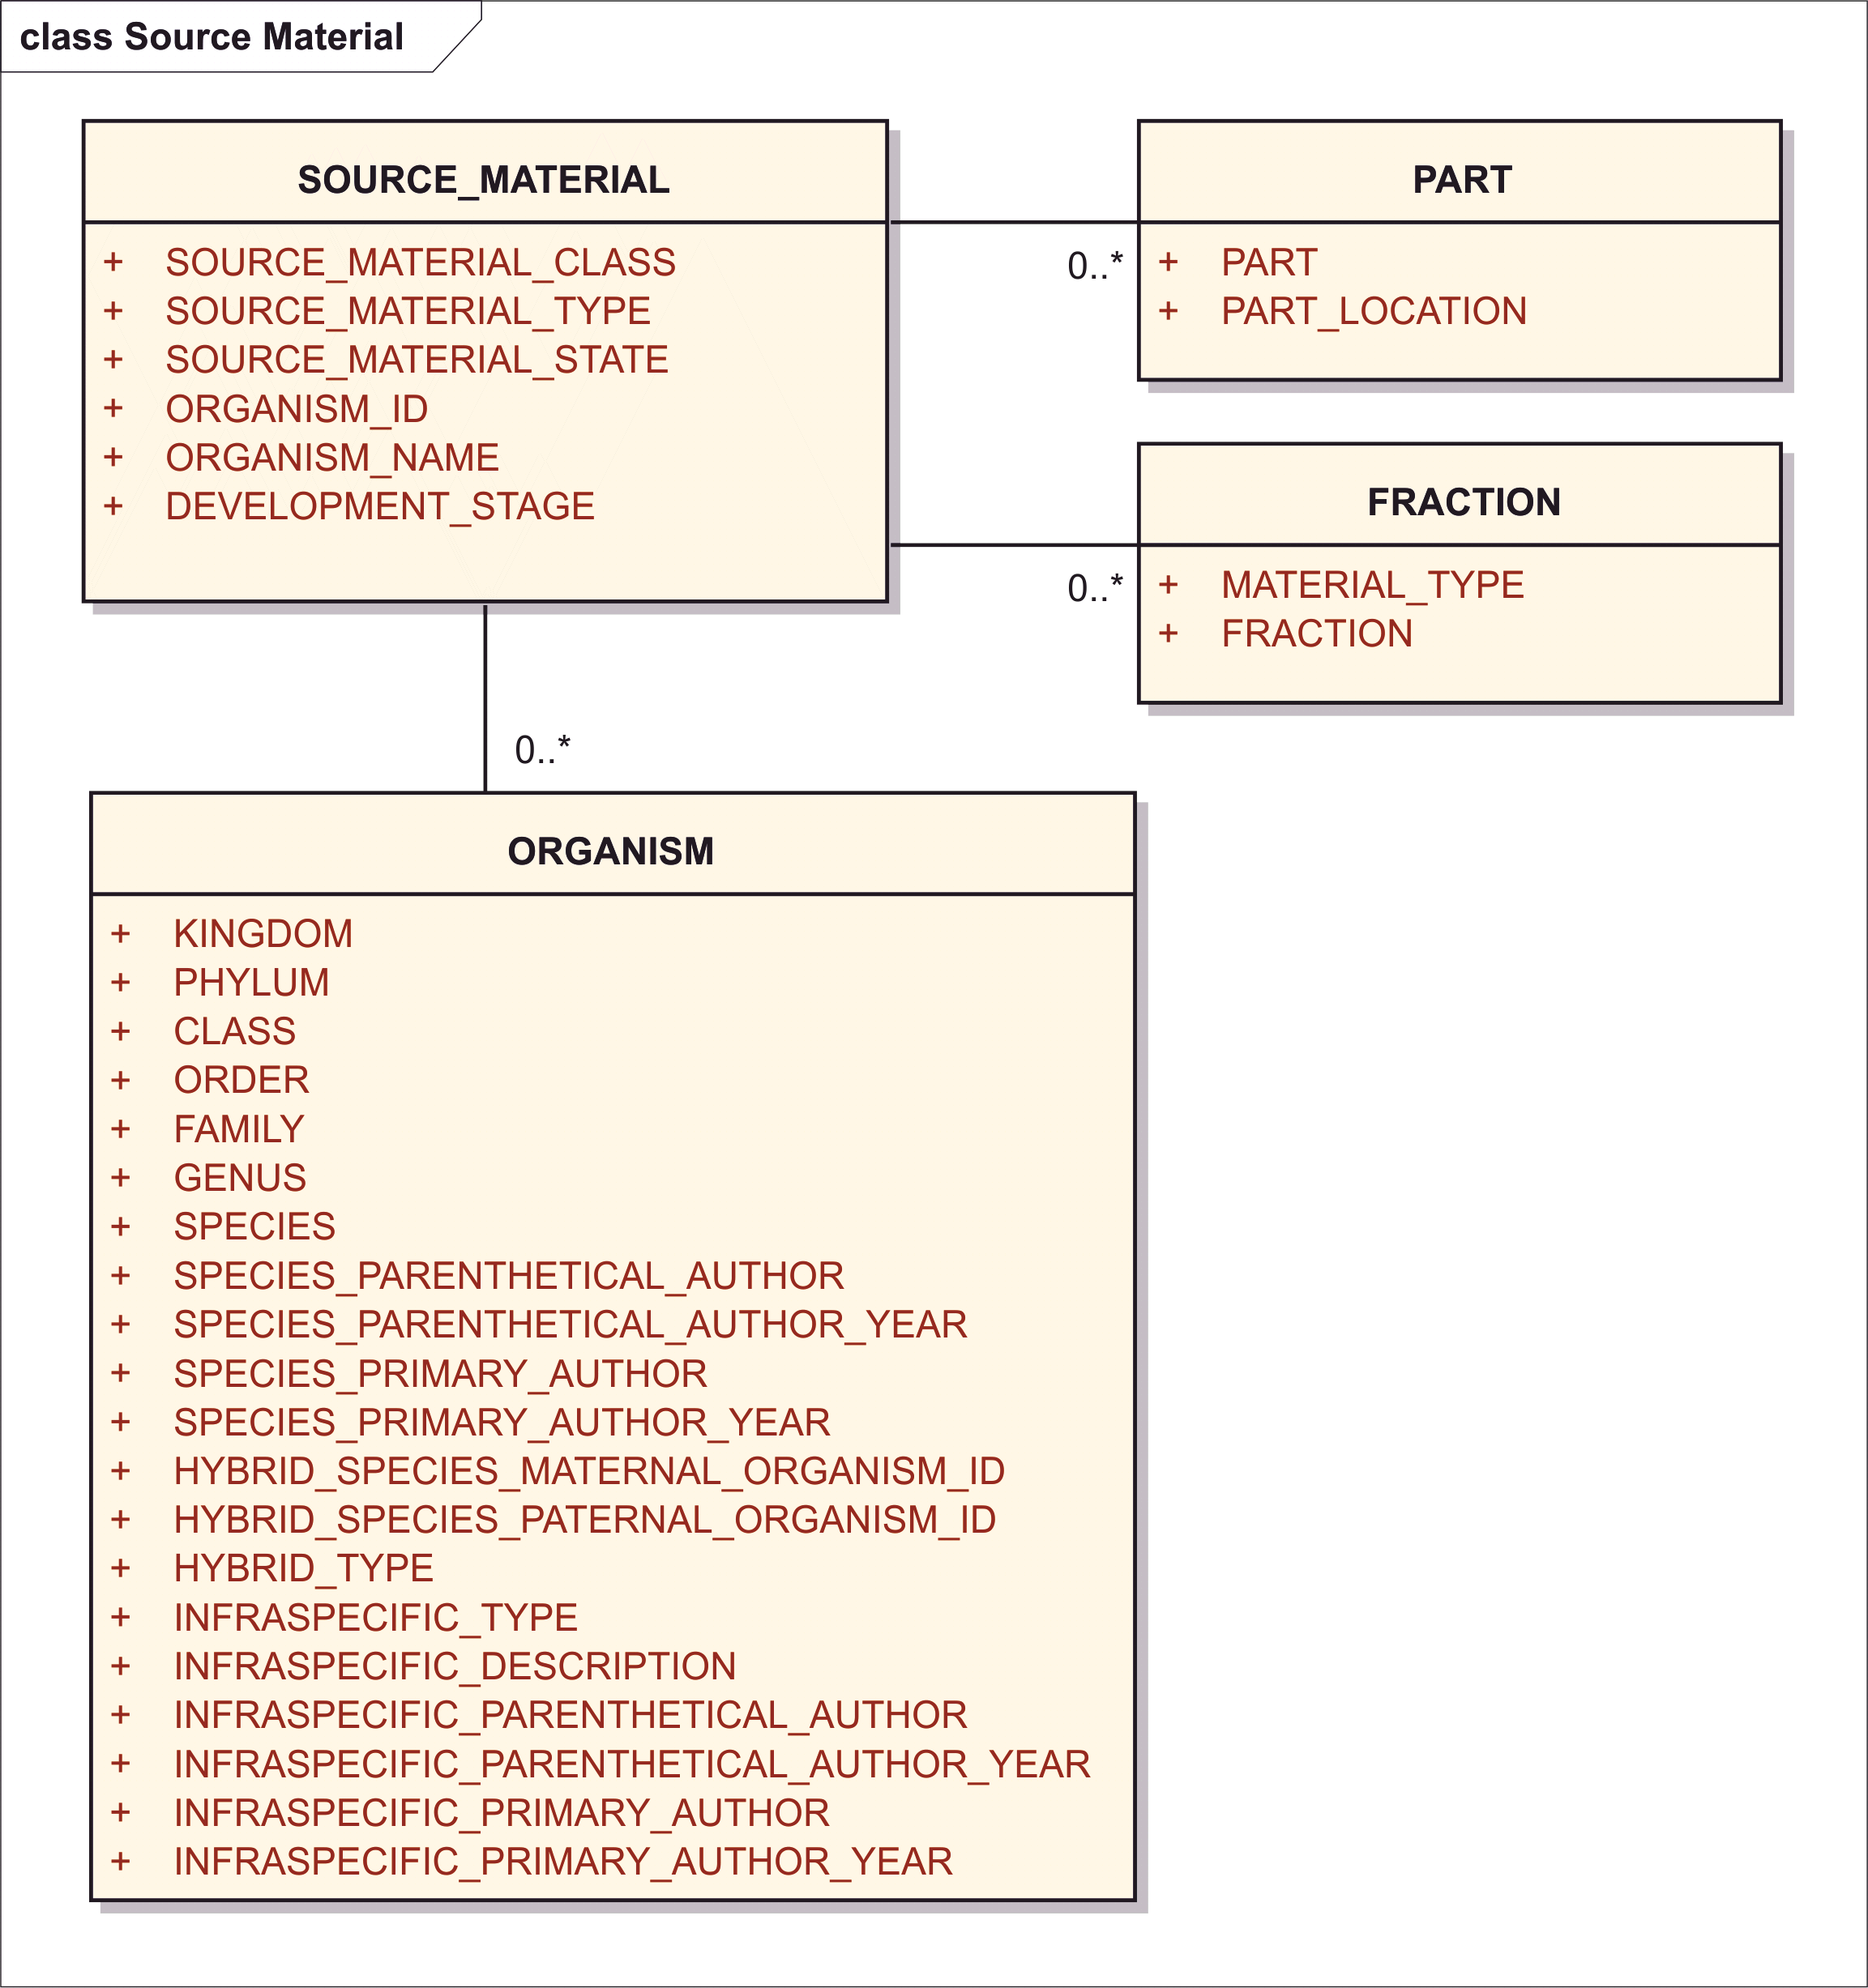
Figure 17 – Information Model for Source Material
Specifically, the information on the source material shall be provided by means of the following set of data elements.

Source Material Class
Table 65 – Source material class
User Guidance | General high level classification of the source material specific to the origin of the material.
Example(s) | MINERAL, BIOLOGIC
Conformance | CONDITIONAL
Data Type | CD
Values Allowed
Business Rule(s)

Source Material Type
Table 66 – Source material type
User Guidance | The type of the source material shall be specified based on a controlled vocabulary. For vaccines this section refers to the class of infectious agent.
Example(s) | bacterium, human, mammal, fungus, virus, plant
Conformance | CONDITIONAL
Data Type | CD
Values Allowed
Business Rule(s) | The “Source_Material_Type” values are presented based on the “source material class” values above. Because organic / inorganic is just a class best captured in terminology of the source material types, only one data element is needed for Type which implies Class.

Source Material state
Table 67 – Source material state
User Guidance | The state of the source material when extracted.
Example(s) | Live, activated, inactivated, attenuated, conjugated, live (attenuated).
Conformance | CONDITIONAL
Data Type | CD
Values Allowed
Business Rule(s)

Organism ID
Table 68 – Organism ID
User Guidance | The unique identifier associated with the source material parent organism shall be specified.
Example(s)
Conformance | CONDITIONAL
Data Type | II
Values Allowed
Business Rule(s)

Organism Name
Table 69 – Organism name
User Guidance | The organism accepted Latin name shall be provided based on the binomial Latin nomenclature.
Example(s) | Ginkgo biloba L.
Conformance | CONDITIONAL
Data Type | CD
Values Allowed
Business Rule(s)

Development Stage
Table 70 – Development stage
User Guidance | Stage of life for animals, plants, insects and microorganisms. This information shall be provided only when the substance is significantly different in these stages (e.g., foetal bovine serum).
Example(s) | foetus, infant, juvenile, adult, senescent, leafing, pre-flowering, flowering, fruiting, etc.
Conformance | CONDITIONAL
Data Type | CD
Values Allowed
Business Rule(s) | If it is a distinguishing factor, even if it is implicitly understood by experts.

Part Description (repeat as necessary)
Information of the part of the material used to produce the substance shall be provided by means of the following data elements:

Part
Table 71 – Part
User Guidance | The portion of an organism with a definable anatomical location.
Example(s) | Cartillage, Root and Stolon
Conformance | CONDITIONAL
Data Type | CD
Values Allowed
Business Rule(s) | Depending on the Source_Material_Type values (e.g. human/mammalian or plant) the relevant controlled vocabulary applies (e.g. organism or plant).

Part Location
Table 72 – Part location
User Guidance | The detailed anatomic location when the part can be extracted from different anatomical locations of the organism. Multiple alternative locations may apply.
Example(s) | For cartilage: knee, elbow , stomach, shoulder
Conformance | CONDITIONAL
Data Type | CD
Values Allowed
Business Rule(s) | Applicable only if Source_Material_Type is human or mammalian

Fraction (repeat as necessary)
Many complex materials are fractions of parts of plants, animals, or minerals. Fraction elements are often necessary to define both Substances and Specified Substances Group 1. For substances derived from Plants, fraction information will be captured at the Substance information level. Additional information for Extracts, such as extraction solvent composition, will be captured at the Specified Substance Group 1 information level. For other types of substances fractions will be captured at the substance level (e.g. blood products).

Material type
Table 73 – Material type
User Guidance | The specific type of the material constituting the omponent.
Example(s) | LIPIDS; PHOSPHOLIPIDS; PROTEINS; NUCLEIC ACID
Conformance | CONDITIONAL
Data Type | CD
Values Allowed
Business Rule(s)

Fraction
A controlled vocabulary for specific fractions may be developed.
Table 74 – Fraction
User Guidance
Example(s) | OILS; JUICE; POLYCLONAL ANTIBODIES; SERUM; PLASMA
Conformance | CONDITIONAL
Data Type | CD
Values Allowed
Business Rule(s)

Organism
This section describes the organism which the substance is derived from. For vaccines, the parent organism shall be specified based on these section elements. As and Example full taxonomy will be described for the Substance Name: Ginkgo biloba L., Leaf
Organism Taxonomy
A significant challenge in ISO 11238 implementation surrounds the concept of organism because varying opinions exist among taxonomic experts about how individuals should be grouped. This is often referred to as the species problem. The species problem is a mixture of difficult related questions that often come up when biologists define the word "species". Definitions are usually based on how individual organisms reproduce and which other individuals they are capable of reproducing with to produce fertile offspring. This definition works well for vertebrates but is less useful for plants and useless for bacteria, viruses, and many protists. The practical approach to “species” that allows implementation of the standard is that each “species” is a kind of organism and each “species” is based on a set of characteristics that are shared by all the organisms in the “species”.
This common usage of "species" is as a category, type, or natural kind. These “species” share common morphological, genetic and signature constituent characteristics. Traditional taxonomy may not be able to provide sufficient type or kind distinctions so other characteristics may be required to properly differentiate organism groups. From this point of view, bitter fennel is distinct from sweet fennel based on consistently different chemical profiles even though they are only marginally recognized in taxonomic trees as distinct. The same is true for hot peppers versus sweet peppers and collards versus kale. Similarly, microorganism host and serotype distinctions are often important and necessary. Detailed strain information is also necessary to describe viruses because their genomes change rapidly but the virus strains should be grouped at the species or serotype level.
The standard recognizes the traditional seven levels of taxonomy as well as several intraspecific types and hybrids. While these are all useful grouping concepts, they have not been implemented consistently for the entire taxonomic tree. The general approach to management of organism groupings is to defer to scientific taxonomy experts. These experts review the scientific literature and determine the appropriate grouping concepts. These concepts are managed as accepted or valid scientific names. For higher plants and fungi, Kew Gardens has become the primary providers of this expert opinion. That information is available publicly through the World Catalogue of Plant Species and Index Fungorum as represented publicly in the Medical Plants Name Service (gold standard data, http://apps.kew.org/mpns-portal/ ), the Plant List (includes a zero to three star data quality rating http://www.theplantlist.org/ ) and Species Fungorum (http://www.speciesfungorum.org/). Taxonomic information for most other organisms is available through Catalogue of Life (COL, currently 1,600,000+ organsims, http://www.catalogueoflife.org/col/) and its 151 contributing source databases. The most notable contributers are Kew Gardens and the Integrated Taxonomic Information System (www.itis.gov ). COL has integrated the source datasets into a common seven level taxonomic tree using an eight kingdom model and includes intraspecifics where relevant. For organisms omitted in the above sources, NCBI taxonomy (http://www.ncbi.nlm.nih.gov/taxonomy ) is the most useful source database.
The higher levels of taxonomy are useful but all levels above family are not required for organism definition. The primary definition of organism is the combination of genus and species with author and family in that order providing validation. Intraspecific type and description and hybrid characteristics are also definitional where appropriate. The organism should be described as whole with no other characteristics. Because taxonomy is continuously changing, new organism identifiers should only be generated after analyzing potential collisions with existing identifiers using the above public datasets and/or conferring with appropriate taxonomic experts. Developmental stage, part and viral strain characteristics should be associated with separate identifiers that refer back to the whole organism parent substance.

Kingdom
Table 75 – Kingdom
User Guidance | The kingdom of an organism shall be specified.
Example(s) | Plantae
Conformance | CONDITIONAL
Data Type | CD
Values Allowed
Business Rule(s) | This is derived from the species and is referenced from an appropriate terminology / taxonomy (e.g., the NCBI Entrez Taxonomy ID implies all higher levels.)

Phylum
Table 76 – Phylum
User Guidance | The phylum of an organism shall be specified.
Example(s) | Tracheophyta
Conformance | CONDITIONAL
Data Type | CD
Values Allowed
Business Rule(s) | This is derived from the species and is referenced from an appropriate terminology / taxonomy (e.g., the NCBI Entrez Taxonomy ID implies all higher levels.)

Class
Table 77 – Class
User Guidance | The class of an organism shall be specified.
Example(s) | Mammalia, Maxillopoda, Sauropsida. Ginkgoopsida
Conformance | CONDITIONAL
Data Type | CD
Values Allowed
Business Rule(s) | This is implied by the species and is referenced from an appropriate terminology / taxonomy (e.g., the NCBI Entrez Taxonomy ID implies all higher levels.)

Order
Table 78 – Order
User Guidance | The order of an organism shall be specified,
Example(s) | Ginkgoales
Conformance | CONDITIONAL
Data Type | CD
Values Allowed
Business Rule(s) | This is implied by the species and is referenced from an appropriate terminology / taxonomy (e.g., the NCBI Entrez Taxonomy ID implies all higher levels.)

Family
Table 79 – Family
User Guidance | The family of an organism shall be specified.
Example(s) | Ginkgoaceae
Conformance | CONDITIONAL
Data Type | CD
Values Allowed
Business Rule(s) | This is implied by the species and is referenced from an appropriate terminology / taxonomy (e.g., the NCBI Entrez Taxonomy ID implies all higher levels.)

Genus
Table 80 – Genus
User Guidance | The genus of an organism shall be specified; refers to the Latin epithet of the genus of the plant/animal; it is present in names for genera, species and infraspecies.
Example(s) | Ginkgo
Conformance | CONDITIONAL
Data Type | CD
Values Allowed
Business Rule(s)

Species
Table 81 – Species
User Guidance | The species of an organism shall be specified; refers to the Latin epithet of the species of the plant/animal; it is present in names for species and infraspecies.
Example(s) | Biloba
Conformance | CONDITIONAL
Data Type | CD
Values Allowed
Business Rule(s) | Must be specified as a code from an appropriate taxonomy terminology (e.g., NCBI Taxonomy ID)

Species Literature Reference
Species are described by original articles, and the taxonomy may vary over time, so the reference to the original article is critical. A reference to an article should be complete and not just use author name abbreviations.
The structure is the same as reference source, with the addition of adding structured authors and years:
The reference source will be captured according to Section 4.6.

Species Parenthetical Author
The species parenthetical author should be captured as reported. For herbal substances the author will be captured according to the MPNS of Kew Gardens.
Table 82 – Species parenthetical author
User Guidance | The parenthetical author of an organism species shall be specified; refers to the first author who published the plant/animal name (of any rank).
Example(s) | L.
Conformance | CONDITIONAL
Data Type | ST
Values Allowed
Business Rule(s)

Species Parenthetical Author Year
Table 83 – Species parenthetical author year
User Guidance | The parenthetical author year of an organism species an organism shall be specified; refers to the year in which the first author published the plant/animal name (of any rank).
Example(s) | 2010, 2011
Conformance | OPTIONAL
Data Type | ST
Values Allowed
Business Rule(s)

Species Primary Author
Table 84 – Species primary author
User Guidance | The primary author of an organism species shall be specified; refers to the first author, who published the plant/animal name (of any rank).
Example(s) | Sch.Bip
Conformance | OPTIONAL
Data Type | ST
Business Rule(s)

Species Primary Author Year
Table 85 – Species primary author year
User Guidance | The primary author year of an organism species shall be specified; refers to the year in which the first author published the plant/animal name (of any rank).
Example(s) | 2010
Conformance | OPTIONAL
Data Type | ST
Values Allowed
Business Rule(s)

Hybrid Species Maternal Organism ID
Table 86 – Hybrid species maternal organism ID
User Guidance | The identifier of the maternal species constituting the hybrid organism shall be specified based on a controlled vocabulary.
Example(s)
Conformance | CONDITIONAL
Data Type | II
Values Allowed
Business Rule(s)

Hybrid Species Paternal Organism ID
Table 87 – Hybrid species paternal organism ID
User Guidance | The identifier of the paternal species constituting the hybrid organism shall be specified based on a controlled vocabulary.
Example(s)
Conformance | CONDITIONAL
Data Type | II
Values Allowed
Business Rule(s)

Hybrid Type
Table 88 – Hybrid type
User Guidance | The hybrid type of an organism shall be defined.
Example(s) | Yes, No
Conformance | OPTIONAL
Data Type | BL
Values Allowed
Business Rule(s) | If the hybridisation step is present, the organism is a hybrid.

Infraspecific Type
Table 89 – Infraspecific type
User Guidance | The infraspecific type of an organism shall be specified.
Example(s) | cultivar, variety, serotype, strain, subspecies; cell line; year of isolation
Conformance | OPTIONAL
Data Type | CD
Values Allowed
Business Rule(s)

Infraspecific Description
Infraspecific information will be used to describe strains, serotypes, varieties, cultivars and cell lines. Often there is not a naming or taxonomic authority for this information. Standardised formats for this information may be developed. The actual infraspecific information should also be captured in the naming of these substances and synonyms should be maintained to help to identify infraspecific information and avoid duplication.
Table 90 – Infraspecific description
User Guidance | The infraspecific description of an organism shall be specified based on a controlled vocabulary. For Influenza Vaccine, the infraspecific description shall contain the syntax of the antigen in line with the WHO convention.
Example(s) | A/BRISBANE/59/2007(H1N1)
Conformance | CONDITIONAL
Data Type | CD
Values Allowed
Business Rule(s)

Infraspecific Literature Reference
The reference source will be captured according to Section 4.6.

Infraspecific Parenthetical Author
Table 91 – Infraspecific parenthetical author
User Guidance | The infraspecific parenthetical author of an organism shall be specified; refers to the first author who published the infraspecific plant/animal name (of any rank).
Example(s)
Conformance | OPTIONAL
Data Type | ST
Values Allowed
Business Rule(s)

Infraspecific Parenthetical Author Year
Table 92 – Infraspecific parenthetical author year
User Guidance | The infraspecific parenthetical author year of an organism shall be specified; refers to the year in which the first author published the infraspecific plant/animal name (of any rank).
Example(s) | 2011
Conformance | OPTIONAL
Data Type | ST
Values Allowed
Business Rule(s)

Infraspecific Primary Author
Table 93 – Infraspecific primary author
User Guidance | The infraspecific primary author of an organism shall be specified; refers to the first author who published the infraspecific plant/animal name (of any infraspecific rank).
Example(s)
Conformance | OPTIONAL
Data Type | ST
Values Allowed
Business Rule(s)

Infraspecific Primary Author Year
Table 94 – Infraspecific primary author year
User Guidance | The infraspecific primary author year of an organism shall be specified; refers to the year in which the first author published the infraspecific plant/animal name (of any infraspecific rank).
Example(s) | 2009
Conformance | OPTIONAL
Data Type | ST
Values Allowed
Business Rule(s)

Modification (repeat as necessary)
The Modification section is to be used to describe irreversible modifications to material (e.g., PEGylation, phosphorylation, hydrogenation etc.). The modifications may be physical, chemical, enzymatic, etc.. Modifications may be described by their structural result (substitution of moieties to residues, etc.) or by the process, reagents, or processing time if a specific structural modification cannot be determined (e.g. aggregated albumin).
A minimal description of the modification process shall be generated when a definitive structural modification cannot be determined.
This section applies to:
- Nucleic Acids
- Proteins
- Polymer
- Structurally Diverse Substances
- Mixture
- Specified Substance Group 1
This section shall be repeatable to describe each modification occurred on each residue modified.
The information model for the class modification group is shown in figure 18.
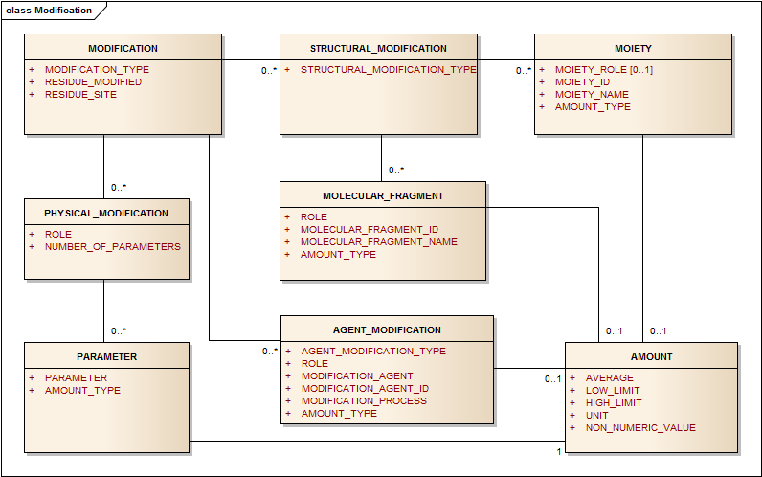
Figure 18 – Information Model for Modifications
Modifications will be divided into structural modifications where the existing molecular structure is discretely modified, physical modifications where no new covalent bonds are formed and agent modifications where the chemical modifications are diverse or unclear.
Specifically, information on the modification shall be provided by means of the following descriptors:

Modification Type
The modification type becomes apparent by its description. Structural modification is described using the structural elements. Agent and physical modifications are described by a series of elements. Agents are also substances in their own right.
Table 95 – Modification type
User Guidance | The type of the modification should be specified. Modifications will be divided into structural modifications where the existing molecular structure is discretely modified, physical modifications where no new covalent bonds are formed and agent modifications where the chemical modifications are diverse or unclear.
Example(s) | structural modifications, agent modifications, moiety, Physical Modification
Conformance | CONDITIONAL
Data Type | CD
Values Allowed
Business Rule(s)

Residue Modified
Table 96 – Residue modified
User Guidance | The amino acid or nucleic acid base that is modified. It may be known that lysine residues are modified but the particular lysine in the sequence may not be known. It should be captured for both specific and non-specific modifications.
Example(s) | Lysine
Conformance | CONDITIONAL
Data Type | CD
Values Allowed
Business Rule(s)

Residue Site
Table 97 – Residue site
User Guidance | The position of specific residue undergone to modifications shall be described.
Example(s) | 1_20 ; Protein unit 1, amino acid at position 20; C-Terminal removal
Conformance | CONDITIONAL
Data Type | ST
Values Allowed
Business Rule(s)

Structural Modification
All structurally specific post-translational modifications are expressed as amino acid substitutions. In order to limit ambiguity, all structural substitutions will be represented with a single structural element that contains the amino acid, a linker if present and the conjugate as a single entity. The substituted amino acid is assumed to connect through the alpha amino and the carboxylic acid group. If there is potential ambiguity or if the connectivity is not through the alpha amino acid groups, connection points or atoms should be used. The substituted amino acid will be a substance in its own right. For informational purposes the linker and conjugate can also be indicated as separate elements. When the sites of modifications are known they should be listed. For a modification that is not site specific, the extent of modification of should be captured. New substances would be created if there are consistent differences in the extent of modification. For example a monoclonal antibody with an average of two toxins conjugated to it would be a different substance than the same monoclonal antibody with an average of four toxin conjugates.
It should be noted that post-translational modifications, such as glycosylation, phosphorylation, or sulfation that result in microheterogeneity will not be described at the substance level, but could be described at the specified substance level. The microheterogeneity of proteins can be captured at the Specified Substance Group 1 the level and type of glycosylation is necessary to distinguish the material.
EXAMPLE Substitution of N terminal amino acid by pyroglutamic acid.
Structural modification is conditional and becomes required when the type of modification as described in Section 4.11.1 refers to a structural modification, then the following specifications apply:

Structural Modification Type
Table 98 – Structural modification type
User Guidance | The Type of structural modification should be described.
Example(s) | Amino Acid Substitution
Conformance | CONDITIONAL
Data Type | CD
Values Allowed
Business Rule(s)

Moiety
For structural modifications, the moiety shall be provided based on the specifications provided in Section

Amount type
Amount type should be captured according to Section .

Amount
Amount shall be captured as specified in Section

Molecular Fragment
For covalent modifications of proteins, nucleic acids, polymers or even structurally diverse material, fragments will be created and used to capture the extent of the modification.

Fragment Role
For modified proteins covalent modifications will be captured as a fragment modification. For many protein modifications the fragment will typically be a modified amino acid.
Table 99 – Fragment role
User Guidance | The role of the fragment.
Example(s) | N-Terminal Pyroglu Formation
Conformance | CONDITIONAL
Data Type | CD
Values Allowed
Business Rule(s)

Molecular Fragment ID
Each fragment will be identified with a Substance ID if available. If not available a new ID will be assigned with the submission.
Table100 – Molecular fragment ID
User Guidance | The unique identifier assigned to the substance representing the fragment based on the ISO 11238 substance controlled vocabulary.
Example(s)
Conformance | REQUIRED
Data Type | CD
Values Allowed | ISO 11238 Substance ID
Business Rule(s)

Molecular Fragment Name
Each fragment will also have at least one name associated with the fragment.
Table101 – Molecular fragment name
User Guidance | The name of the moiety shall be provided.
Example(s) | propylene glycol
Conformance | REQUIRED
Data Type | CD
Values Allowed | ISO 11238 substance name.
Business Rule(s) | ISO 11238 substance preferred name is selected as default value. The substance name is implicit and derived from the Moiety ID described in Section 5.1.5.2.2.

Amount type
Typically there will be an amount type relationship that indicates the degree of fragment substitution. Typically a single moiety will typically be assigned the value 1 and ranges for moieties that are stoichiometric will be relative to. The amount type should be captured according to Section 4.8.5.3.1.

Amount
The amount shall be captured as specified in Section 4.9.

Agent Modification
This type describes modifications that do not result in the addition of a single well-defined chemical entity (i.e. formaldehyde, glutaraldehyde treatment, peroxide treatment). In the inactivation of vaccines or treatment of tissue matrices, agent modification is essential for the description of these materials. Agent modification is also used in describing the culturing of cells that result in phenotypic differentiation. The agent modification could also be used to capture the actual agent that reacts with a protein that results in the attachment of a well-defined chemical fragment or entity. The following descriptors would be used to define agent modifications.

Agent Modification Type
Table 102 – Agent modification type
User Guidance | Refers to the type of the agent caused the modification.
Example(s) | chemical, enzymatic, immunological, organism
Conformance | REQUIRED
Data Type | CD
Values Allowed
Business Rule(s)

Role
Table 103 – Role
User Guidance | For proteins, agent (a chemical that results in non-specific modifications of a protein) or moiety (a specific moiety added to a protein molecule).
Example(s) | antigen, linker, conjugate, inactivation, antigen priming
Conformance | REQUIRED
Data Type | CD
Values Allowed
Business Rule(s)

Modification Agent
Table 104 – Modification agent
User Guidance | Established or primary name of the modifying agent.
Example(s) | Formaldehyde
Conformance | REQUIRED
Data Type | CD
Values Allowed | ISO 11238 substance name
Business Rule(s) | Implicitly derived from the value of the Modification Agent ID.

Modification Agent ID
Table105 – Modification agent ID
User Guidance | Unique identifier for modifying agent.
Example(s) | UNII code
Conformance | CONDITIONAL
Data Type | II
Values Allowed | ISO 11238 Substance ID
Business Rule(s)

Modification Process
Table106 – Modification process
User Guidance | Refers to the description of the modification process.
Example(s) | cell culture, UV irradiation, etc.
Conformance | CONDITIONAL
Data Type | CD
Values Allowed
Business Rule(s)

Amount type
Amount type should be captured according to Section 4.7.13.3.1.

Amount
Amount shall be captured as specified in Section Physical Modification.
The physical modification is optional; when applicable the information shall be provided by means of the following descriptors:

Role
Table 107 – Role
User Guidance | To be used to describe the function of the modification.
Example(s) | inactivation, activation
Conformance | REQUIRED
Data Type | CD
Values Allowed
Business Rule(s)

Number of Parameters
Table 108 – Number of parameters
User Guidance | The number of parameters that is going to be described as a result of the modification shall be provided.
Example(s) | For thermal denaturation two parameters, temperature and time, are typically captured.
Conformance | CONDITIONAL
Data Type | INT
Values Allowed
Business Rule(s) | This number can be counted and is never explicitly represented. This value is calculated implicitly.

          - Parameters
Primarily used for nonspecific modification, specifies how a modification is quantified or extent of physical treatment.
            - Parameter
Table 109 – Parameter
User Guidance | Refers to the conditions under with the modification has been produced.
Example(s) | time, temperature, etc.
Conformance | CONDITIONAL
Data Type | ST
Values Allowed
Business Rule(s) | Required parameters depend on process.

Amount type
Should be indicated per Section 4.7.13.3.1

Amount
The information related to the amount shall be provided as per specification described in Section 4.9.

Property
The section serves to provide information related to biological, physical or chemical characteristics associated with a substance. This information can be essential for the definition of each type of substance when structural elements are not sufficient to distinguish between similar substances.
EXAMPLE The pH of magnesium aluminometasilicate is necessary to distinguish low and high pH substances; viscosity is used to distinguish many polymers and should always be reported if known. At the Specified Substance Group 1 level, qualitative properties such as sterility are essential to distinguish materials from each other. Melting points and solubility that differ significantly for what is believed to be the same substance could either be indicative of purity or of polymorphism. Different polymorphs would be considered different specified substances at the Specified Substance Group 1 level.
Properties can have values that are quantitative, semi-quantitative or qualitative. For semi qualitative values a consistent scale should be used.
Property information is typically used for distinguishing substances or Specified Substances Group 1 from one another. It is possible however that a request for specific general property information that may be independent of defining information may be requested. Some of this information may be used to determine if two substances or specified substances are the same.
EXAMPLE For chemical substances; elemental analysis, mass and NMR spectra can be very helpful in determining whether two materials are different chemical substances and also in verifying that the molecular structure is correct. Solubility information, melting, boiling and critical points, partition coefficients (Log Kow), and pKa values should also be supplied if known.
The property information shall be provided by means of the following data elements:

Property Type
Each property will be associated with a single property type and the list of property types should be maintained.
Table 110 – Property type
User Guidance | Type of the property for which the information is provided.
Example(s) | physical, chemical, enzymatic, immunological
Conformance | CONDITIONAL
Data Type | CD
Values Allowed | Each property must be provided with a fully terminologically defined concept for measurements. Such definition would include any necessary “types” such as this.
Business Rule(s)

Property Name
Table 111 – Property name
User Guidance | The name of the property shall be specified based on a controlled vocabulary.
Example(s) | VISCOSITY, PH, CELL SURFACE ANTIGEN, SPECTRA
Conformance | CONDITIONAL
Data Type | CD
Values Allowed
Business Rule(s) | A fully defined coded concept must always be provided.

Property Parameters (new classes to be included in the ISO 11238 Standard in the next revision)
Parameters are often associated with properties and should be captured. In order to compare or distinguish substances it is important that measurements are taken using the same parameters. Parameters are not elements that will typically be searchable, but standard formats for given property measurements may be defined.
Table 112 – Property parameters
User Guidance | A field that should be used to capture parameters that were used in the measurement of a property.
Example(s) | For Viscosity, solvent concentration and temperature should be captured as a single entity.
Conformance | OPTIONAL
Data Type | ST
Values Allowed
Business Rule(s)

Substance Name
Table 113 – Substance name
User Guidance | To be used to identify a substance related to a defining property, for example: cell surface antigens (the Substance ID for CD4 would be captured to defined CD4 positive cells).
Example(s)
Conformance | OPTIONAL
Data Type | CD
Values Allowed | ISO 11238 substance name
Business Rule(s) | The preferred term will be the default value implicitly derived from the Substance ID (Section 4.4).

Substance ID
Table 114 – Substance ID
User Guidance | Substance ID of a substance upon which a defining property depends; the identifier of the substance related to a defining property shall be described where applicable and based on controlled vocabulary.
Example(s) | Solubility in Water, the Substance ID for Water shall be specified.
Conformance | CONDITIONAL
Data Type | II
Values Allowed | ISO 11238 Substance ID
Business Rule(s)

Amount type
Should be indicated per 4.7.13.3.1

Amount
The information related to the amount shall be provided as per specification described in Section 4.9. The non-numeric value in the case of spectra would be the actual spectra or a reference to the document containing the actual spectra.

Version (repeat as necessary)
This section shall provide information on the version of the substance. Where no “Version Number” and “Effective Date” have been assigned by an authority source, the version number shall be set as 0 with the date set as the date of initial submission of the substance. Any changes or updates to a given substance will result in a new version. This could include changes in the definition of the substance or the addition of names, codes. The version of substances should be tracked. Submitters should also indicate if it is a new version of a previous submission.

Version Number
Table 115 – Version number
User Guidance | The number of the version of the substance shall be provided.
Example(s) | 1, 2, 3, 99
Conformance | REQUIRED
Data Type | INT
Values Allowed
Business Rule(s) | If same document set exists, version must be greater than the last submitted version

Effective date
Table 116 – Effective date
User Guidance | The date when the substance was effective shall be provided in line with the ISO 8601 date format. This shall be defined when the substance is generated or modified.
Example(s) | 20110219
Conformance | CONDITIONAL
Data Type | TS
Values Allowed
Business Rule(s) | The value may be implicitly derived.

Change Made
Table 117 – Change made
User Guidance | The description of the updates or changes of the substance shall be specified. The field will be left empty when first insert of substance.
Example(s) | Update to previous version to include additional translation.
Conformance | CONDITIONAL
Data Type | CD
Values Allowed
Business Rule(s)

Substance definitions
All material will be traced back to one of the five types of substances or a mixture substance as described below. All substances will be described as a single substance type or as a mixture. The Annexes give additional examples into how to choose the correct type of substance and what specific elements to submit.
If the substance type as defined in Section 4.3 is equal to Chemical substance, the following data elements and conformances apply.

Chemical Substance
Chemical substances are a single substance type whose primary defining element is the molecular structure. Chemical substances shall be defined on the basis of their complete covalent molecular structure; the presence of a salt (counter-ion) and/or solvates (water, alcohols) is also captured. Purity, grade, physical form or particle size are not taken into account in the definition of a chemical substance or in the assignment of a Substance ID.
EXAMPLE Purified Water, Water for Injection, Sterile Water for Injection USP, ice and steam all map to the same substance Water, but would be separate specified substances Group 1.
In order to assign a Substance ID for a chemical substance, a complete covalent structure with all stereochemistry (R or S and E or Z) defined shall be submitted. The stoichiometry (mole ratio) of counterions or solvates present in the material shall also be provided in the structural representation.
The molecular representation (molfile, SMILES, InChI, CDX) of the substance shall be provided with all stereochemistry assigned or sites of unknown stereochemistry identified. An actual image of the structure should be provided in an accompanying document.
The information typically provided to INN, USAN, BAN or JAN to assign a non-proprietary name is typically sufficient to define chemical substances. Active substances and excipients are typically defined in accordance with INN, JAN, or USAN definitions or European Pharmacopoeia (EP), Japanese Pharmacopoeia (JP), or United States Pharmacopeia (USP/NF) monographs. The labelling requirements provided by monographs should be taken into account when defining and distinguishing substances. Information beyond monograph requirements may occasionally be necessary to distinguish substances.
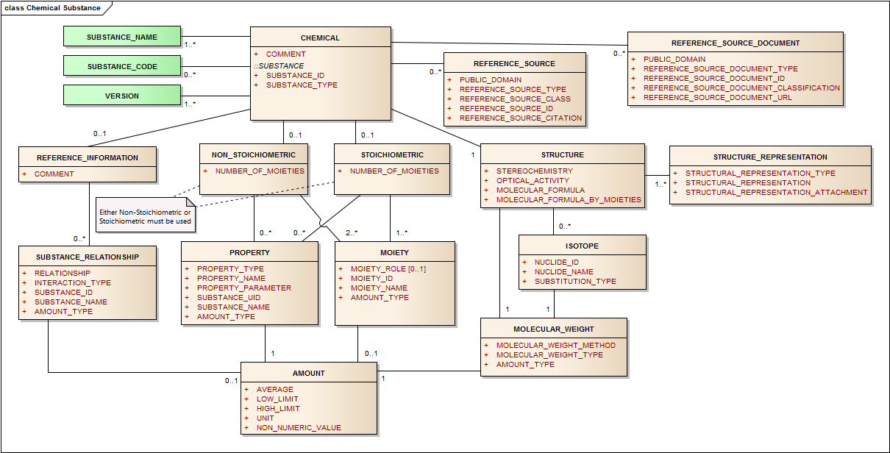
Figure 19 – Information model for the Chemical Substance

Structure
The information related to the structure shall be provided as per specification described in Section 4.9
Chemical substances can either be stoichiometric or non-stoichiometric (i.e. substances with variable or unknown stoichiometry). Variable or unknown stoichiometry should be indicated by brackets without a number associated with the brackets around moieties where the stoichiometry is either variable or unknown.
For ingredients in drug products, a preferred format may be specified (mol, SMILES, etc.) for the transmittal of information. Although most chemicals exist primarily with a single structure representation, there are a number of substances that have multiple structural representations in equilibrium. This is illustrated in the glucose (Dextrose) example above.

Stoichiometric
Table 118 – Stoichiometric
User Guidance | This field describes if a substance can be represented as single covalent structural moiety or a salt or solvate with a defined and constant ratio ions or molecules and solvents.
Example(s) | Yes, No
Conformance | REQUIRED
Data Type | BL
Values Allowed | Yes/No
Business Rule(s)

Stoichiometric Chemicals
Stoichiometric chemical substances are substances that contain complete chemical structures and definite stoichiometric ratios among moieties. Stoichiometric ratios between moieties should be whole integers and not fractions. They can be defined by a single representation of the complete molecular structure and a stereochemistry descriptor. The representation can be of one of the four types listed above. The following examples of defining elements for various types of chemical substances help illustrate the information needed to define substances. There are a variety of drawing tools that can generate any of the formats described.
EXAMPLE Ethanol is an example of an achiral substance and can be completely defined by either one of the three following representations:
InChI Representation STRUCTURAL_REPRESENTATION_TYPE: “InChI”
STRUCTURAL_REPRESENTATION: “INCHI=1/C2H6O/c1-2-3/h3H,2H2,1H3”
STEREOCHEMISTRY: “ACHIRAL”
SMILES Representation STRUCTURAL_REPRESENTATION_TYPE: “SMILES”
STRUCTURAL_REPRESENTATION: “CCO”
STEREOCHEMISTRY: “ACHIRAL” (same as above)
Mol representation STRUCTURAL_REPRESENTATION_TYPE: “MOL”
STRUCTURAL_REPRESENTATION:
3 2 0 0 0 0 0 0 0 0999 V2000
3.9063 -7.3125 0.0000 C 0 0 0 0 0 0 0 0 0 0 0 0
4.6223 -6.8991 0.0000 C 0 0 0 0 0 0 0 0 0 0 0 0
5.3383 -7.3125 0.0000 O 0 0 0 0 0 0 0 0 0 0 0 0
1 2 1 0 0 0 0
2 3 1 0 0 0 0
M END
STEREOCHEMISTRY “ACHIRAL” (same as above)
Levofloxacin Sodium. This is an example of a chiral substance and salt. An INCHI, SMILES or Molfile is sufficient to define this substance.
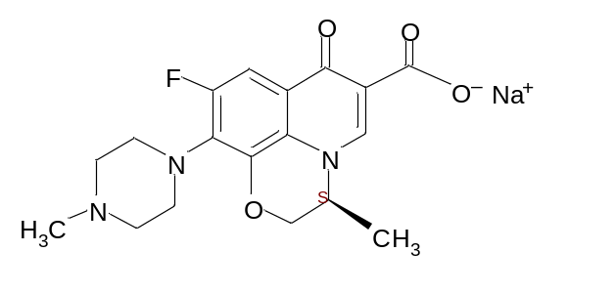

InChI Representation STRUCTURAL_REPRESENTATION_TYPE: “INCHI”
STRUCTURAL_REPRESENTATION:
“InChI=1S/C18H20FN3O4.Na/c1-10-9-26-17-14-11(16(23)12(18(24)25)8-22(10)14)7-13(19)15(17)21-5-3-20(2)4-6-21;/h7-8,10H,3-6,9H2,1-2H3,(H,24,25);/q;+1/p-1/t10-;/m0./s1”
STEREOCHEMISTRY “CHIRAL”
SMILES Representation
STRUCTURAL_REPRESENTATION_TYPE: “SMILES”
STRUCTURAL_REPRESENTATION:
“C[C@H]1COc2c3n1cc(c(=O)c3cc(c2N4CCN(CC4)C)F)C(=O)[O-].[Na+]”
STEREOCHEMISTRY: “CHIRAL”
Mol Representation STRUCTURAL_REPRESENTATION_TYPE: “MOL”
STRUCTURAL_REPRESENTATION:
27 29 0 0 1 0 0 0 0 0999 V2000
14.5167 -9.0507 0.0000 N 0 0 0 0 0 0 0 0 0 0 0 0
15.1250 -7.9548 0.0000 C 0 0 0 0 0 0 0 0 0 0 0 0
13.8500 -8.7215 0.0000 C 0 0 0 0 0 0 0 0 0 0 0 0
13.2625 -9.0840 0.0000 C 0 0 0 0 0 0 0 0 0 0 0 0
13.8500 -8.0048 0.0000 C 0 0 0 0 0 0 0 0 0 0 0 0
15.1250 -8.7048 0.0000 C 0 0 0 0 0 0 0 0 0 0 0 0
14.4667 -7.6340 0.0000 C 0 0 0 0 0 0 0 0 0 0 0 0
12.6334 -8.7673 0.0000 C 0 0 0 0 0 0 0 0 0 0 0 0
13.2625 -9.8506 0.0000 O 0 0 0 0 0 0 0 0 0 0 0 0
12.6334 -8.0048 0.0000 C 0 0 0 0 0 0 0 0 0 0 0 0
13.2292 -7.6548 0.0000 C 0 0 0 0 0 0 0 0 0 0 0 0
12.0167 -9.1298 0.0000 N 0 0 0 0 0 0 0 0 0 0 0 0
15.8250 -7.6007 0.0000 C 0 0 0 0 0 0 0 0 0 0 0 0
14.5167 -9.7840 0.0000 C 0 0 0 0 0 0 0 0 0 0 0 0
10.7417 -9.8965 0.0000 N 0 0 0 0 0 0 0 0 0 0 0 0
14.4667 -6.8965 0.0000 O 0 0 0 0 0 0 0 0 0 0 0 0
13.9125 -10.1632 0.0000 C 0 0 0 0 0 0 0 0 0 0 0 0
12.0167 -9.8798 0.0000 C 0 0 0 0 0 0 0 0 0 0 0 0
11.3584 -8.7757 0.0000 C 0 0 0 0 0 0 0 0 0 0 0 0
15.8250 -6.9548 0.0000 O 0 0 0 0 0 0 0 0 0 0 0 0
11.9542 -7.7132 0.0000 F 0 0 0 0 0 0 0 0 0 0 0 0
10.7417 -9.1340 0.0000 C 0 0 0 0 0 0 0 0 0 0 0 0
11.4000 -10.2465 0.0000 C 0 0 0 0 0 0 0 0 0 0 0 0
16.6458 -7.9631 0.0000 O 0 5 0 0 0 0 0 0 0 0 0 0
10.0792 -10.1715 0.0000 C 0 0 0 0 0 0 0 0 0 0 0 0
15.3500 -10.3215 0.0000 C 0 0 0 0 0 0 0 0 0 0 0 0
17.3000 -7.9630 0.0000 Na 0 3 0 0 0 0 0 0 0 0 0 0
21 10 1 0 0 0 0
22 19 1 0 0 0 0
23 18 1 0 0 0 0
24 13 1 0 0 0 0
25 15 1 0 0 0 0
14 26 1 1 0 0 0
4 9 1 0 0 0 0
5 7 1 0 0 0 0
8 10 2 0 0 0 0
15 23 1 0 0 0 0
2 6 2 0 0 0 0
3 1 1 0 0 0 0
4 3 2 0 0 0 0
5 3 1 0 0 0 0
6 1 1 0 0 0 0
7 2 1 0 0 0 0
8 4 1 0 0 0 0
9 17 1 0 0 0 0
10 11 1 0 0 0 0
11 5 2 0 0 0 0
12 8 1 0 0 0 0
13 2 1 0 0 0 0
14 1 1 0 0 0 0
15 22 1 0 0 0 0
16 7 2 0 0 0 0
17 14 1 0 0 0 0
18 12 1 0 0 0 0
19 12 1 0 0 0 0
20 13 2 0 0 0 0
M CHG 2 24 -1 27 1
M END
STEREOCHEMISTRY “CHIRAL”

Comment
Comments should be used sparingly to capture information that does not fit into other fields. They may be used to indicate that alternate structures exist.
Table 119 – Comment
User Guidance | Any comment can be provided in this field, if necessary.
Example(s)
Conformance | OPTIONAL
Data Type | ST
Values Allowed
Business Rule(s)

Chemical substances, whose primary defining element is the molecular structure, shall be defined on the basis of their complete covalent molecular structure; the presence of a salt (counter-ion) and/ or solvates is also captured. The molecular structure, the molecular formula, the molecular weight and optical activity, together with the representation of the stereochemistry are mandatory elements to be provided.
Although the molecular weight can be derived from the structure, this element should be presented at the substance level for chemical substances in order to substantiate the provided structural information.
The ISO 11238 Substance standard should be updated for the element molecular weight at the next version since this element is missing in the Class Chemical substances.
In addition the molecular formula should be described according to the moieties even for stoichiometric substances. See above Molecular formula by moieties and Molecular formula, which is ment to be equal to the sum of molecular formula by moieties.
In addition to earlier versions the element group moiety Is connected with the stoichiometric chemical substance.

Non- Stoichiometric Chemicals
The section applies to chemical substances that do not have defined stoichiometry.
This section is used only when the Stoichiometric Element (Section ) is equal to No.
Every non-stoichiometric substance will have more than one moiety. Each moiety will be enclosed in brackets indicating stoichiometry where known and transmitted in a single structural representation. Every non-stoichiometric moiety will have a complete structural representation and also be described as a substance in its own right. If ranges of amounts for the non-stoichiometric moieties are known they will be preferably captured as mole ratios or weight percent if mole ratios cannot be determined.

Number of Moieties
Table 120 – Number of Moieties
User Guidance | The number of moieties specified shall be provided. Non-stoichiometric chemical substances must have at least two moieties. Each moiety shall be represented by a chemical structure.
Example(s) | 2
Conformance | CONDITIONAL
Data Type | INT
Values Allowed
Business Rule(s) | The numeric value shall be always ≥ 2; The value is automatically calculated (Implicit) based on the number of Moiety classes as described in Section 5.1.5.2)

Moiety (repeat as necessary)
The moiety section serves for the description of both the moiety and the other fragment constituting the substance. Each moiety within the chemical substance is to be identified and the composition range of the moieties when known is to be provided by means of the following data elements:
The element group Moiety should be attached also to the element class Chemical, Stoichiometric substances in order to describe a salt and solvates relationship to the active moiety in an unambiguous way with respect to the description of the molecular formula and sometimes the official names.
The element molecular weight must be included in the next version of the standard and be included in the Structure Class Information Model together with the element group amount.
The element group moiety and amount should also be tied to the element group stoichiometric substances.
This will help to describe salts and solvates and hydrated substances in a more unambiguous way with respect to the description of the molecular formula and sometimes official names. See figure 10.
EXAMPLE Aluminium Sesquichlorohydrex Propylene Glycol is defined by relationships between five moieties, the aluminium cation, chloride and hydroxide ions, propylene glycol and water; three of the five moieties have mole ratios to each other. The ratio of aluminium cation to chloride to hydroxide is 2:3:3. The amount of propylene glycol and water is variable and not stoichiometric.

Moiety Role
For many peptides the moiety role of counterions such as acetate should be indicated.
Table 121 – Moiety role
User Guidance | The role of the moiety should be specified if there is a specific role the moiety is playing.
Example(s) | Counter-ion
Conformance | OPTIONAL
Data Type | CD
Values Allowed
Business Rule(s)

Moiety ID
Each moiety in a non-stoichiometric substance will be identified with a Substance ID if available. If not available a new ID will be assigned with the submission.
Table 122 – Moiety ID
User Guidance | The unique identifier assigned to the substance representing the moiety based on the ISO 11238 substance controlled vocabulary.
Example(s)
Conformance | REQUIRED
Data Type | II
Values Allowed | ISO 11238 Substance ID
Business Rule(s)

Moiety Name
Each moiety will also have at least one name associated with the moiety.
Table 123 – Moiety name
User Guidance | The name of the moiety shall be provided.
Example(s) | propylene glycol
Conformance | REQUIRED
Data Type | CD
Values Allowed | ISO 11238 substance name.
Business Rule(s) | ISO 11238 substance preferred name is selected as default value. The substance name is implicit and derived from the Moiety ID described in Section 5.1.5.2.2.

Amount type
Typically there will be an amount type relationship that will be consistent for all of the moieties. A single moiety will typically be assigned the value 1. Ranges of moieties that are stoichiometric will be assigned successive values. The amount type should be captured according to Section 4.7.13.3.1.

Amount
The amount shall be captured as specified in Section 4.9.

Property (repeat as necessary)

Property shall be captured as specified in Section 4

Proteins/ Peptides
A protein is defined as a single unit of a linear amino acid sequence, or a combination of subunits that are either covalently linked or have a defined invariant stoichiometric relationship. This includes all synthetic, recombinant and purified proteins of defined sequence, whether the use is therapeutic or prophylactic. This set of elements will be used to describe albumins, coagulation factors, cytokines, growth factors, peptide/protein hormones, enzymes, toxins, toxoids, recombinant vaccines, and immunomodulators.
Proteins and peptides are defined by their molecular structure based on the amino acid sequence, disulfide linkages, sites and a general type of glycosylation, based on the cell or organism type from which the protein was isolated from or produced (e.g. yeast, plant, mammalian, human). The method of production is generally not a defining element for proteins and peptides. For a given non-glycosylated peptide, whether naturally isolated, produced by recombinant technology, or chemically synthesised, it will be defined as the same substance when there are no resultant differences in the amino acid sequence and disulfide linkages.
EXAMPLE: Recombinant and chemically synthesised salmon calcitonin are chemically identical and therefore considered to be the same substance with the same Substance ID.
Proteins that have consistently different types of glycosylation are assigned separate Substance IDs. Human and primate glycosylation differ from other mammalian glycosylation in that terminal sialic acid residues are only acetylated and not glycolated. Glycosylation in human and old world monkeys also differ from other mammals in lacking the alpha, 1,3-galactose epitopes. Avian, insect, plant, fish and yeast also have consistently different glycosylation. Yeast, plant, insect and avian glycosylation are also significantly different from mammalian and human glycosylation and glycoproteins produced in such systems would each have a separate Substance ID even if the amino acid sequences and disulfide linkages are the same
EXAMPLE Coagulation Factor VIII isolated from human blood versus that produced by recombinant technology in Chinese hamster ovary (CHO) cells are considered to be different substances even if they have the same amino acid sequence and disulfide linkages. The glycosylation type would distinguish these types.
In defining proteins, microheterogeneity is typically not taken into account in the assignment of a Substance ID. Microheterogeneity generally refers to slight differences in the structure of proteins. Most of these differences are due to post-translational modification. There can also be slight differences in the ends of molecules due to differential protease activity. Many of these differences are in the extent of occupancy and type of glycan present on a given site. Therefore a given glycoprotein produced in different mammalian cell lines would have the same Substance ID. Post–translational modifications will be captured when they are both complete and non-variable or when they are essential for bioactivity.
EXAMPLE In many blood clotting factors, glutamate residues are converted to gamma-carboxyglutamate residues. These modifications are essential for activity and will be captured as a structural modification.

Microheterogeneity
The ISO 11238 Substance Standard does not explicitly capture microheterogeneity. Microheterogeneity is typically caused by differential post-translational modifications that lead to differences in the type and extent of glycosylation, phosphorylation, sulphation and/or other modifications throughout the ensemble of molecules of a given protein. Recently regulatory agencies are receiving more detailed information on the microheterogeneity of proteins in medicinal products. This information may be used to further distinguish proteins at the Specified Substance Group 1 level. Detailed guidelines on capturing this information may be given in subsequent editions of this document and Protein Annex.
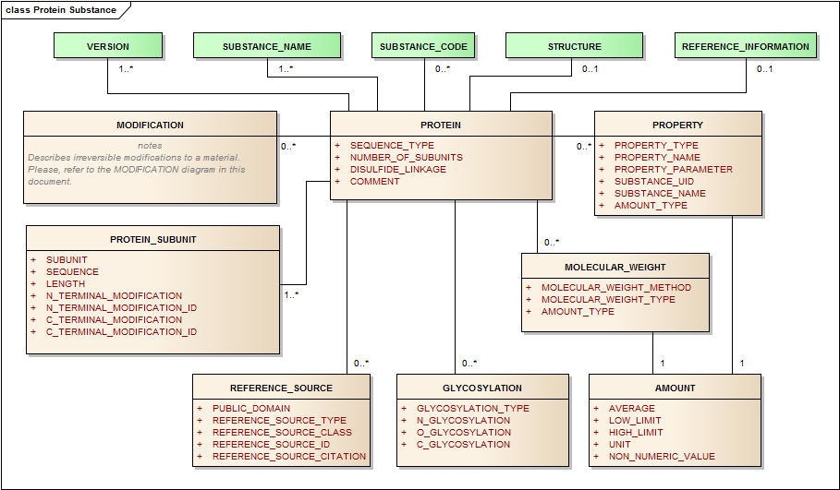
Figure 11 – Information model for the Protein Substance
If the substance type as defined in Section 4.3 is equal to Protein substance, the following data elements and conformances apply in order to assign Substance IDs.

Sequence Type
Table 124 – Sequence type
User Guidance | The protein descriptive elements will only be used when a complete or partial amino acid sequence is available or derivable from a nucleic acid sequence.
Example(s) | COMPLETE; PARTIAL
Conformance | REQUIRED
Data Type | CD
Values Allowed
Business Rule(s)

Number of subunits
Although many proteins form multimeric complexes, particularly at high concentrations, subunits are typically either connected through disulfide linkages or other covalent linkages or have strong non-covalent interactions with defined stoichiometry largely independent of concentration.
Table 125 – Number of subunits
User Guidance | Number of linear sequences of amino acids linked through peptide bonds. The number of subunits constituting the protein shall be described. It is possible that the number of subunits can be variable.
Example(s) | 1
Conformance | CONDITIONAL
Data Type | INT
Values Allowed
Business Rule(s) | This number is implicit and derived from number of protein subunits.

Disulfide Linkage
Disulfide linkages imply that two cysteines connect forming a sulfur to sulfur linkage. There are also instances where disulfide linkages can form through other modified or substituted acids or amino acids containing a thiol (See Desmopressin example in Annex C: Protein/Peptide Substances).
Table 126 – Disulfide linkage
User Guidance | The disulphide bond between two cysteine residues either on the same subunit or on two different subunits shall be described. The position of the disulfide bonds in the protein shall be listed in increasing order of subunit number and position within subunit followed by the abbreviation of the amino acids involved. The disulfide linkage positions must actually contain the amino acid Cysteine at the respective positions.
Example(s) | “Subunit 1 position 10 – Subunit 2 position 16” refers to a disulfide linkage between the residue of cysteine in the position 10 and 16 respectively of the first and second subunit. A convenient shorthand such as 1_10-2_16 could also be used.
Conformance | REQUIRED
Data Type | ST
Values Allowed | The values have to be separated with semi-colons as defined in the examples in the Annex C.
Business Rule(s)

Comment
Table 127 – Comment
User Guidance | Any comment can be provided in this field, if necessary.
Example(s)
Conformance | OPTIONAL
Data Type | ST
Values Allowed
Business Rule(s)

Protein Subunit (repeat as necessary)
This section refers to the description of each subunit constituting the protein. A subunit is a linear sequence of amino acids linked through peptide bonds. The Subunit information shall be provided when the finished protein is a complex of multiple sequences; subunits are not used to delineate domains within a single sequence. Subunits are listed in order of decreasing length; sequences of the same length will be ordered by decreasing molecular weight; subunits that have identical sequences will be repeated multiple times.

Subunit
Table 128 – Subunit
User Guidance | Index of primary sequences of amino acids linked through peptide bonds in order of decreasing length. Sequences of the same length will be ordered by molecular weight. Subunits that have identical sequences will be repeated and have sequential subscripts.
Example(s) | 1, 2, 3 (..)
Conformance | REQUIRED
Data Type | INT
Values Allowed
Business Rule(s)

Sequence
Table 129 – Sequence
User Guidance | The sequence information shall be provided enumerating the amino acids from N- to C-terminal end using standard single-letter amino acid codes. Uppercase shall be used for L-amino acids and lowercase for D-amino acids. Transcribed proteins will always be described using the translated sequence; for synthetic peptide containing amino acids that are not represented with a single letter code an X should be used within the sequence. The modified amino acids will be distinguished by their position in the sequence..
Example(s)
Conformance | REQUIRED
Data Type | ST
Values Allowed
Business Rule(s)

Length
Table 130 – Length
User Guidance | Length of linear sequences of amino acids contained in the subunit
Example(s) | 25
Conformance | REQUIRED
Data Type | INT
Values Allowed
Business Rule(s) | The sequence length is implicitly derived from the linear sequences of amino acids contained in the subunit.

N_Terminal Modification
Table 131 – N_Terminal modification
User Guidance | The name of the fragment modified at the N-terminal of the protein shall be specified.
Example(s) | N-Terminal Pyroglu Formation; Pyroglutamic acid (pE),
Conformance | CONDITIONAL
Data Type | CD
Values Allowed | ISO 11238 substance names
Business Rule(s) | If an N-terminal modification exists, this element becomes required. The preferred name as specified in ISO 11238 is the default value. The value is implicit and derived based on the N_Terminal Modification ID.

N_Terminal Modification ID
Table 132 – N_Terminal modification ID
User Guidance | Unique identifier for molecular fragment modification based on the ISO 11238 Substance ID.
Example(s) | UNII code; SZB8301W42 (UNII)
Conformance | CONDITIONAL
Data Type | II
Values Allowed | ISO 11238 Substance ID
Business Rule(s)

C_Terminal Modification
Table 133 – C_Terminal modification
User Guidance | The modification at the C-terminal shall be specified.
Example(s) | amide, ethyl ester etc, C-Terminal Lysine removal
Conformance | CONDITIONAL
Data Type | CD
Values Allowed | ISO 11238 substance names
Business Rule(s) | If a C-terminal modification exists, this element becomes required. The preferred name as specified in ISO 11238 is the default value. The value is implicit and derived based on the C_Terminal Modification ID.

C_Terminal Modification ID
Table 134 – C_Terminal modification ID
User Guidance | Unique identifier for molecular fragment modification based on the ISO 11238 Substance ID.
Example(s) | UNII code, K3Z4F99H6 (UNII), Lysine (K)
Conformance | CONDITIONAL
Data Type | II.
Values Allowed | ISO 11238 Substance ID
Business Rule(s)

Molecular Weight (repeat as necessary)
The molecular weight or a molecular weight range for proteins, polymers or nucleic acids should be provided if known. Multiple molecular weights that either depend on the method or type should also be provided.
If the molecular weight is available, the following specifications apply:

Molecular Weight Method
There are a variety of methods used to determine molecular weight. The method is often associated with the type of molecular weight. Each method should be captured.
Table 135 – Molecular weight method
User Guidance | The method by which the molecular weight was determined.
Example(s) | SDS-PAGE, calculated, light scattering, viscosity, gel permeation centrifugation; end group analysis.
Conformance | REQUIRED
Data Type | CD
Values Allowed
Business Rule(s)

Molecular Weight Type
There are basically four types of molecular weights associated with polymers, proteins and nucleic acids. The four types are number average, M_{n}; viscosity average, M_{v}; weight average, M_{w}; and Z-average, M_{z.} Polydispersity is an important property that will distinguish different polymers from one another. Polydispersity is typically defined as the ratio of weight average molecular weight to the number average molecular weight (M_{w}/M_{n}).
Table 136 – Molecular weight type
User Guidance | Type of molecular weight such as exact, average (also known as. number average), weight average
Example(s) | Number Average, Weight Average
Conformance | CONDITIONAL
Data Type | CD
Values Allowed | M_{n}; viscosity average, M_{v}; weight average, M_{w}; and Z-average M_{z.} Polydispersity
Business Rule(s) | If known it shall be provided

Amount
The information on amount shall be captured as specified in Section 4.9.

Glycosylation
Glycosylation is both variable and heterogeneous. Glycosylation sites typically have multiple glycans attached to them and even differ on the extent of glycosylation on a given site. For Glycosylated proteins, the type and sites of glycosylation should be provided. Glycosylation is applicable to both proteins and structurally diverse substances. Although sites of N-glycosylation can generally be predicted from the amino acid sequence, sites of O-glycosylation and C-glycosylation are usually determined experimentally and may not be completely known at the time of submission and can be added to a substance when known. Generally all sites that have occupancy greater than 5% should be submitted to define the glycoprotein. Although analytical techniques are evolving to better characterise the glycans attached to proteins this data will not be required to define a substance but could be captured at the Specified Substance Group 1 level. There can be substantial differences in glycosylation that are often dependent on the particular clone of a cell line that is used to produce a protein or even vary on a batch to batch basis.

Glycosylation Type
The different glycosylation types are determined by the cell that either the protein or specified substance was synthesised in. The different types are based on consistent differences in the glycosylation. Human glycosylation differs from mammalian glycosylation in several ways, human glycans do not contain glycolic acid residues on terminal sialic acid and they do not contain terminal .alpha.1-> 3-galactose. Old world monkeys also lack the ability to form .alpha. 1-> 3-galactose, but do have glycolic acid esters on terminal sialic acid residues. Other glycosylation types typically have substantial differences in both glycans used and the extent of site occupancy. Glycosylation type may also be captured for structurally diverse substances, particularly vaccines which may be produced in either human, mammalian cell or old world monkey cells. The glycosylation type will often have substantial effects on the immunogenicity of the protein or vaccine.
Table 137 – Glycosylation type
User Guidance | The type of the glycan shall be specified based on a controlled vocabulary.
Example(s) | HUMAN, OLD WORLD MONKEY, MAMMALIAN, AVIAN, REPTILIAN; FUNGAL, BACTERIAL, PLANT, INSECT, MAMMALIAN AFUCOSYLATED, YEAST HUMANISED
Conformance | CONDITIONAL
Data Type | CD
Values Allowed
Business Rule(s)

N-Glycosylation
N-linked glycosylation: The sites of N-glycosylation can typically be predicted from the amino acid sequence. The sequence NX(S/T) which indicates an asparagine followed any amino acid other than proline and then followed by either a serine or threonine will typically be a site of N-glycosylation.
Table 138 – N_Glycosylation
User Guidance | Information on the site of n-glycosylation (asparagine); n-glycosylation is to be listed according to the protein sequence.
Example(s) | Position 34 of this Subunit, an Asparagine; for a single subunit protein 1_34
Conformance | CONDITIONAL
Data Type | ST
Values Allowed | The position of that subunit must actually contain an amino acid that can have N-linked glycosylation.
Business Rule(s)

O-Glycosylation
O-linked glycosylation: The sites of O-glycosylation cannot typically be predicted from the sequence alone and are discovered through analytical methods. Sites may become identified at later stages in clinical development. The Substance ID typically should not change as new sites are identified but the version of the substance would.
Table 139 – O_Glycosylation
User Guidance | Information on the site of o-glycosylation (serine, threonine, tyrosine, hydroxylysine, hydroxyproline) shall be provided.
Example(s) | Position 34 of this Subunit, a Serine.
Conformance | CONDITIONAL
Data Type | ST
Values Allowed | The position of that subunit must actually contain an amino acid with an OH group (i.e., serine or threonine or tyrosine).
Business Rule(s)

C-Glycosylation
C-linked glycosylation: The consensus sequence for C-glycosylation is WxxW/F where the first tryptophan undergoes c-mannosylation.
Table 140 – C_Glycosylation
User Guidance | Information on the C-Glycosylation: site of C-glycosylation (tryptophan) shall be provided.
Example(s) | Position 45 of this Subunit, a Tryptophan
Conformance | CONDITIONAL
Data Type | ST
Values Allowed
Business Rule(s)

Structure
The information related to the structure shall be provided as per specification described in Section A structural representation should be provided for any structural modifications of the proteins. The representation should include the first atom of the protein which is modified. For amino acid replacements and fragment additions a substance will be created in its own right. In addition or in lieu of the data structure listed above, HELM notation can be a suitable format for transmitting definitive information on selected proteins and peptides (see http://www.pistoiaalliance.org/projects/active-projects/hierarchical-editing-language-for-macromolecules-helm/).

Modification
If applicable, the modification should be described based on specification provided in Section 4.11

Property
If applicable, the Property should be described based on specification provided in Section 4.12.

Amount type
See Section 4.7.13.3.1.

Amount
Amount shall be captured as specified in Section 4.9.

Molecular Weight
Information on molecular weight should be described based on specifications in Section 5.2.7.

Nucleic Acids
Nucleic acids are defined by three distinct elements: the base, sugar and linkage. Individual substance/moiety IDs will be created for each of these elements. The nucleotide sequence will be always entered in the 5’-3’ direction.
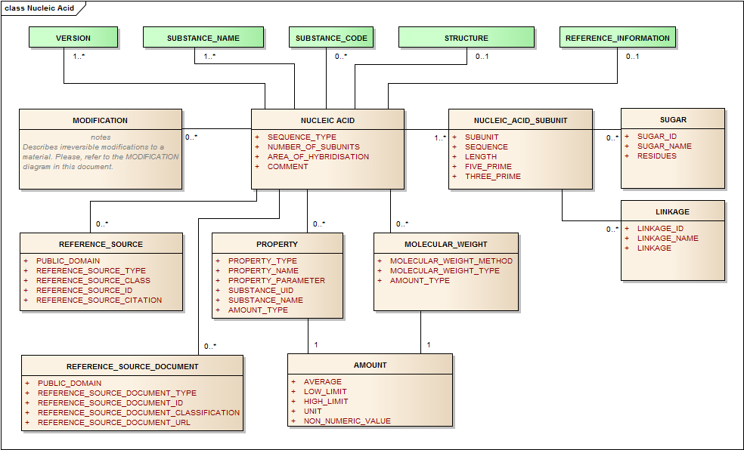
Figure 12– Information Model for Nucleic Acid
The Nucleic Acid set of elements are only to be used to describe nucleic acids that have:
- A length greater than three bases or base pairs;
- Elements to be used for oligonucleotides
- Genes used in gene therapy
- Any nucleic acid aptomers
For the description of nucleic acids the following information can be used to assign Substance IDs:
- Nucleotide Sequence
- Sugar or sugar-like entities
- Linkage (typically phosphate)
- Nucleic Acid Type (RNA, DNA, plasmid, single or double stranded)
- Any Modifications to the substance either sequence specific (i.e. modified or unnatural base, sugar, phosphate linkage) or non-sequence specific modifications.

Structure
There are multiple alternative ways of representing the structure of nucleic acids. Figure 13 provides an example of one of the possible structural representations. While the sequence of nitrogenous bases is given as a single letter notation, the backbone structure is represented as a polymeric single repeat unit (Section 5.4 “Polymers”). A structural representation can be provided for relatively short oligonucleotides but the textual fields illustrated below should be sufficient to describe nucleic acid based substances.
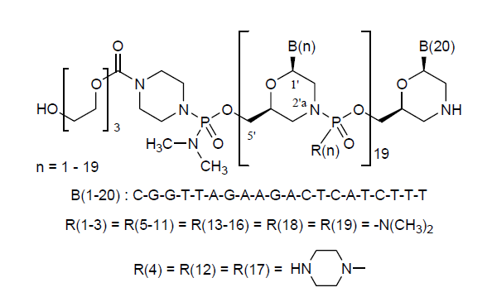
Figure 13 – Representative Structural Representation of nucleic acids

Sequence Type
Table 141 – Sequence type
User Guidance | The type of the sequence shall be specified based on a controlled vocabulary.
Example(s) | COMPLETE; PARTIAL
Conformance | REQUIRED
Data Type | CD
Values Allowed
Business Rule(s)

Number of Subunits
Table 142 – Number of subunits
User Guidance | The number of linear sequences of nucleotides linked through phosphodiester bonds shall be described. Subunits would be strands of nucleic acids that are tightly associated typically through Watson-Crick base pairing.  NOTE: If not specified in the reference source, the assumption is that there is 1 subunit.
Example(s) | 1, 2, or 3
Conformance | REQUIRED
Data Type | INT
Values Allowed
Business Rule(s) | This number is implicit and derived from number of nucleic acid subunits.

Area of hybridisation
Table 143 – Area of hybridisation
User Guidance | The area of hybridisation shall be described if applicable for double stranded RNA or DNA. The number associated with the subunit followed by the number associated to the residue shall be specified in increasing order.  The underscore “_” shall be used as separator as follows: “Subunit_number Residue”.
Example(s) | Each residue shall be specified followed by a comma and space.
Conformance | CONDITIONAL
Data Type | ST
Values Allowed
Business Rule(s)

Comment
Table 144 – Comment
User Guidance | Any comment can be provided in this field, if necessary.
Example(s)
Conformance | OPTIONAL
Data Type | ST
Values Allowed
Business Rule(s)

Nucleic Acid Subunit (repeat as necessary)
Subunits are listed in order of decreasing length; sequences of the same length will be ordered by molecular weight; subunits that have identical sequences will be repeated multiple times.

Subunit
Table 145 – Subunit
User Guidance | Index of linear sequences of nucleic acids in order of decreasing length. Sequences of the same length will be ordered by molecular weight. Subunits that have identical sequences will be repeated and have sequential subscripts.
Example(s) | 1, 2, 3 (..)
Conformance | REQUIRED
Data Type | INT
Values Allowed
Business Rule(s)

Sequence
Table 146 – Sequence
User Guidance | Actual nucleotide sequence notation from 5' to 3' end using standard single letter codes. In addition to the base sequence, sugar and type of phosphate or non-phosphate linkage should also be captured.
Example(s) | GATTCA
Conformance | REQUIRED
Data Type | ST
Values Allowed | Sequence of the letters G, C, T, A, and U
Business Rule(s)

Length
Table 147 – Length
User Guidance | The length of the sequence
Example(s) | 5
Conformance | REQUIRED
Data Type | INT
Values Allowed
Business Rule(s) | The sequence length is implicitly derived by the sequence description.

Sugar (Repeat as necessary) (new classes to be included in the ISO 11238 Standard in the next revision)

Residues
The residues that contain a given sugar entity will be captured. Each sugar present in the nucleic acid will be represented.
Table 148 – Residues
User Guidance | The residues that contain a given sugar will be captured. The order of given residues will be captured in the 5‘-3‘direction consistent with the base sequences listed above.
Example(s) | 1_1-1_20 would indicate that residues 1-20 of a given strand contain a particular sugar.
Conformance | REQUIRED
Data Type | ST
Values Allowed | ISO 11238 Substance ID
Business Rule(s)

Sugar ID
The Substance ID type of sugar to which the base is connected. For naturally occurring nucleic acids the sugar is typically either .beta.-D-ribose or .beta.-D-deoxyribose. The actual configuration of the sugar shall be captured.
Table 149 – Sugar ID
User Guidance | The Substance ID of the sugar or sugar-like component that make up the nucleotide
Example(s) | UNII code for ribose:
Conformance | REQUIRED
Data Type | II
Values Allowed | ISO 11238 Substance ID
Business Rule(s)

Sugar name
The type of sugar to which the base is connected. For naturally occurring nucleic acids the sugar is typically either .beta.-d-ribose or .beta.-d-deoxyribose.
Table 150 – Sugar name
User Guidance | The name of the sugar or sugar-like component that make up the nucleotide
Example(s) | Ribose, deoxyribose, 2,5-dihydroxy-morphilino
Conformance | REQUIRED
Data Type | CD
Values Allowed | ISO 11238 substance name
Business Rule(s) | This is implicit and derived from the Sugar ID. The preferred name is the default value.

Linkage Group (new classes to be included in the ISO 11238 Standard in the next revision)

The linkages between sugar residues will also be captured.

Linkage

This element will indicate the orientation of the linkage. The 3‘-5‘ linkage is the most prevalent form.
Table 151 – Linkage
User Guidance | The entity that links the sugar residues together should also be captured for nearly all naturally occurring nucleic acid the linkage is a phosphate group. For many synthetic oligonucleotides phosphorothioate linkages are often seen. Linkage orientation is assumed to be 3’-5’. If the linkage is either 3’-3’ or 5’-5’ this should be specified.
Example(s)
Conformance | CONDITIONAL
Data Type | CD
Values Allowed | 3’-5’ , 3’-3’ or 5’-5’ this should be specified.
Business Rule(s)

Linkage Name
Table 152 – Linkage name
User Guidance | Each linkage will be registered as a fragment and have at least one name. A single name shall be assigned to each linkage.
Example(s) | Phosphothioate
Conformance | CONDITIONAL
Data Type | CD
Values Allowed
Business Rule(s)

Linkage ID
Table 153 – Linkage ID
User Guidance | Each linkage will be registered as a fragment and have an ID.
Example(s)
Conformance | CONDITIONAL
Data Type | II
Values Allowed
Business Rule(s)

Five Prime
Table 154 – Five prime
User Guidance | The nucleotide present at the 5’ terminal shall be specified based on a controlled vocabulary.  Since the sequence is represented from the 5' to the 3' end, the 5’ prime nucleotide is the letter at the first position in the sequence. A separate representation would be redundant.
Example(s)
Conformance | CONDITIONAL
Data Type | CD
Values Allowed
Business Rule(s) | Implicit  NOTE: If not specified in the available reference source this value shall be derived from the nucleic acid sequence.

Three Prime
Table 155 – Three prime
User Guidance | The nucleotide present at the 3’ terminal shall be specified based on a controlled vocabulary.  Since the sequence is represented from the 5' to the 3' end, the 5’ prime nucleotide is the letter at the last position in the sequence. A separate representation would be redundant.
Example(s)
Conformance | CONDITIONAL
Data Type | CD
Values Allowed
Business Rule(s) | NOTE: If not specified in the available reference source this value shall be derived from the nucleic acid sequence.

Modification
If applicable, the modification should be described based on specification provided in Section 4.11

Property
If applicable, the Property should be described based on specification provided in Section 4.12.

Amount type
In Section 4.7.13.3.1.

Amount
Amount shall be captured as specified in Section 4.9.

Molecular Weight
Information on molecular weight should be described based on specifications in Section 5.2.7.

Reference Source
Information on Reference source should be described based on specifications in Section 4.6.

Polymers –To be addressed in more detail in the next version of the TS
Polymers are polydisperse molecular ensembles defined using combination structural and descriptive elements. The structural elements are the structural repeating units along with end groups and salt forms. The number and/or weight average molecular weight, degree of polymerisation, degree or extent of substitution of fragments and physical properties related to molecular weight are descriptive elements that may be required to assign a Substance ID. For synthetic polymers, the monomers used to prepare the polymer should also be provided. For copolymers, the type of copolymer (random, block, branched, etc.), along with the block/branch size and number of blocks or branches, should also be provided. A technical specification sheet and/or information sheet from a manufacturer is often sufficient to generate a Substance ID. For polymers derived from biological matrixes, the source of the polymer should also be provided.
EXAMPLE Starch is a mixture of two polymers amylose and amylopectin. It is normally isolated from wheat, corn, rice, potato, or tapioca and source material elements should be used to capture the source.
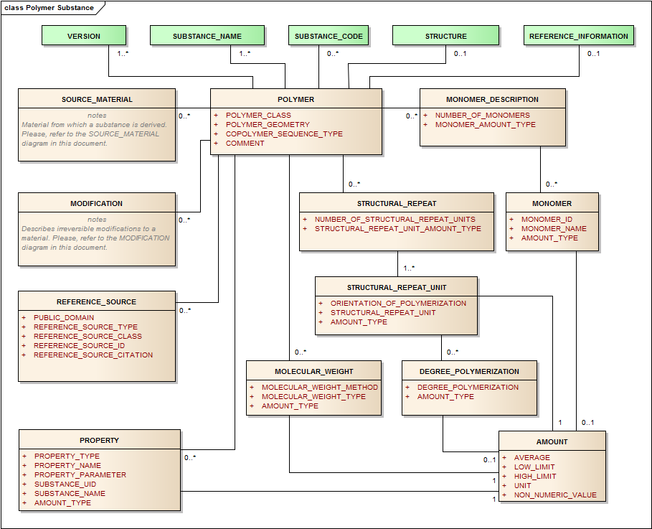
Figure 14 – Information Model for Polymer Substance
For the description of polymer substances a combination of the following elements should be submitted to assign Substance IDs:
- Structural Representations of the Structural Repeating Units and/or Monomers
- Explicit Connectivity between Structural Repeating Units and End-groups
- Number Average Molecular Weight and/or Limits
- Weight Average Molecular Weight and/or Limits
- Degree of Polymerisation
- Physical Properties Related to Molecular Structure (i.e. Viscosity, Density, etc.)
- For Copolymers: Relative Amounts of Monomers
- For Block Copolymers: Block Size and Block Number
- For Substituted Polymers: Substituents and the Degree of Substitution
- Any Process that Modifies the Chemical Structure
The general set of information shall be provided by means of the followings data elements.

Substance Name
The information related to the name of the substance shall be provided as per specification described in Section 4.5. The naming of polymers can be different from other types of substances. Official Names are typically given to classes of substances and not individual polymers. A naming convention to distinguish polymers within a class may be developed.
EXAMPLE POLYQUATERNIUM-47 is an INCI for an acrylate copolymer but it is necessary to indicate the relative amounts of the different acrylate Structural Repeat Units and the molecular weight. A specific name for a distinct polymer would be POLYQUATERNIUM-47 (METHACRYLAMIDOPROPYLTRIMETHYLAMMONIUM CHLORIDE-CO-METHYL ACRYLATE-CO-ACRYLIC ACID 45:10:45; 1200000 MW).

Structure
The information related to the structure shall be provided as per specification described in Section 4.9. The structure wherever possible should be representative of the structural repeating units that make up the polymer. The structure should be contained within brackets. The end groups or an asterisk indicating connectivity to another structural repeating unit should be drawn outside the brackets. For random copolymers, each structural repeating unit should be drawn in the same structural representation, but not directly connected to each other. For block copolymers, the structural repeating units will be directly connected to each other. End groups, when known, should also be attached to the structural repeating units. Molfiles are the preferred format for the molecular structure of the repeating unit.

Polymer Class
Table 156 – Polymer class
User Guidance | Type of polymer.
Example(s) | homopolymer, copolymer, crosspolymer
Conformance | REQUIRED
Data Type | CD
Values Allowed
Business Rule(s)

Polymer Geometry
Table 157 – Polymer geometry
User Guidance | The geometry of the polymer shall be described.
Example(s) | linear, branched, cross linked, network, dendritic, star, comb, brush
Conformance | REQUIRED
Data Type | CD
Values Allowed
Business Rule(s)

Copolymer Sequence type
Table 158 – Copolymer sequence type
User Guidance | The type of copolymer of the polymer sequence shall be described
Example(s) | random, alternating, block, graft, statistical
Conformance | REQUIRED
Data Type | CD
Values Allowed
Business Rule(s)

Comment
Table 159 – Comment
User Guidance | Any comment can be provided in this field, if necessary.
Example(s)
Conformance | OPTIONAL
Data Type | ST
Values Allowed
Business Rule(s)

Monomer Description (repeat as necessary)
For synthetic polymers, this set of descriptors intends to specify and quantify the monomers used for the synthesis of the polymer or copolymer. The information on the monomer shall be provided by means of the following data elements:

Number of Monomers
Table 160 – Number of monomers
User Guidance | The number of diverse monomers used to synthesise the polymer shall be specified.
Example(s) | 2
Conformance | REQUIRED
Data Type | INT
Values Allowed
Business Rule(s) | This number can be counted and is never explicitly represented.

Amount Type

Should be captured according to 4.8.5.3.1. Indicate how the quantitative amount of Structural Repeating Units is captured (e.g. mole ratio, weight ratio, mole percent, weight percent).

Monomer (repeat as necessary)
This section identifies and quantifies the monomer(s) used in the synthesis of the polymer.

Monomer ID
Table 161 – Monomer ID
User Guidance | The unique identifier assigned to the monomer.
Example(s)
Conformance | REQUIRED
Data Type | II
Values Allowed
Business Rule(s)

Monomer Name
Table 162 – Monomer name
User Guidance | The name of the monomer shall be provided; established or primary name of monomer.
Example(s)
Conformance | REQUIRED
Data Type | CD
Values Allowed
Business Rule(s)

Amount
The information related to the amount shall be provided as per specification described in Section 4.9.

Structural Repeat (repeat as necessary)
This section specifies and quantifies the repeated units and their configuration. A structural representation should also be submitted. Information on the structural repeat unit shall be provided by means of the following data elements:

Number of Structural Repeat Units
Table 163 – Number of structural repeat units
User Guidance | The number of diverse structural repeated units represented in the structure of the polymer shall be specified.
Example(s) | Homopolymers will only have 1 Structural Repeat Unit; copolymers will typically have more than 1.
Conformance | REQUIRED
Data Type | IN  T
Values Allowed
Business Rule(s) | Implicitly derived

Amount Type

Should be captured according to 4.7.13.3.1.Indicate how the quantitative amount of Structural Repeating Units is captured (e.g. mole ratio, weight ratio, mole percent, weight percent).

Structural Repeat Unit (repeat as necessary)
or synthetic polymers the structural repeat units are typically generated from the polymerisation of monomers. The Structural Repeat Unit for polyethylene is ethylene and not methylene.

Orientation of Polymerisation
This element is used to indicate how Structural Repeat Units connect to each other. In addition to the Orientation of Polymerisation explicit connections between Structural Repeating Units can be indicated by connection points.
Table 164 – Orientation of polymerisation
User Guidance | The orientation of the polymerisation shall be described.
Example(s) | head-tail, head-head, random
Conformance | REQUIRED
Data Type | CD
Values Allowed
Business Rule(s)

Structural Repeat Unit
Table 165 – Structural repeat unit
User Guidance | Structural repeat units are essential elements for defining polymers. Specific guidance will be given in the polymer annex
Example(s) | 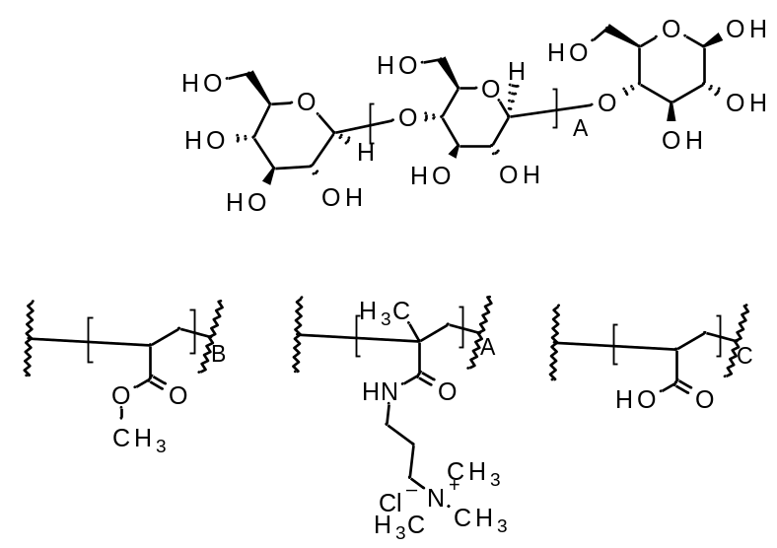
Conformance | REQUIRED
Data Type | Molfile; SMILES; InChI
Values Allowed
Business Rule(s) | End groups if defined can be attached to the Structural Repeat Unit. The Structural Repeat Unit should be the largest repeating structural fragment

Amount
The information related to the amount shall be provided as per specification described in Section 4.9.

Degree of Polymerisation (repeat as necessary)
This section applies to homopolymer and block co-polymers where the degree of polymerisation within a block can be described. The following information shall be provided where available:

Polymerisation degree
Table 166 – Polymerisation degree
User Guidance | The type of the degree of polymerisation shall be described.
Example(s)
Conformance | REQUIRED
Data Type | CD
Values Allowed
Business Rule(s)

Amount
The information related to the amount shall be provided as per specification described in Section 4.9.

Molecular Weight (repeat as necessary)
The information related to the molecular weight shall be provided as per specification described in Section 5.2.6.

Property (repeat as necessary)
The information related to the property of the polymer shall be provided as per specification described in Section 4.12.

Reference Source (repeat as necessary)
The information related to the source of the property of the polymer shall be provided as per specification described in Section 4.6.

Structurally-Diverse Substances
There are a wide variety of substances described as structurally diverse substances. Structurally diverse substances are typically substances that have a variety of structurally diverse constituents that cannot be captured as a mixture of a limited number of related single substances. This category would be used to describe the following class of substances:
- Herbals , The Herbal preparation OIL is discussed in the Chemical Annex B, section C2 to C.3.4
The Herbal Preparation, Extract, exudates as well as the (Herbal) Substance (fresh), Herbal Drug are discussed in the Herbal ANNEX E. and to be addressed in the next version of the TS.
- Homeopathic Substances ; To be addressed in the next version of the TS.
- Vaccines – To be addressed in the next version of the TS
- Complex blood products – To be addressed in the next version of the TS
- Polyclonal Immunoglobulins – To be addressed in the next version of the TS
- Cells, tissues, complex animal derived products – To be addressed in the next version of the TS
Minerals - To be addressed in the next version of the TS
For organism-based substances, the parent organism is essential defining information.
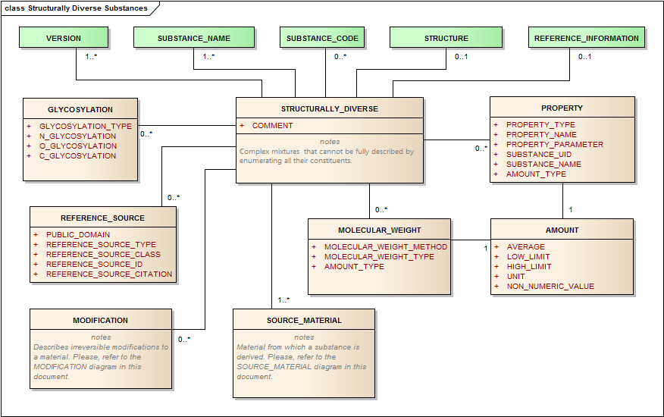
Figure 15 – Information Model for Structurally-Diverse Substance
The majority of these substances will be derived from a biological organism, but they could be complex natural materials such as coal tar or mineral oil.

Herbals and Substances Used in the Preparation of Plant-Based Allergenic Extracts
Substances in herbal preparations and most substances in allergenic preparations shall be defined simply by taxonomic information and the plant part. Taxonomic information, particularly the scientific name of a medicinal plant, is essential for defining herbal substances in medicinal products. The Kew Gardens Medicinal Plant Names Services (MPNS) should be the authoritative source for all scientific names and should also maintain a list of plant parts and fractions. A controlled vocabulary for medicinal plant taxonomy has been developed and will be maintained by the Kew Gardens Medicinal Plant Names Services. A submitter should choose the current accepted scientific name provided by MPNS. The MPNS Portal should be accessed via www.kew.org/mpns. The service should be contacted if the herbal substance material cannot be mapped to records in the MPNS. It should be noted that many common and even pharmacopoeial names of herbs often map to more than one plant species, but it is important that the actual herbal substance (defined as a particular species) shall be used in defining a substance.
Although herbal products in some jurisdictions are not regulated as medicinal products, they are a major class of products covered in the IDMP standards. Many jurisdictions have a clear distinction between herbal substances and herbal preparations and that is what is followed in this implementation guide. Herbal substances are defined by the taxonomic definition of the plant represented by the plant’s scientific name which includes the genus, species and author. Additional taxonomy such as kingdom, phylum, class order, and family could also be captured to assist in the classification of substances. The part or parts or the plant that are used in the preparation are also included in the substance definition. Identification of a substance may also require an indication of the plant life cycle captured in the name of the plant part such as inflorescence or sprout.
EXAMPLE The common term chamomile typically refers to the flowers of two distinct plants identified by the accepted scientific names Matricaria chamomilla L. and Chamaemelum nobile (L.) All. The term chamomile is ambiguous and a submitter should refer to the specific species that is contained in the product.
Time and place of harvest, type of soil, the use of fertilisers, pesticides and herbicides, the amount of daylight and water, although important they are not captured as part of the substance definition. A cultivar or variety of a plant may be defined as a different substance if known differences in constituents exist (e.g., broccoli and cauliflower are defined as different substances even though they share the same genus and species). Herbal preparations are considered fractions of the Herbal substance will be captured at the substance level for Oils, and to some extent for Extracts. Additional information of the extract will be defined at the Specified Substances Group 1 information level. Fractions of plants parts such as commodity oils, juices, and exudates such as acacia gum and herbal extracts such as teas and tinctures and will always map to the parent organism and part or parts. A variety of examples of herbal substances and herbal preparations are present in Annex E: Herbal Substances and Herbal Specified Substances.
The Herbal Annex E should be referred to for user guidance and business rules for the various elements of the source material for structurally diverse substances as they apply to Herbals. Examples are given for Herbals derived from plant material, as well as material from algae and fungi, which are also classified as Herbals. Other types of natural materials, such as animals and minerals are also treated as Herbals in Kampo extracts and other systems of medicine. Although Annex E doesn’t include any examples, algae, fungi, animals and minerals are also classified as Herbals.

Naming Vegetable Oils
The business rules for naming of vegetable oils are described in ISO/DTS 19844 Section Structurally Diverse Substance, Herbals, section 5.5.1 and in the section Source material (Section 4.10).
NOTE The information model for Structurally Diverse substances has to be updated in the Main body document of the ISO/DTS 19844 as by the latest version and in the ISO 11238 standard. Since in the next version of the Implementation Guide a proposal will be made to include both the information for the Herbal drug (a term used here in preference to Herbal substance) and the Herbal preparation at the substance information level. Additional Herbal drug and Herbal preparation information can be included in the Substance_type Structurally Diverse Specified Substance Group 1 information level. This is needed to capture the marker and signature substances at this level in order to comply with the Regulatory regulation.
The terms Substance and Specified Substance are used as defined by ISO 11238. The terms Herbal drug (Herbal substance) and Herbal preparation are used as defined by pharmacopoeias, and will both be captured at the Substance level. In addition, a more basic unit, comprising unprocessed, fresh material of a single species or infraspecies (occasionally a genus) + part, with no affiliation to any particular pharmacopoeia, will also be captured at the Substance level; for clarity, these will be referred to as Substance (fresh) in this Annex, The information model also accommodates fraction information at the substance level. The element <Fraction> will be considered as two Herbal preparation_Types: <Oil, Exudate, Juice> or <Extract>, each requiring different information.
Specified substance group 1 includes additional information for substances and multi-substance material. Additional information for Herbal drugs and for Herbal preparations e.g. additional information for an extract such as extraction solvent composition, Herbal Drug/ Herbal extract ratio will be captured at this level along with the constituents and marker or signature substances.

Example Olive Oil, Virgin
Olive Oil, Virgin EP is defined as a Herbal preparation (because it has been obtained by expression). There is no defined Herbal drug for this Herbal preparation, but instead it’s source material is the ripe drupes (fruit) of Olea europaea L.
For the purposes of the ISO 11238, the Herbal preparation is defined as a Substance as [<Scientific genus/binomial/trinomial without Author>,<Part(s)>,<Fraction>], i.e. Olea europaea, Fruit, Oil.; Common name: Olive Oil, Virgin. The source material for the Herbal preparation, with the relationship of Parent substance, giving the Substance_Role the value <Parent>, is a separate Substance (fresh) defined as [<Scientific genus/binomial/trinomial with Author>,<Part(s)>], i.e. Olea europaea L., Fruit.
The name [<Scientific genus/binomial/trinomial with Author>,<Part(s)>] refers to a Substance Name in terms of the ISO 11238 that is not an official name in any pharmacopoeia or other legislation. The inclusion of the author is to ensure that it is not confused with the official names for Herbal drugs and Herbal preparations which are also defined as Substances by the ISO 11238. The scientific element of the name is usually a binomial (species), but may be a trinomial (infraspecies such as a variety or subspecies) or a genus, as appropriate, together with the author of the name. The Part element of the name should be chosen from a CV consisting of a restricted number of terms.
The name [<Scientific genus/binomial/trinomial without Author>,<Part(s)>] refers to a Substance Name in terms of the ISO 11238 and is the equivalent to a Herbal drug Name. There is no such Substance Name for Olive Oil in this example from the EP, although other pharmacopoeias might define a Herbal drug for Olea europaea, Fruit.
The name [<Scientific genus/binomial/trinomial without Author>,<Part(s)>], [Fraction] refers to a Substance Name in terms of the ISO 11238 and is equivalent to an Herbal preparation Name.
The Herbal preparation Name has two Herbal preparation Name_Types; one for the Substance fraction: Oil, Exudate, Juice and one for the Substance fraction: Extract. This is done to differentiate between the cardinalities of the Herbal preparation_types.
The Herbal preparation-Substance (fresh) is a two way relationship. The Herbal preparation_type <Oil, Exudate, Juice> is prepared from one Substance (fresh).
NOTE Several Herbal preparations, e.g. Juices, can be a mixture of separately obtained juices obtained from the Herbal substances and mixed after expression. The final preparation is then a multi-substance material which is captured at the Specified substance Group 1 level.
The Herbal preparation_type <Extract> can be prepared from one or more Herbal drugs and by one or more extraction steps and by one or different extraction solvent compositions. Only the first extraction solvent composition is used in the element solvent. Further details of the Herbal preparation and Herbal drug are described in the ANNEX E, Structurally Diverse substances, Herbals and for the Oils the information is provided the Chemical ANNEX B.
For the Herbal preparation Olive Oil, Virgin the result of the information model will read:
Substance_ID: HJFTE78543 (Artificial ID); (UNII: 6UYK2W1W1E)
Substance Name (Herbal preparation name): Olea europaea, Fruit, Oil
Substance Name_Type: Other
Herbal preparation_Type: Oil 1)
Substance Name: Olive Oil, Virgin
Substance Name_Type: Official (for further elements see tabular format in the Chemical Annex B.)
Parent Substance_ID: OLIJF5643S
Parent Substance_Name: Olea europaea L., Fruit

Substance Type
Table 167 – Substance type
User Guidance | Information about the substance type as described and in accordance with ISO 11238 definitions
Example(s) | Structurally Diverse
Conformance | REQUIRED
Data Type | CD
Values Allowed | Structurally Diverse
Business Rule(s)

Substance ID
Table 168 – Substance ID
User Guidance | ID to be used in all electronic submissions to identify a substance. Generated when sufficient information is available to unambiguously define a substance. ID will be permanently associated with a given substance and each substance at the substance level shall have one and only one ID.  NOTE If a unique “Substance ID” has been assigned, this “Substance ID” shall be specified based on the Substance Name controlled vocabulary. In the absence of a unique “Substance ID”, e. g. for the initial submission of the substance, this data element is not required.
Example(s) | DEVTYS543H
Conformance | REQUIRED
Data Type | II
Values Allowed | Value could be a code associated with a preferred term, or a specific type of data. If a code is transmitted the preferred term associated with that code should also be transmitted.
Business Rule(s) | All substances will be identified by a single ID.  NOTE: the Substance ID is NOT SPECIFIED for Substance ID Request  NOTE: The ID will only be released to the public if the defining information is in the public domain or if a company that provides the defining information requests public release or releases the code in public marketing materials. Defining information found in patents will usually not be sufficient to release the ID to the public. Even if an ID can be released there may be elements that will not be released to the general public. An ID will always be released to an organisation that requests an ID and supplies information to define a substance. A Flag to control the release of the ID to the general public is part of the Reference Source information (Section 4.6).

Substance Name
Table 169 – Substance name
User Guidance | Name or company code associated with the Substance.  A Substance is always a single species, or infraspecies, or is occasionally a single genus. It will have a Name which is composed of:  [Scientific genus/binomial/trinomial with Author] [Part(s)]  The scientific element of the name is usually a binomial, but may be a trinomial or a genus, as appropriate, together with the author of the name. The Name is not an official name in any pharmacopoeia or other legislation, and the inclusion of the author is to ensure that it is not confused with the official names for specified substances that are derived from a single species substance. It can be written in any language and its jurisdiction can be restricted using Name_Status.
Example(s) | Harpagophytum procumbens (Burch.) DC. ex Meisn., Root
Conformance | REQUIRED
Data Type | ST
Values Allowed | Free text, multiple names allowed, each in its own <asNamedEntity> element.
Business Rule(s) | Mandatory all substances shall have at least one name or company code associated with the substance.

Substance Name Type
Table 170 – Substance name type
User Guidance | Each name shall be associated with a type.
Example(s) | Official name, systematic name, generic name, brand name, company code
Conformance | REQUIRED
Data Type | CD
Values Allowed | OFFICIAL, SYSTEMATIC, COMPANY CODE, OTHER
Business Rule(s) | A name shall have one and only one name type.

Language
Table 171 – Language
User Guidance | If the name is language dependent, that language shall be specified. Company codes are not language dependent and no language should be specified.
Example(s) | en – English, de – German, fr –French
Conformance | REQUIRED
Data Type | CD
Values Allowed | ISO 639-2 alpha-2 codes
Business Rule(s) | Multiple codes assigned to the same language are to be considered synonyms and only one of them needs to be specified.  While xml:lang and JSON allows country-specification of language, e.g., en_US vs. en_UK or pt_PT vs. pt_BR, such specificity is to be avoided except if the country variant of the language exceptionally does give rise to an alternative spelling. In that case, only the exceptional spelling needs to be tagged with the country-specific language code, not the regular spelling for that language in all other countries.

Official Name Type
Table 172 – Official name type
User Guidance | Designation of which authority assigned the Official Name. All official names need to have at least one such designation. The name type is the name of the authority or authorities that have assigned or have adopted the name.
Example(s) | BAN, COSING, EP, FCC, INCI, INN, JAN, JECFA, MARTINDALE, USAN, USP.
Conformance | REQUIRED – all official names require a designation of naming authority
Data Type | CD
Values Allowed | All values in the name assigning authority identifier system.
Business Rule(s) | All official names must have a naming authority designated. If multiple authorities have assigned the same name, a separate <asNamedEntity> is specified for each authority that needs to be listed.

Reference Sources

Public Domain
Table 173 – Public domain
User Guidance | Indication of whether the source is in the public domain. Company codes will only be released if the defining information is associated with the code in a public source such as Chemical Abstracts (CAS), a journal article, or a poster at scientific meeting attributable to the company.
Example(s) | Yes, No
Conformance | REQUIRED
Data Type | BL
Values Allowed
Business Rule(s)

Reference Source Type
Table 174 – Reference source type
User Guidance | The reference source type in which the data elements were actually found.
Example(s) | BP, CHEMID (NLM), EP, IND, INN, ITIS, JAN, JOURNAL, JP, KEGG, MARTINDALE, NDA, PERSONAL CARE PRODUCTS COUNCIL (PCPC), PUBCHEM, USAN, USP, WEB PAGE
Conformance | REQUIRED
Data Type | CD
Values Allowed
Business Rule(s) | Mandatory all names should have at least one source.

Source Material

Source Material Class
Table 175 – Source material class
User Guidance | General classification of the source material;
Example(s) | Organic
Conformance | REQUIRED
Data Type | CD
Values Allowed
Business Rule(s)

Source Material Type
Table 176 – Source material type
User Guidance | The type of the source material shall be specified based on controlled vocabulary
Example(s) | fungus, plant, animal
Conformance | REQUIRED
Data Type | CD
Values Allowed
Business Rule(s)

Organism ID
Table 177 – Organism ID
User Guidance | The unique identifier associated with the plant material shall be specified.
Example(s)
Conformance | REQUIRED
Data Type | II
Values Allowed
Business Rule(s)

Organism Name
Table 178 – Organism name
User Guidance | The organism accepted Scientific name shall be provided based on the genus, binomial or trinomial.
Example(s) | Harpagophytum procumbens (Burch.) DC. ex Meisn.
Conformance | REQUIRED
Data Type | CD
Values Allowed
Business Rule(s) | The accepted scientific name for plants and fungi is provided by Kew’s Medicinal Plant Names Services (MPNS). The names for other organisms will be provided by other authoritative sources.

Development Stage
Table 179 – Development stage
User Guidance | Stage of life for plants. This information shall be provided only when the substance is significantly different in these stages.
Example(s) | leafing, pre-flowering, flowering, fruiting, etc.
Conformance | OPTIONAL
Data Type | CD
Values Allowed
Business Rule(s) | If it is a distinguishing factor, even if it is implicitly understood to experts.

Organism (repeat as necessary)
This section describes the plant which the substance derived from.

Kingdom
Table 180 – Kingdom
User Guidance | The kingdom of a plant shall be specified.
Example(s) | Plantae
Conformance | CONDITIONAL
Data Type | CD
Values Allowed
Business Rule(s) | This can be derived from the Organism name as referenced in the appropriate terminology / taxonomy (e.g., the Kew’s Medicinal Plant Names Services (MPNS), NCBI Entrez Taxonomy or the Catalog of Life.). Catalog of Life typically capture complete taxonomy in a manner consistent with this standard.

Phylum
Table 181 – Phylum
User Guidance | The phylum of a plant shall be specified.
Example(s) | Tracheophyta
Conformance | CONDITIONAL
Data Type | CD
Values Allowed
Business Rule(s) | This is implied by the organism ID and name as referenced in the appropriate terminology / taxonomy (e.g., the NCBI Entrez Taxonomy ID implies all higher levels.)

Class
Table 182 – Class
User Guidance | The class of the plant shall be specified.
Example(s) | Magnoliopsida
Conformance | CONDITIONAL
Data Type | CD
Values Allowed
Business Rule(s) | This is implied by the Organism ID and name as referenced in the appropriate terminology / taxonomy (e.g., the NCBI Entrez Taxonomy ID implies all higher levels.)

Order
Table 183 – Order
User Guidance | The order of the plant shall be specified,
Example(s) | Lamiales
Conformance | CONDITIONAL
Data Type | CD
Values Allowed
Business Rule(s) | This is implied by the Organism ID and name as referenced in the appropriate terminology / taxonomy (e.g., the NCBI Entrez Taxonomy ID implies all higher levels.)

Family
Table 184 – Family
User Guidance | The family of the plant shall be specified.
Example(s) | Pedaliaceae
Conformance | CONDITIONAL
Data Type | CD
Values Allowed
Business Rule(s) | This is implied by the Organism ID and name as referenced in the appropriate terminology / taxonomy (e.g., the NCBI Entrez Taxonomy ID implies all higher levels.)

Genus
Table 185 – Genus
User Guidance | The genus of the organism shall be specified; refers to the genus element of the plant/animal scientific name; it is present in names for genera, species and infraspecies.
Example(s) | Harpagophytum
Conformance | REQUIRED
Data Type | CD
Values Allowed
Business Rule(s) | This is implied by the Organism name as referenced in the appropriate terminology / taxonomy. For plants, it will be the current accepted genus name provided by Medicinal Plant Names Services.

Species
Table 186 – Species
User Guidance | The species of the organism shall be specified; refers to the scientific epithet of the species of the plant/animal; it is present in names for species and infraspecies.
Example(s) | Procumbens
Conformance | REQUIRED
Data Type | CD
Values Allowed
Business Rule(s) | This is implied by the Organism name as referenced in the appropriate terminology / taxonomy. For plants, it will be the current accepted species name provided by Medicinal Plant Names Services.

Part Description (repeat as necessary)

Part
Table 187 – Part
User Guidance | The portion of a plant with a definable anatomical location.
Example(s) | Tuburous Root
Conformance | REQUIRED
Data Type | CD
Values Allowed
Business Rule(s) | A controlled vocabulary for plant parts is maintained by Kew’s Medicinal Plant Names Services.
.

Part Location
Table 188 – Part location
User Guidance | The location of the part in the plant with a definable anatomical location.
Example(s)
Conformance | CONDITIONAL
Data Type | CD
Values Allowed
Business Rule(s) | If recognised by the expert to be relevant for the definition of the substance, it shall be provided.

All the other elements related to the Organism class as referenced in the ISO 11238 Standard are optional for the herbal substance description.

Version (repeat as necessary)
Version associated with the substance will be captured as described in Section 4.13.

Vaccines - Annex addressing this will be included in the next version of the TS
Most vaccines will be described as structurally diverse substances. For viral and many bacteria vaccines the taxonomic description will nearly always include infraspecific information. The strain and/or serovar should be captured for all of the vaccines. The state of the virus or bacteria shall also be captured along with the strain.
EXAMPLE Many vaccines are live attenuated or inactivated and this should be captured.
Some organisms such as Influenza A virus require identification of subspecies, variety, strain, serovar, type, form, or cultivar group to accurately describe them. Relevant taxonomic identification numbers are helpful in parent organism identification.

Purified Blood Products and Polyclonal Antibodies – Annex addressing this will be included in the next version of the TS
Purified blood products (distinct clotting factors, human serum albumin) and monoclonal immunoglobulins are described as proteins. Polyclonal immunoglobulins are described as structurally diverse materials and require identification of the immunoglobulin type and targeted antigen.

Cells and Tissues – Annex addressing this will be included in the next version of the TS
Cells and tissues are also described as structurally diverse substances. Information on individual donors or extent of pooling is not captured at the substance level. Information on a particular cell line shall be captured as infraspecific information.
Many natural substances are modified chemically, physically, or biologically. A new substance will be generated if such a modification changes the chemical structure of one or more chemical entities in the substance. A polysaccharide conjugate vaccine is described as a component of an organism part chemically conjugated to another substance or substances. The type of conjugation chemistry and the identity of the conjugated chemical entity or entities are needed to describe the resulting structurally diverse conjugate. When a genetically-modified organism or cell is used, the inserted gene biological genetic modifications must be described.

Minerals - Annex addressing this will be included in the next version of the TS
Structurally-diverse substances not derived from organisms often require property descriptions as defining characteristics. In this way, light mineral oil is distinguished from mineral based on density or viscosity while petroleum distillates require a boiling range. These natural mixtures may be chemically, physically, or biologically modified prior to use so information about modifications may also be necessary to define them.
In order to assign a Substance ID for other structurally-diverse substances (non-organism derived), the following information shall be provided:
- Source Material (e.g., Coal, Petroleum)
- Physical Properties Related to Molecular Structure of the substance or ensemble of substances (i.e. Viscosity, Density, etc.)
- Any Process that Fractionates or Modifies the Source Chemically

Mixture Substance (repeat as necessary)
Material that contains multiple substances can be mixture substance if the substances are either isolated or synthesised together. Racemic mixtures or substances containing unknown or mixed stereochemistry will not be defined as mixtures, but will be represented as substances that contain impurities or degradants. Mixtures of mixtures will not be allowed. Each component of a mixture should be listed. Substances present in trace amounts will not be listed in a mixture unless they are known to have a specific effect. Mixtures are also used when substance ambiguity exists in authoritative sources (e.g. aloe).

Figure 15 – Information Model for Mixture Substance
The following information on mixture shall be provided:

Mixture Type
There are basically three potential mixture types. Most mixtures will be “all of” mixtures meaning that all of the constituents are present in the mixture. The other two types of mixture are “one of” or “any of”. “Any of” mixtures will mean that at least one of the constituents must be present but other constituents may or may not be present.
Table 189 – Mixture type
User Guidance
Example(s) | ALL OF; ONE OF; ANY OF
Conformance | REQUIRED
Data Type | CD
Values Allowed
Business Rule(s)

Mixture Constituent (repeat as necessary)
The mixture constituent set of elements aims to describe the constituents of the mixture substance. Such information shall be provided by means of the following data elements:

Constituent ID
Table 190 – Constituent ID
User Guidance | The unique identifier assigned to the constituent substance.  NOTE: If a unique “Substance ID” has been assigned, this “Substance ID” shall be specified based on the Substance Name controlled vocabulary. In the absence of a unique “Substance ID” e. g. for the initial submission of the substance this data element is not required.
Example(s)
Conformance | CONDITIONAL
Data Type | II
Values Allowed
Business Rule(s)

Constituent Name
Table 191 – Constituent name
User Guidance | The name of the constituent of the mixture shall be described; established or primary substance name. Teicoplanin A₂₋₁ Is one of the five constituents of the mixture of glycopeptides Teicoplanin produced by certain strains of Actinoplanes teichomyceticus sp.
Example(s) | Teicoplanin A₂₋₁
Conformance | CONDITIONAL
Data Type | ST
Values Allowed
Business Rule(s)

Constituent Requirement
Table 192 – Constituent requirement
User Guidance | A flag indicating if this component is required.
Example(s) | Always present, may be present.
Conformance | OPTIONAL
Data Type | CD
Values Allowed
Business Rule(s)

Specified Substance
There are a number of regulatory needs when defining materials in medicinal products. The globalisation of supply chains, widespread contract manufacturing and the high value of many medicinal products places a much greater burden on both regulatory agencies and companies to ensure that the material used in medicinal products is correctly identified with known pedigree.
Although the substance model captures information essential to the description of materials in medicinal products there is often a strong regulatory need for additional information that is not captured at the substance level. The four groups of Specified Substance elements allow for the explicit capture of information essential for the evaluation and tracking of material used in medicinal products. Each of the four groups of elements provides information essential for these regulatory needs in a manner that should facilitate compliance.

Specified Substance Group 1 (repeat as necessary)
Multiple substance materials (e.g. simethicone, aluminium lakes, and flavours), herbal extracts, juices, oils and tinctures and polymorphic forms of materials will be described and differentiated using Specified Substance Group 1 elements.
Specified substances Group 1 will always have at least one constituent; all constituents will either be substance or Specified Substance Group 1. The modification group elements and fraction elements are also necessary to define many specified substances Group 1. For herbal preparations, the drying process could be considered as a modification process. An extraction is a preparation. There can be a liquid extract or dry extract being made from the (Herbal) Substance (fresh) or from the (Herbal) Substance (dry) which is the Herbal Drug in terms of the Pharmacopoeia.
Single component substances that differ in physical form will be defined as different specified substances Group 1. For example crystalline insulin and amorphous insulin are two different specified substances Group 1. To avoid confusion, if substance information is sufficient for regulatory needs, the substance information and ID should be used to describe the medicinal product.
The information model for specified substances Group 1 is listed in figure 16.
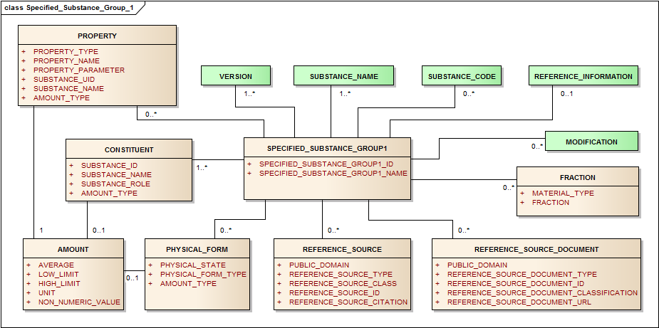
Figure 16 – Information model for the Specified Substance Group 1

Specified Substance Group 1 ID
Table 193 – Specified Substance group 1 ID
User Guidance | The unique identifier assigned to the Specified Substance Group 1 shall be specified.  NOTE If a unique “Specified Substance ID” has been assigned, this “Specified Substance ID” shall be specified based on the Substance Name controlled vocabulary.  In the absence of a unique “Specified Substance ID” e. g. for the initial submission of the substance this data element is not required.
Example(s)
Conformance | REQUIRED
Data Type | II
Values Allowed
Business Rule(s) | The ID of the substance will be automatically assigned by the system once the message will be processed.  NOTE: the Specified Substance ID is NOT SPECIFIED for Specified Substance ID Request

Specified Substance Group1 Name
Table 194 – Specified Substance group 1 name
User Guidance | The name of the Specified Substance Group 1 shall be provided in this field.  [Scientific genus/binomial/trinomial without Author] [Part(s)] [Fraction][Extraction solvent composition][Herbal Drug/Native Herbal Preparation(DER)]
Example(s) | Ginkgo biloba, Leaf, Dry Extract acetone-Water (60 – 40)(65-37 = 1 w,w)
Conformance | REQUIRED
Data Type | ST
Values Allowed
Business Rule(s) | Name conventions can be adopted regionally as the latest version of the Naming Conventions document.

Substance Name (repeat as necessary)
Names associated with a Specified Substance Group 1 will be captured in manner similar to Substance Name (Section 4.5). The name type should be specified and, for Official Names, the same format should be followed (Section 4.5.4).

Substance Code
Codes associated with a Specified Substance Group 1 will be captured in manner similar to Substance Codes (Section 4.7).

Version (repeat as necessary)
Version associated with a Specified Substance Group 1 will be captured in manner similar to Substance Version (Section 4.13).

Reference Sources
Reference Information will also be captured in a manner similar to the substance reference information (Section 4.6).

Property (repeat as necessary)
Property values will be captured in a manner similar to those described for substances (Section 4). It is possible to capture both definitional properties and properties that provide additional information about a substance. For example the melting point of a polymorphic substance or solubility or rate of dissolution of a crystalline material could be a defining property of a given Specified Substance Group 1.

Fraction (new classes to be included in the ISO 11238 Standard in the next revision)
For herbal substances the fraction element should be used to capture oils and juices derived from specific parts of plants.
Table 195 – Fraction
User Guidance | The fraction of the plant where the herbal substance is derived.
Example(s) | Oils, juices, essential oil
Conformance | CONDITIONAL
Data Type | CD
Values Allowed
Business Rule(s) | When the herbal substance is derived from a fraction of the plant, the description of the fraction is required.

Modification
Modifications particularly those involving herbal preparations should be captured at the Specified Substance Group 1 level when they are not captured at the substance level, section 4.11.
EXAMPLE The refinement of olive oil to remove or reduce free acids would be a modification captured at the Specified Substance Group 1 level. Partial or complete hydrogenation of given oil would also be captured at the Specified Substance Group 1 level.

Reference Information (repeat as necessary)
The Reference Information is not essential for the definition of the substance. If provided, the conformance as described in Section 4.7.8.1.

Constituent (repeat as necessary)
The constituents group of elements serves several roles, each substance in multiple substance materials will be captured as a component. Signature, active markers, and limit substances and extraction solvents will also be captured for herbal extracts. The amount of components, constituents and extraction solvents will also be captured. A different Specified Substance Group 1 will be created if these amounts consistently vary.
At least one constituent is necessary for every Specified Substance Group 1 (i.e. the parent Substance ID).

Substance ID
Each constituent should be identified by either a Substance ID or a Specified Substance ID.
Table 196 – Substance ID
User Guidance | Every Specified Substance Group 1should have at least one constituent and the Substance ID for each constituent should be captured.
Example(s) | ISO 11238 Substance or Specified Substance ID
Conformance | REQUIRED
Data Type | II
Values Allowed | ISO 11238 Substance or Specified Substance ID
Business Rule(s) | A constituent can be a substance or a Specified Substance Group 1.

Substance Name
Table 197 – Substance name
User Guidance | The name of the substance which is the constituent of the Specified Substance Group 1 shall be described; Preferred or Official Name of the constituent.
Example(s)
Conformance | REQUIRED
Data Type | CD
Values Allowed | ISO 11238 Substance or Specified Substance name
Business Rule(s) | This value is implicit and derived from the Substance ID. The Preferred name is the default value.

Substance Role
Table 198 – Substance role
User Guidance | The role of the substance in the specified substance shall be described based on a controlled vocabulary. An impurity component is not described in the Specified Substance Group 1. The parent ID of a Specified Substance Group 1shall always be specified.
Example(s) | active marker, component, degradant, metabolite, active moiety, parent substance
Conformance | REQUIRED
Data Type | CD
Values Allowed | COMPONENT, EXTRACTION SOLVENT, SIGNATURE SUBSTANCE; MARKER SUBSTANCE
Business Rule(s)

Amount type
In Section 4.7.13.3.1.

Amount
The information related to the amount shall be provided as per specification described in Section 4.9.

Physical Form (repeat as necessary)
This section is to capture information on the physical form of the specified substance (e.g. crystalline amorphous, tincture, dry extract), the state of matter, and slightly more detailed form of the final specified substance (e.g., solid, liquid, gas, or emulsion). Biphasic insulin is one example of a crystal in which part is dissolved and part is in solution. There are also instances of substances being partially crystalline and partially amorphous which would be two different form types and a mixture of Specified Substances, different polymorphic crystalline types. If two polymorphs are distinguished by crystalline type, the symmetry group that distinguishes the crystalline types should be captured as a property.
The Physical form is not always applicable (e.g. for multiple substances) and therefore is conditional; however when it is applicable (e.g. herbal preparation or when the form of the substance is available), the physical form is required to be provided in accordance with the following specifications:

Physical State
Table 199 – Physical state
User Guidance | The actual state of the substance in packaged product or administered product
Example(s) | solid, liquid
Conformance | REQUIRED
Data Type | CD
Values Allowed | SOLID, LIQUID, GAS, EMULSION, GEL
Business Rule(s) | This information is implicit and derived from the Physical Form Type

Physical Form Type
Table 200 – Physical form type
User Guidance | Type of the physical form
Example(s) | crystalline, amorphous, tincture, dry, extract
Conformance | REQUIRED
Data Type | CD
Values Allowed
Business Rule(s) | When the physical state is available, it shall be provided as it defines a new Substance ID

Amount type
In Section 4.7.13.3.1.

Amount
The information related to the amount shall be provided as per specification described in Section 4.9.
When there is an Amount, it must be specified as an observation with a measurable property code.

Specified Substance Group 1 intended for Herbal Substance and Herbal Preparation
This iteration of the document covers specifically Herbal Specified Substance Group 1.

Specified Substance Group 1 ID
Table 201 – Specified Substance group 1 ID
User Guidance | The unique identifier assigned to the Specified Substance Group 1 shall be specified.  NOTE If a unique “Specified Substance ID” has been assigned, this “Specified Substance ID” shall be specified based on the Substance Name controlled vocabulary.  In the absence of a unique “Specified Substance ID” e. g. for the initial submission of the substance this data element is not required.
Example(s) | UFR78E23Y
Conformance | REQUIRED
Data Type | II
Values Allowed
Business Rule(s) | The ID of the substance will be automatically assigned by the system once the message will be processed.  NOTE: the Specified Substance ID is NOT SPECIFIED for Specified Substance ID Request

Specified Substance Group1 Name
Table 202 – Specified Substance group 1 name
User Guidance | The name of the Specified Substance Group 1 shall be provided in this field as available in official name sources.
Example(s) | Harpagophytum zeyheri, Root, Dry Extract Ethanol-Water (60-40)(1.5-3.0 = 1 w/w)
Conformance | REQUIRED
Data Type | ST
Values Allowed
Business Rule(s)

Substance Name (repeat as necessary)
Names associated with a Specified Substance Group 1 will be captured in manner similar to Substance Name (Section 4.5). The name type should be specified and, for Official Names, the same format should be followed (Section 4.5.4). Names used in pharmacopoeias, legislation or regulations should always be used when available.

Version (repeat as necessary)
Version associated with a Specified Substance Group 1 will be captured in manner similar to Substance Version (Section 4.13).

Reference Sources
Reference Information will also be captured in a manner similar to that describe in a manner similar to the substance reference information (Section 4.6).

Fraction (new classes to be included in the ISO 11238 Standard in the next revision)
Note that the fraction Oil, will be captured at the substance information level. The fraction Class at the Specified Substance Group 1 information level is ment to capture additional information regarding the Extraction Types Dry, Liquid extract captured at the Substance level.
Information at the Specified Substance Group 1 level is used to capture the extraction solvent composition and the (Herbal) Drug to Native Herbal Preparation (Extract) ratio, and to describe the constituents present in the extract.
Table 203 – Fraction
User Guidance | The fraction of the plant where the herbal substance is derived.
Example(s) | Dry Extract DER (Drug extratct Ratio 20 g plant material = 1 g Dry extract) (20 = 1)
Conformance | CONDITIONAL
Data Type | CD
Values Allowed
Business Rule(s) | When the herbal substance is derived from a fraction of the plant, the fraction is required.

Modification (new classes to be included in the ISO 11238 Standard in the next revision)
Modifications, particularly those involving herbal preparations, should be captured at the Specified Substance Group 1 level when they are not captured at the substance level, Section 4.11.

Constituent (repeat as necessary)

Substance ID
Table 204 – Substance ID
User Guidance | Every Specified Substance Group 1 should have at least one constituent and the Substance ID each constituent should be captured.
Example(s) | ISO 11238 Substance or Specified Substance ID
Conformance | REQUIRED
Data Type | II
Values Allowed | ISO 11238 Substance or Specified Substance ID
Business Rule(s) | Mandatory, at least one constituent is necessary for every Specified Substance Group 1. A constituent can be a substance or a specified substance.

Substance Name
Table 205 – Substance name
User Guidance | The name of the substance which is the constituent of the Specified Substance Group 1 shall be described; Preferred or Official Name of the constituent.
Example(s) | Ethanol-Water
Conformance | REQUIRED
Data Type | CD
Values Allowed | ISO 11238 Substance or Specified Substance name
Business Rule(s) | This value is implicit and derived from the Substance ID. The Preferred name is the default value.

Substance Role
Table 206 – Substance role
User Guidance | The role of the substance in the specified substance shall be described based on a controlled vocabulary. An impurity component is not described in the Specified Substance Group 1. The parent ID of a Specified Substance Group 1 shall always be specified.
Example(s) | active marker, parent substance
Conformance | REQUIRED
Data Type | CD
Values Allowed | COMPONENT, EXTRACTION SOLVENT, SIGNATURE SUBSTANCE; ACTIVE MARKER
Business Rule(s) | Markers for herbal specified substance are conditional, when available information on markers shall be provided.

Amount type
In Section 4.7.13.3.1.

Amount
The information related to the amount, where applicable, shall be provided as per specification described in Section 4.9.

Physical Form (repeat as necessary)

Physical State
Table 207 – Physical state
User Guidance | The actual state of the substance in packaged product or administered product
Example(s) | solid, liquid
Conformance | REQUIRED
Data Type | CD
Values Allowed | SOLID, LIQUID, GAS, EMULSION, GEL
Business Rule(s) | This information is implicit and derived from the Physical Form Type

Physical Form Type
Table 208 – Physical form type
User Guidance | Type of the physical form
Example(s) | Dry Extract
Conformance | CONDITIONAL
Data Type | CD
Values Allowed
Business Rule(s) | When the physical state is available, it shall be provided as it defines a new Substance ID

Amount type
Table 209 – Amount type
User Guidance | Most elements that have a quantitative value will also have a field called amount type. Amount type shall always be specified because the actual value of the amount is often dependent on it.  Example: In capturing the actual relative amounts of substances or molecular fragments it is essential to indicate whether the amount refers to a mole ratio or weight ratio. For any given element an effort should be made to use the same amount type for all related definitional elements.
Example(s)
Conformance | CONDITIONAL
Data Type | CD
Values Allowed
Business Rule(s)

Amount
The information related to the amount, when applicable, shall be provided as per specification described in Section 4.9.

Specified Substance Group 2 (repeat as necessary)
Specified Substances Group 2 will be used to capture the manufacturer of a given substance as well as limited manufacturing information. The defining elements are the parent substance which will be either a substance or a Specified Substance Group 1. Many biosimilar substances will be distinguished at this level. Any manufacturing information specific to the finished product will be described based on the ISO 11615: 2012 model and according to the specifications outlined in ISO TS 20443 and 20451.
Each manufacturer should be identified with a code, such as D.U.N.S. number (as ID), and a name. The manufacturing type can be manufacturer. The description of the repackager or distributor will be specified at the medicinal product level and be based on the ISO 11615: 2012 model, and the specifications outlined in the ISO TS 20443 and 20451. It is also important to capture the production method type (i.e. synthetic, extractive, biosynthetic) production type and the production system that describes the cell line or animal from which a given substance is isolated from.
The manufacturer is not necessarily the entity that has market authorisation, but the entity that manufactures or repackages the material. If a substantial change in a critical manufacturing process occurs, a new Specified Substance Group 2 ID should be generated. This would result in a new version of the Specified Substance Group 2. The grade of a material as described for Specified Substance Group 3 can also be provided as a non-definitional field when relevant.
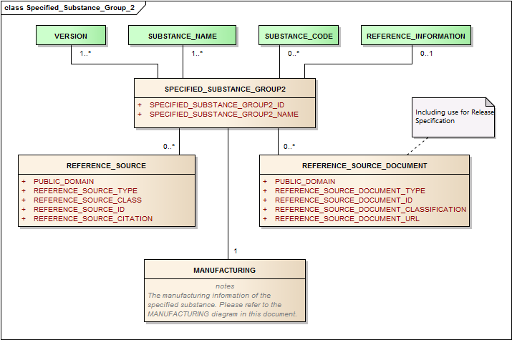
Figure 17 – Information model for the Group 2 specified substance
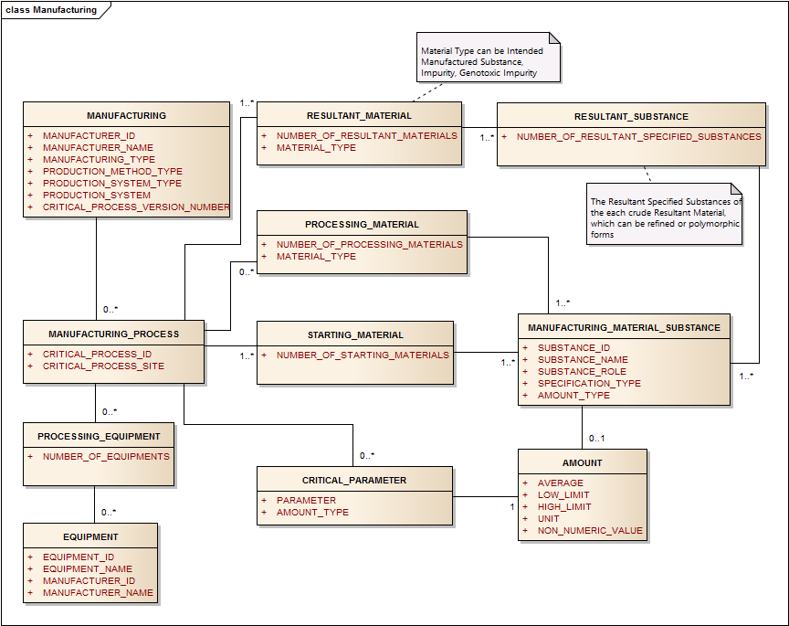
Figure 18 – Information model for the Group 2 specified substance
In this Substance Class Specified Substance Group 2 the Element group Reference Source Document is included. The Reference Source Document Type provides the manufacturer to submit the Release specification of the manufactured preparation, according to figure 17.
Only the Element Group Manufacturing in figure 18 is mend to be implemented yet up to the minimum information captured for the attributes in this element group. However in future versions of the Implementation Guide this element group can be extended up to a Manufacturing Class with the information model as is shown in figure 18. The element group Manufacturing information is extended as a class and is yet allocated at the Specified Substance Group 4 information level in the ISO 11238 Substance Standard. This (extended) manufacturing information is shown only for informational purposes and is mend to capture the starting materials, impurities and the intended manufactured substance. The model follows up to now not any further information than the element group Manufacturing.

Specified Substance Group2 ID
Table 210 – Amount type
User Guidance | The unique identifier assigned to the Specified Substance Group 2 shall be specified.  NOTE: If a unique “Specified Substance ID” has been assigned, this “Specified Substance ID” shall be specified based on the Substance Name controlled vocabulary.  In the absence of a unique “Specified Substance ID” e. g. for the initial submission of the substance this data element is not required.
Example(s)
Conformance | REQUIRED
Data Type | II
Values Allowed
Business Rule(s) | NOTE: the Specified Substance ID is NOT SPECIFIED for Specified Substance ID Request

Specified Substance Group2 Name
Table 211 – Specified Substance group 2 name
User Guidance | The name of the Specified Substance Group 2 shall be provided in this field. The name should be coined from the preferred term of the substance and the manufacturer.
Example(s) | Human Insulin Drugco
Conformance | REQUIRED
Data Type | ST
Values Allowed
Business Rule(s) | The name should be coined from a concatenation of the preferred term of the parent substance and the manufacturer (i.e. Human Insulin Drugco). Regions may provide additional guidance as the latest version of the Naming Conventions document (Ref. Doc.: EMA/720247/2011).

Parent Substance ID
Table 212 – Parent Substance ID
User Guidance | The Substance or Specified Substance Group 1 ID that identifies the manufactured substance. The unique identifier assigned to the substance that is the parent of the specified substance shall be provided based on controlled vocabulary. The ID of the parent for the Specified Substance Group 2 may refer to either a Substance ID or a Specified Substance Group 1 ID.  NOTE: If a unique “ID” has been assigned, this “ID” shall be specified based on the Substance Name controlled vocabulary. In the absence of a unique “ID” e. g. for the initial submission of specified substance and parent substance, the name of the parent substance shall be specified.
Example(s)
Conformance | REQUIRED
Data Type | II
Values Allowed | ISO 11238 substance or specified Substance ID
Business Rule(s)

Manufacturing
The manufacturing information shall be provided according to the following specifications:

Manufacturer ID
Table 213 – Manufacturer ID
User Guidance | The unique code used to track manufacturers.
Example(s)
Conformance | CONDITIONAL
Data Type | II
Values Allowed
Business Rule(s) | An ID associated with each manufacturer may or may not be linked to a manufacturer site; when available it shall be provided.  A necessary condition for the Specified Substance Group 2 to exist is: either the Manufacturer ID, Name and type is available AND/OR the production method type, product system type and production system exist. The manufacturer and production description can coexist, at least one of those shall be provided.

Manufacturer Name
Table 214 – Manufacturer name
User Guidance | The name of the manufacturer of the specified substance.
Example(s)
Conformance | CONDITIONAL
Data Type | ST
Values Allowed
Business Rule(s) | The general name of the manufacturer not linked to a specific site. This is implicit and derived from the Manufacturer ID.  A necessary condition for the Specified Substance Group 2 to exist is: either the Manufacturer ID, Name and type is available AND/OR the production method type, product system type and production system exist. The manufacturer and production description can coexist, at least one of those shall be provided.

Manufacturing Type
Table 215 – Manufacturing type
User Guidance | The type of operation performed by the entity associated with the substance.
Example(s) | Manufacturer (of Substance or Specified Substance)
Conformance | CONDITIONAL
Data Type | CD
Values Allowed
Business Rule(s) | If a repackager the original manufacturer should also be captured.  A necessary condition for the Specified Substance Group 2 to exist is: either the Manufacturer ID, Name and type is available AND/OR the production method type, product system type and production system exist. The manufacturer and production description can coexist, at least one of those shall be provided.

Production Method Type
Table 216 – Production method type
User Guidance | The overall type of production system, synthetic, extractive, biosynthetic.
Example(s) | synthetic, extractive, biosynthetic, semi-synthetic
Conformance | CONDITIONAL
Data Type | CD
Values Allowed
Business Rule(s) | When applicable and available it shall be provided.  A necessary condition for the Specified Substance Group 2 to exist is: either the Manufacturer ID, Name and type is available AND/OR the production method type, product system type and production system exist. The manufacturer and production description can coexist, at least one of those shall be provided.

Production System Type
Table 217 – Production system type
User Guidance | Should be captured for material derived from both extractive and biosynthetic production method, for synthesised peptides and nucleic acids.
Example(s) | Plant, animal, bacterial, fungal, insect cell line, yeast, mammalian cell line, human cell line, animal tissue, human tissue, solid phase chemistry, solution chemistry
Conformance | CONDITIONAL
Data Type | CD
Values Allowed
Business Rule(s) | Should be captured for all material derived from extractive or biosynthetic production methods and some synthetic peptides and nucleic acids. When applicable and available it shall be provided.  A necessary condition for the Specified Substance Group 2 to exist is: either the Manufacturer ID, Name and type is available AND/OR the production method type, product system type and production system exist. The manufacturer and production description can coexist, at least one of those shall be provided.

Production System
Table 218 – Production system
User Guidance | The production system description shall be provided when available.
Example(s) | CHO cell, goat, bovine lungs
Conformance | CONDITIONAL
Data Type | CD
Values Allowed | Should be captured for all material derived from extractive or biosynthetic production methods and some synthetic peptides and nucleic acids. When applicable and available it shall be provided.  A necessary condition for the Specified Substance Group 2 to exist is: either the Manufacturer ID, Name and type is available AND/OR the production method type, product system type and production system exist. The manufacturer and production description can coexist, at least one of those shall be provided.
Business Rule(s) | Production System, System Type and Method are all to be represented in one terminology. When applicable and available it shall be provided.  A necessary condition for the Specified Substance Group 2 to exist is: either the Manufacturer ID, Name and type is available AND/OR the production method type, product system type and production system exist. The manufacturer and production description can coexist, at least one of those shall be provided.

Critical Process Version Number
Table 219 – Critical process version number
User Guidance | Should be captured for material derived from both extractive and biosynthetic production method, for synthesised peptides and nucleic acids.
Example(s) | 2
Conformance | OPTIONAL
Data Type | INT
Values Allowed | Start at one and increases if a major critical process changes occur (i.e. changes in master cell bank; elimination or addition of a chromatographic purification process).
Business Rule(s) | The critical process version number shall be tied to the production system.

NOTE The version should be tied to the Production System Type and will change if a critical process changes.

Substance Name (repeat as necessary)
Names associated with a Specified Substance Group 2 will be captured in manner similar to Substance Name (Section 4.5). Trade names associated with the manufacturer can be captured at this level.

Substance Code
Codes associated with a Specified Substance Group 2 will be captured in manner similar to Substance Codes (Section 4.7)

Reference Sources
Reference Information will also be captured in a manner similar to that describe in a manner similar to the substance reference information (Section 4.6).

Version (repeat as necessary)
Version associated with a Specified Substance Group 2 will be captured in manner similar to Substance Version (Section 4.13).

Specified Substance Group 2 for Herbal preparations

Specified Substance Group2 ID
Table 220 – Specified Substance group 2 ID
User Guidance | The unique identifier assigned to the Specified Substance Group 2 shall be specified.  NOTE: If a unique “Specified Substance ID” has been assigned, this “Specified Substance ID” shall be specified based on the Substance Name controlled vocabulary.  In the absence of a unique “Specified Substance ID” e. g. for the initial submission of the substance this data element is not required.
Example(s) | AGHFT4352E
Conformance | REQUIRED
Data Type | II
Values Allowed
Business Rule(s) | NOTE: the Specified Substance ID is NOT SPECIFIED for Specified Substance ID Request

Specified Substance Group2 Name
Table 221 – Specified Substance group 2 ID
User Guidance | The name of the Specified Substance Group 2 shall be provided in this field. The name should be coined from the preferred term of the substance and the manufacturer.  The Name Extract and Parent relationship with the herbal preparation. Coupling to the manufacturer.
Example(s) | Harpagophytum procumbens, Root, Dry Extract Ethanol-Water (60-40) (1.5–3.0 = 1 w/w) – Manufacturer Ex.
Conformance | REQUIRED
Data Type | ST
Values Allowed
Business Rule(s) | The name should be coined from a concatenation of the preferred term of the parent substance and the manufacturer (i.e. Human Insulin Lilly).

Parent Substance ID
Table 222 – Parent Substance ID
User Guidance | The Substance or Specified Substance Group 1 ID that identifies the manufactured substance. The unique identifier assigned to the substance that is the parent of the specified substance shall be provided based on controlled vocabulary. The ID of the parent for the Specified Substance Groups 1, 2 or 3may refer to either a Substance ID or a Specified Substance Group 1 ID.  NOTE: If a unique “ID” has been assigned, this “ID” shall be specified based on the Substance Name controlled vocabulary. In the absence of a unique “ID” e. g. for the initial submission of specified substance and parent substance, the name of the parent substance shall be specified.
Example(s) | EXCTER654E (= Specified Substance Group 1 ID of the Herbal preparation)
Conformance | REQUIRED
Data Type | II
Values Allowed | ISO 11238 Substance or Specified Substance ID
Business Rule(s)

Manufacturing

Manufacturer ID
Table 223 – Manufacturer ID
User Guidance | The unique code used to track manufacturers.
Example(s)
Conformance | CONDITIONAL
Data Type | II
Values Allowed
Business Rule(s) | An ID associated with each manufacturer may or may not be linked to a manufacturer site; when available it shall be provided.  A necessary condition for the Specified Substance Group 2 to exist is: either the Manufacturer ID, Name and type is available AND/OR the production method type, product system type and production system exist. The manufacturer and production description can coexist, at least one of those shall be provided.

Manufacturer Name
Table 224 – Manufacturer name
User Guidance | The name of the manufacturer of the specified substance.
Example(s)
Conformance | CONDITIONAL
Data Type | ST
Values Allowed
Business Rule(s) | The general name of the manufacturer not linked to a specific site. This is implicit and derived from the Manufacturer ID.  A necessary condition for the Specified Substance Group 2 to exist is: either the Manufacturer ID, Name and type is available AND/OR the production method type, product system type and production system exist. The manufacturer and production description can coexist, at least one of those shall be provided.

Manufacturing Type
Table 225 – Manufacturing type
User Guidance | The type of operation performed by the entity associated with the substance.
Example(s) | Manufacturer (of the Substance or Specified Substance).
Conformance | CONDITIONAL
Data Type | CD
Values Allowed
Business Rule(s) | A necessary condition for the Specified Substance Group 2 to exist is: either the Manufacturer ID, Name and type is available AND/OR the production method type, product system type and production system exist. The manufacturer and production description can coexist, at least one of those shall be provided.

Production Method Type
Table 226 – Production method type
User Guidance | The overall type of production system, synthetic, extractive, biosynthetic.
Example(s) | Extraction
Conformance | CONDITIONAL
Data Type | CD
Values Allowed
Business Rule(s) | The general name of the manufacturer not linked to a specific site. This is implicit and derived from the Manufacturer ID.  A necessary condition for the Specified Substance Group 2 to exist is: either the Manufacturer ID, Name and type is available AND/OR the production method type, product system type and production system exist. The manufacturer and production description can coexist, at least one of those shall be provided.

Version (repeat as necessary)
Version associated with a Specified Substance Group 2 will be captured in manner similar to Substance Version (Section 4.13)

Specified Substance Group 3 (repeat as necessary)

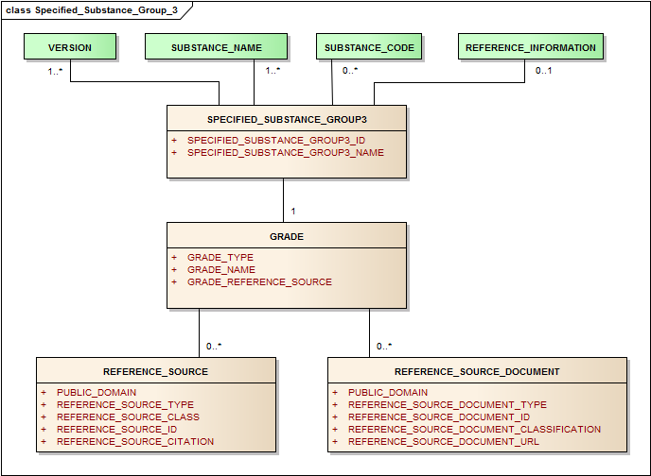
Figure 19 – Information model for the Group 3 specified substance
Figure 19 provides the information to capture the grade of a substance. This group is mend to be for Phamacopoeial Grades (EP,USP). Each grade will lead for a separate Specified Substance Group 3 Identifier. However there are applications in which regulatory approval has been achieved for more than one grade and sometimes the sponsor will add an extra specification, such as particle size which is not captured in the Pharmacopoeial monograph. In this case the model provides in the Reference documentation type “In House” Grade in which a specification set can be laid down covering the EP, USP as well as the intended particle size.
The information on the grade shall be specified by means of the following data elements:

Specified Substance Group3 ID
Table 227 – Specified Substance group 3 ID
User Guidance | The unique identifier assigned to the Specified Substance Group 3 shall be specified.  NOTE: If a unique “Specified Substance ID” has been assigned, this “Specified Substance ID” shall be specified based on the Substance Name controlled vocabulary.  In the absence of a unique “Specified Substance ID” e. g. for the initial submission of the substance this data element is not required.
Example(s)
Conformance | REQUIRED
Data Type | II
Values Allowed
Business Rule(s) | NOTE: the Specified Substance ID is NOT SPECIFIED for Specified Substance ID Request

Specified Substance Group3 Name
Table 228 – Specified Substance group 3 name
User Guidance | The name of the Specified Substance Group 3 shall be provided in this field or it should be derived from the Specified Substance Group 1 Name (Preferred Term)
Example(s) | Name in monograph appended to Grade Type (i.e. sterile water for injection USP)
Conformance | REQUIRED
Data Type | ST
Values Allowed
Business Rule(s)

Parent Substance ID
Table 229 – Parent Substance ID
User Guidance | The unique identifier assigned to the substance that is the parent of the specified substance shall be provided based on controlled vocabulary. The ID of the parent for the Specified Substance Group 3 may refer to either a Substance ID or Specified Substance Group 1 ID.  NOTE: If a unique “ID” has been assigned, this “ID” shall be specified based on the Substance Name controlled vocabulary. In the absence of a unique “ID” e. g. for the initial submission of specified substance and parent substance, the name of the parent substance shall be specified.
Example(s)
Conformance | REQUIRED
Data Type | II
Values Allowed | ISO 11238 Substance or Specified Substance ID
Business Rule(s)

Grade
The characteristics of the grade of the substance shall be specified.

Grade Type
Table 230 – Grade type
User Guidance | Pharmacopoeial specification type or other specification type.
Example(s)
Conformance | REQUIRED
Data Type | CD
Values Allowed
Business Rule(s) | Each Pharmacopoeial Specification shall be given a separate record as described in the applicable Annexes..

Grade Name
Table 231 – Grade name
User Guidance | Typically the Monograph Title that refers to a given substance or specified substance; for herbal substances standardised or non-standardised will be appended to the name along with standardisation.
Example(s) | quantified, standardised
Conformance | REQUIRED
Data Type | ST
Values Allowed
Business Rule(s)

(Grade) Reference Source
Table 232 – (Grade) reference source
User Guidance | Refers to the relevant reference source of the grade or specific source of monograph.
Example(s) | EP., Ed 7th 2011 (7.2), USP
Conformance | REQUIRED
Data Type | ST
Values Allowed
Business Rule(s)

Reference Source (repeat as necessary)
Reference source will be captured in a manner similar to the one described in Section 4.6.

Version (repeat as necessary)
Version associated with a Specified Substance Group 1 will be captured in manner similar to Substance Version (Section 4.13).
Table 233 – Version
Value Allowed
Business Rule(s)

(Grade) Reference Source
Table 234 – (Grade) reference source
User Guidance | Refers to the relevant reference source of the grade or specific source of monograph.
Example(s) | EP., Ed 7th 2011 (7.2), USP
Conformance | REQUIRED
Data Type | ST
Value Allowed
Business Rule(s)

Reference Source (repeat as necessary)
Reference source will be captured in a manner similar to the one described in Section 4.6.

Version (repeat as necessary)
Version associated with a Group 1 specified substance will be captured in manner similar to Substance Version (Section 4.13).

- (informative)
Annex A

